FIDELIS LABS

Intelli Platform

Functional Requirements Document

Version 2.0 — Comprehensive Edition

Document Details
Version: 2.0 — Comprehensive Edition
Status: Final Draft — For Stakeholder Review
Products Covered: IntelliDepot™ · IntelliStream™ · IntelliCafe™ · IntelliRecruit™
Prepared For: Fidelis Digital Product & Technology Leadership
Date: February 2026
Classification: Confidential & Proprietary
Geographies: India · UAE · Saudi Arabia

I N D I A · U A E · S A U D I A R A B I A

How to Read This Document 4
Use Case Card Format 4
1. Executive Summary 6
1.1 Platform Architecture Overview 6
1.2 AI Agent Orchestration Workflow 7
1.3 Products at a Glance 7
1.4 Design Framework — SUPERS 8
2. IntelliPlatform — Common Core Modules 9
PC-01 — Authentication, Identity & Branding 9
PC-02 — Unified API & Routing Gateway 10
PC-03 — Agentic Orchestration & AI Brain 10
PC-04 — Data Infrastructure & ETL Layer 11
PC-05 — Omni-Channel Delivery & Notification Hub 12
3. IntelliDepot™ — AI-Powered Depot Intelligence Platform 14
3.1 Key Business Benefits 14
3.2 Problem Statement 14
3.3 Scope — In Scope & Out of Scope 15
3.4 Module & AI Agent Matrix 16
3.5 Detailed Use Case Specifications 17
4. IntelliStream™ — CFO Intelligence Suite 42
4.1 Key Business Benefits 42
4.2 Problem Statement 42
4.3 Scope — In Scope & Out of Scope 43
4.4 Module & AI Agent Matrix 44
4.5 Detailed Use Case Specifications 45
5. IntelliCafe™ (SmartCafe) — Employee Experience Platform 58
5.1 Key Business Benefits 58
5.2 Problem Statement 58
5.3 Scope — In Scope & Out of Scope 59
5.4 Module & AI Agent Matrix 60
5.5 Detailed Use Case Specifications 61
6. IntelliRecruit™ (RazorSwift) — AI-Native Talent Intelligence Platform 72
6.1 Key Business Benefits 72
6.2 Problem Statement 72
6.3 Scope — In Scope & Out of Scope 73
6.4 Module & AI Agent Matrix 74
6.5 Detailed Use Case Specifications 75
7. Non-Functional Requirements 88
7.1 Performance Requirements 88
7.2 Availability & Reliability 88
7.3 Security Requirements 89
7.4 Regulatory & Compliance Requirements 90
8. Technology Stack 92
8.1 Core Technology Components 92
8.2 Cloud Deployment Architecture 93
9. Glossary & Acronyms 94

How to Read This Document
Purpose of this FRD
This Functional Requirements Document (FRD) is the single source of truth for what the Intelli Platform does, how users interact with it, what outputs are produced, and what is explicitly excluded. Any reader — whether a product manager, developer, QA engineer, business stakeholder, or implementation partner — should be able to answer the following five questions after reading the relevant sections:

1 | What problem are we solving?  Each product chapter opens with a Problem Statement and Key Benefits section explaining the business pain addressed.
2 | What features will be built?  Each module chapter lists all features in the Agent Matrix table, followed by detailed Use Case Cards for each key feature.
3 | How do users interact?  The Actors Involved, Trigger, and Step-by-Step System Flow sections in each Use Case Card describe exact user interactions.
4 | What outputs are expected?  The Expected Output section of each Use Case Card specifies concrete, measurable outputs delivered by the system.
5 | What is NOT included?  Each product chapter includes an explicit In Scope / Out of Scope table to prevent scope creep and set clear boundaries.

Use Case Card Format
Every key module in this document is documented using a standardized Use Case Card containing 11 fields. The table below explains each field:

Feature Name + ID | Unique identifier (e.g., ID-01) and descriptive name of the module or feature being specified.
Description | A plain-English explanation of what this feature does and why it exists.
Actors Involved | All human users and automated system components that participate in this use case.
Preconditions | Conditions that must be true before this use case can be executed (configuration, data availability, user access).
Trigger(s) | The specific event, schedule, or user action that initiates this use case.
Step-by-Step System Flow | Numbered sequence of system and user actions from trigger to completion. Each step is atomic and testable.
Expected Output | Concrete, observable results produced by the system upon successful completion of this use case.
Postconditions | State of the system after successful execution: what has changed, what records are created, what notifications sent.
Business Rules (BR) | Numbered rules that govern business logic — constraints, limits, approval requirements, and policy-based decisions.
Validation Rules (VR) | Data validation and input verification rules that the system enforces before processing a request.
Error Handling (EH) | Numbered error scenarios with root cause, system response, fallback behavior, and escalation path.

1. Executive Summary
Intelli Platform
Four AI-Native Solutions. One Unified Enterprise Intelligence Ecosystem.

The Intelli Platform is Fidelis Digital's flagship product portfolio — a suite of four AI-native enterprise solutions that transform operations, finance, people, and talent across the world's fastest-growing markets: India, UAE, and Saudi Arabia. Each solution is built on a shared platform core (authentication, AI orchestration, data infrastructure, integrations, and observability), enabling rapid deployment, consistent security, and cross-product intelligence.

4  Enterprise Application Suites | 120+  AI Use Cases | 100+  AI Agents | Global (Todo)

1.1 Platform Architecture Overview
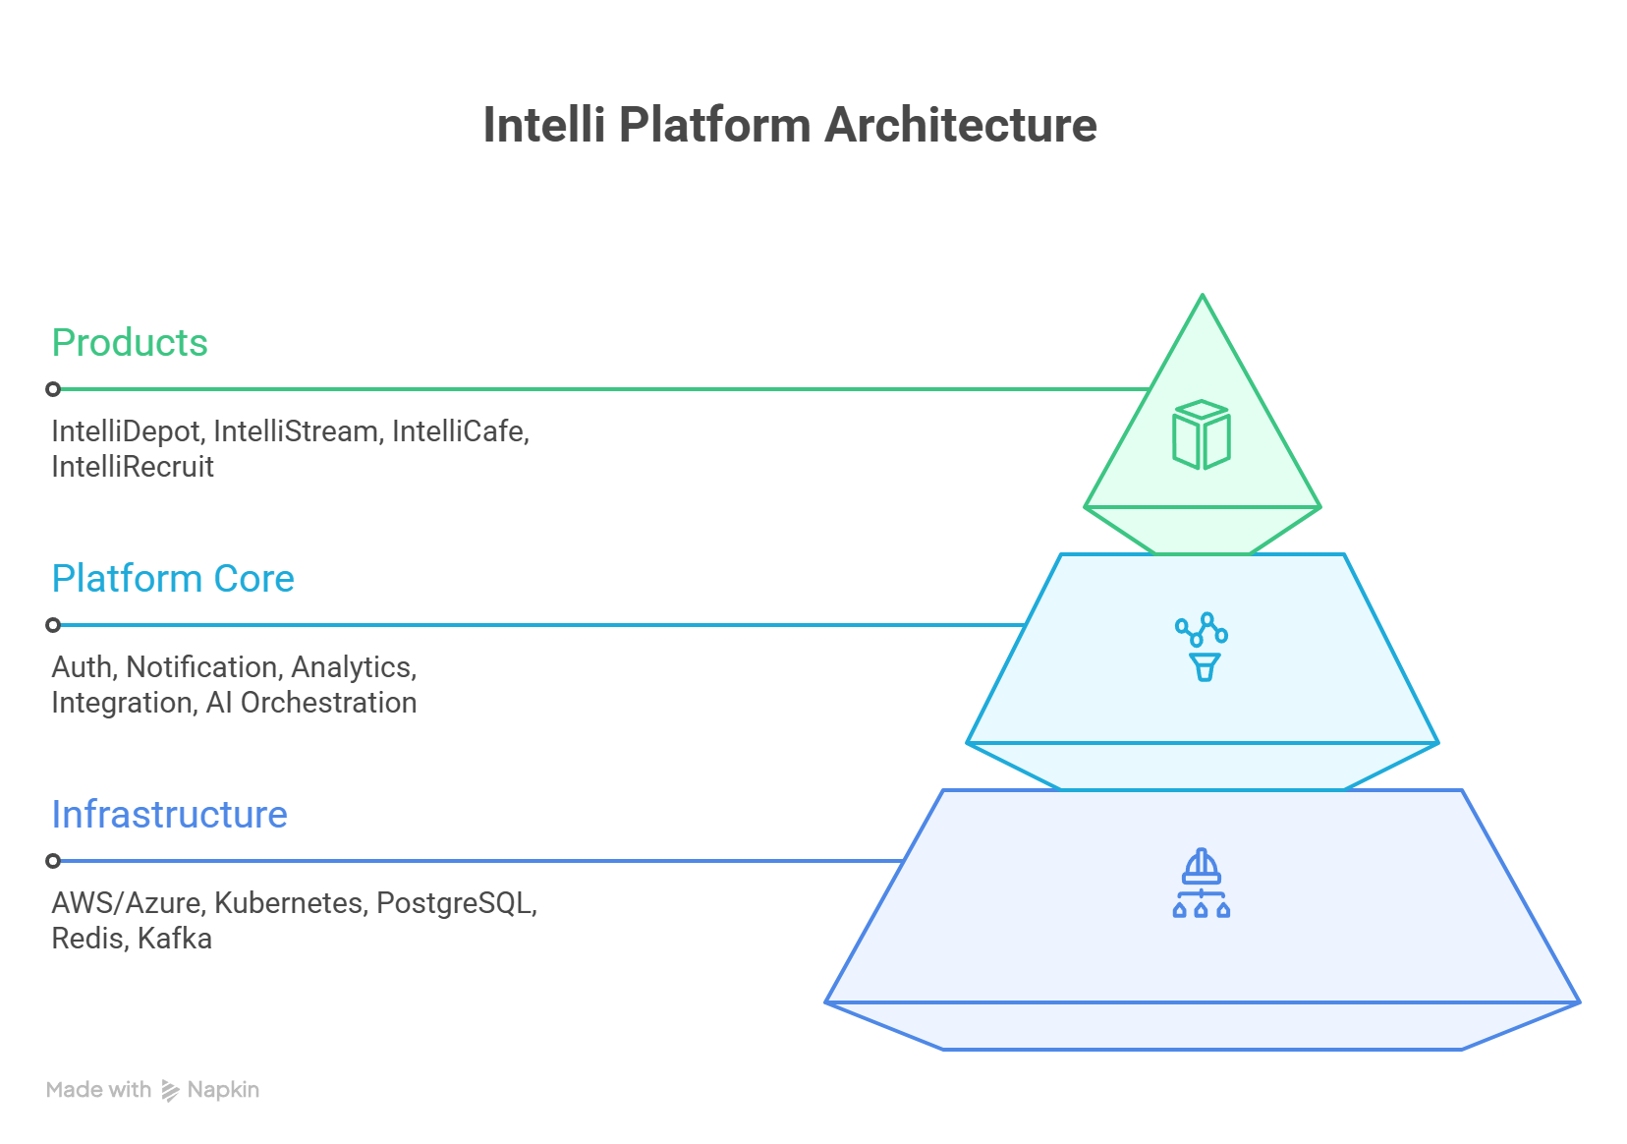

Figure 1.1 — Intelli Platform Layered Architecture
Layer 7 — AI Orchestration Brain
Multi-Agent Coordinator • LLM Gateway • Prompt Management • Agent Memory • Confidence Scoring
Layer 6 — Common Platform Services
Auth & RBAC • API Gateway • Notification Hub • Workflow Builder • Audit Logs
Layer 5 — Data Infrastructure
Data Warehouse • Vector Store • ETL Pipeline • CDC • Backup & Recovery
Layer 0 — Integration Layer
SAP/Oracle ERP • CRM (Salesforce) • HRMS (Workday) • ATS • IoT/Vision • External APIs
Todo : UI Layer | Infrastructure Layer |

1.2 AI Agent Orchestration Workflow
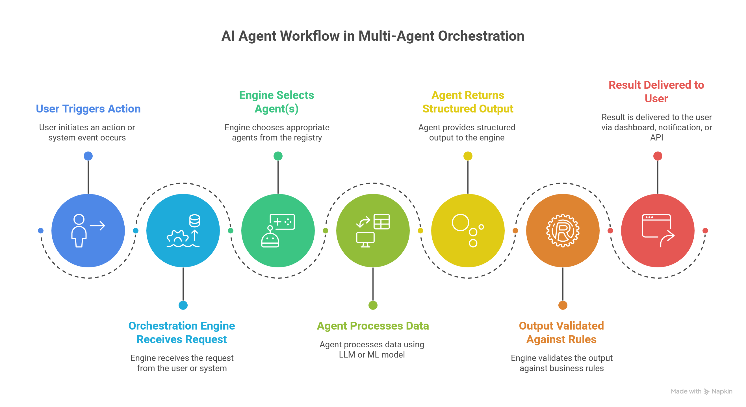
Figure 1.2 — Multi-Agent Orchestration: From Event Trigger to Validated Output

1.3 Products at a Glance
Product | Problem Solved | Key Outcome Metrics
IntelliDepot™ | Manual depot operations: human counting errors, inventory mismatches, reactive SLA management, revenue leakage from pilferage | 30–40% error reduction, 20–35% throughput improvement, real-time ERP sync
IntelliStream™ | CFO blind spots: fragmented data, delayed intelligence, reactive decisions on market/vendor/customer risks | 4–6 hrs/week saved, 90-day advance vendor distress warning, 8–12% churn reduction
IntelliCafe™ | Employee disengagement: no real-time culture intelligence, inconsistent recognition, reactive wellness approach | 25–40% attrition reduction, 3× recognition frequency, burnout detection 30–45 days early
IntelliRecruit™ | Fragmented hiring: disconnected tools, high cost-per-hire, slow time-to-fill, poor candidate experience | 30–50% cost-per-hire reduction, 30–50% faster time-to-hire, 2–3× recruiter productivity

1.4 Design Framework — SUPERS
Every module across all four products is designed and evaluated against the SUPERS framework:

Pillar | Design Requirement
Security | AES-256 encryption at rest, TLS 1.3 in transit, RBAC, MFA, BYOK, PII masking, regional data residency (India/UAE/Saudi), SOC 2 roadmap.
Usability | Mobile-first, offline-capable, multilingual (English/Hindi/Arabic), role-adaptive interfaces, <3 second load time, minimal training requirement.
Performance | P95 API latency <200ms, vision processing <500ms, 99.9% uptime SLA, horizontal auto-scaling via Kubernetes, RTO <4h / RPO <1h.
Extensibility | No-code workflow builder, open REST APIs, webhook support, Boomi/MuleSoft integration middleware, modular architecture with phased deployment.
Explainability | AI transparency, confidence scoring, source citation, reasoning traces, and bias detection ensure every recommendation is explainable and auditable.
Reliability | Automated failover, 99.9% SLA, multi-region deployment, circuit breakers, dead-letter queues, comprehensive health monitoring (Grafana/Datadog).
Scalability | Horizontal pod auto-scaling, read replicas for analytics, sharding for >10TB datasets, 10,000+ concurrent users.

2. IntelliPlatform — Common Core Modules
Common Platform Scope
The following eight platform core modules are shared across all four Intelli products. They are built once and consumed by IntelliDepot, IntelliStream, IntelliCafe, and IntelliRecruit. Changes to these modules affect all products simultaneously.

PC-01: Authentication, Identity & Branding
JWT Sessions • MFA • SSO (SAML/OAuth) • RBAC • White Label
PC-02: Unified API & Routing Gateway
Request Routing • Rate Limiting • WebSocket / SSE • Validation • Event Bus (Kafka)
PC-03: Agentic Orchestration & AI Brain
LangChain/LangGraph • LLM Gateway • Prompt Management • Confidence Scoring • Agent Memory
PC-04: Data Infrastructure & ETL Layer
PostgreSQL / TimescaleDB • Redis / Pinecone • Flink / Spark ETL • CDC Connectors • Data Governance
PC-05: Omni-Channel Delivery & Notification Hub
Web Console • Mobile App • WhatsApp / SMS / Email • Slack / Teams • Report Engine
PC-06: Workflow Automation & Platform Configuration
Workflow Builder • No-Code Rules Engine • SLA Monitoring • Feature Flags • Modular Architecture
PC-07: Predictive Intelligence & Simulation
Forecasting Engine • Sentiment Analysis • What-If Simulation • ROI Tracking • Orchestrator Agent
PC-08: Observability, Governance & AI Experience Engines
Audit Logs • System Monitoring • Multilingual Support • Voice Engine • Avatar Engine

PC-01 — Authentication, Identity & Branding
SUPERS Alignment: Security, Usability
Manages all user identity, session security, multi-factor authentication, single sign-on integration, and multi-tenant white-labeling. The first point of trust for every user across all four products.

Feature / Sub-Component | Functional Specification
Authentication & Authorization | JWT/Cookie session management with automatic refresh. TOTP, SMS, and Email MFA. Configurable session timeout: 30 min (web), 8 hours (mobile). Brute-force lockout after 5 failed attempts.
SSO & Identity Management | SAML 2.0 and OAuth 2.0 support for Azure AD, Okta, Google Workspace, and Ping Identity. IdP-initiated and SP-initiated SSO flows. Group mapping from IdP to platform roles.
Role-Based Access Control (RBAC) | Granular permissions engine with role inheritance. Custom role creation per tenant. Time-bound access grants. Cross-product role mapping (e.g., "Depot Supervisor" role maps to specific IntelliDepot modules only).
White Labelling Engine | Per-tenant: custom logo, color palette, domain (e.g., mycompany.intellidepot.com), email sender name, and app store app icon. No-code configuration via tenant admin panel.
Security & Data Encryption | AES-256 at rest, TLS 1.3 in transit. BYOK (Bring Your Own Key) for enterprise clients. IP whitelisting. Rate limiting: 100 req/min per user, 10,000 req/min per tenant.
Master Identity & User Service | Central identity provider with unified user directory across all Intelli products. Cross-platform role mapping ensuring consistent access governance. SSO federation enabling single login across Depot, Café, Recruit, and Stream. Profile synchronization across products. Automated deprovisioning workflows for offboarded users. Tenant-level user administration with delegated management support.

PC-02 — Unified API & Routing Gateway
SUPERS Alignment: Reliability, Extensibility
Entry point for all requests across all four products. Routes traffic, enforces security, manages rate limits, and provides real-time data via WebSockets.

Feature / Sub-Component | Functional Specification
Integration APIs | URL-based routing to product microservices. API versioning (v1, v2) with backward compatibility. Traffic splitting for A/B deployments and canary releases.
Real-Time Engine | WebSocket connections for live depot alerts, command center updates, and notification streams. Sub-100ms delivery SLA for priority events. SSE support for dashboard data feeds.
Middleware Stack | Pre-request pipeline: structured logging (JSON), rate limiting per user/tenant/IP, CORS management, request ID injection, API key validation.
Validation Layer | Pydantic-based request schema validation. Required field enforcement. Data type and range validation. Malformed requests rejected before reaching business logic.
API Marketplace / SDK Layer | Kafka-based event bus for cross-product events. Dead-letter queues for failed events. Consumer group management. Event replay support for audit and debugging.

PC-03 — Agentic Orchestration & AI Brain
SUPERS Alignment: Explainability, Extensibility
The intelligence core of the platform. Coordinates specialized AI agents across all four products, manages LLM access, handles prompt versioning, and provides explainability for every AI decision.

Feature / Sub-Component | Functional Specification
AI Agent Architecture | LangChain/LangGraph orchestration. Parallel agent execution with result fusion. Agent timeout management and graceful degradation. Cross-product agent coordination for unified insights.
LLM Orchestration Engine | Abstracted LLM API supporting OpenAI GPT-4, Anthropic Claude, Azure OpenAI, and Llama 3 (on-premise). Automatic load balancing and failover between providers. Token usage tracking per tenant.
AI Model Management | Versioned prompt templates per use case. A/B testing framework for prompt optimization. Drift monitoring with automatic rollback to last stable version.
Explainability Engine | Every AI output includes: confidence score (0–100%), source citations, uncertainty band, and model version. Low-confidence outputs trigger human-in-the-loop escalation workflow.
Agent Memory & Context | Short-term (session) and long-term (user preference) memory stores. Cross-session context retention. Privacy-compliant memory clearing on user request or session expiry.

PC-04 — Data Infrastructure & ETL Layer
SUPERS Alignment: Scalability, Reliability
The platform's data backbone — ingesting, transforming, storing, and serving data across all products with tenant isolation, high performance, and comprehensive data governance.

Feature / Sub-Component | Functional Specification
Enterprise Data Connectors | Bi-directional sync with SAP MM/WM, Oracle SCM, Workday, SAP SuccessFactors, Salesforce, HubSpot. Change Data Capture (CDC) for real-time delta sync. Boomi and MuleSoft middleware support.
IoT & Vision Gateway | RTSP stream ingestion from IP cameras. IoT telemetry (MQTT/CoAP) from sensors, weighbridges, RFID readers, and temperature probes. Edge device management (NVIDIA Jetson).
Data Warehouse Support | PostgreSQL (primary OLTP) with RLS tenant isolation. TimescaleDB for time-series. Redis for cache/sessions. Pinecone/Qdrant for vector embeddings. Snowflake/BigQuery for analytics warehouse.
Cross-Platform Data Fabric | Apache Flink for real-time stream processing. Apache Spark for batch ETL jobs. Data quality checks: completeness, consistency, and range validation. Schema registry for schema evolution management.
Data Governance & Privacy Framework | PII detection and masking in pipeline. Data retention policy enforcement. Regional data residency routing (India data stays in India). GDPR right-to-erasure workflow. Data lineage tracking.
Vector Database / Semantic Search | High-dimensional embedding storage using Pinecone/Weaviate/pgvector for semantic content retrieval. Embedding generation pipeline for documents, policies, and knowledge base content. Similarity search with configurable distance metrics. Chunking strategies for optimal retrieval accuracy. Index management with automatic reindexing on content updates. RAG (Retrieval-Augmented Generation) support powering context-aware AI responses across all products.

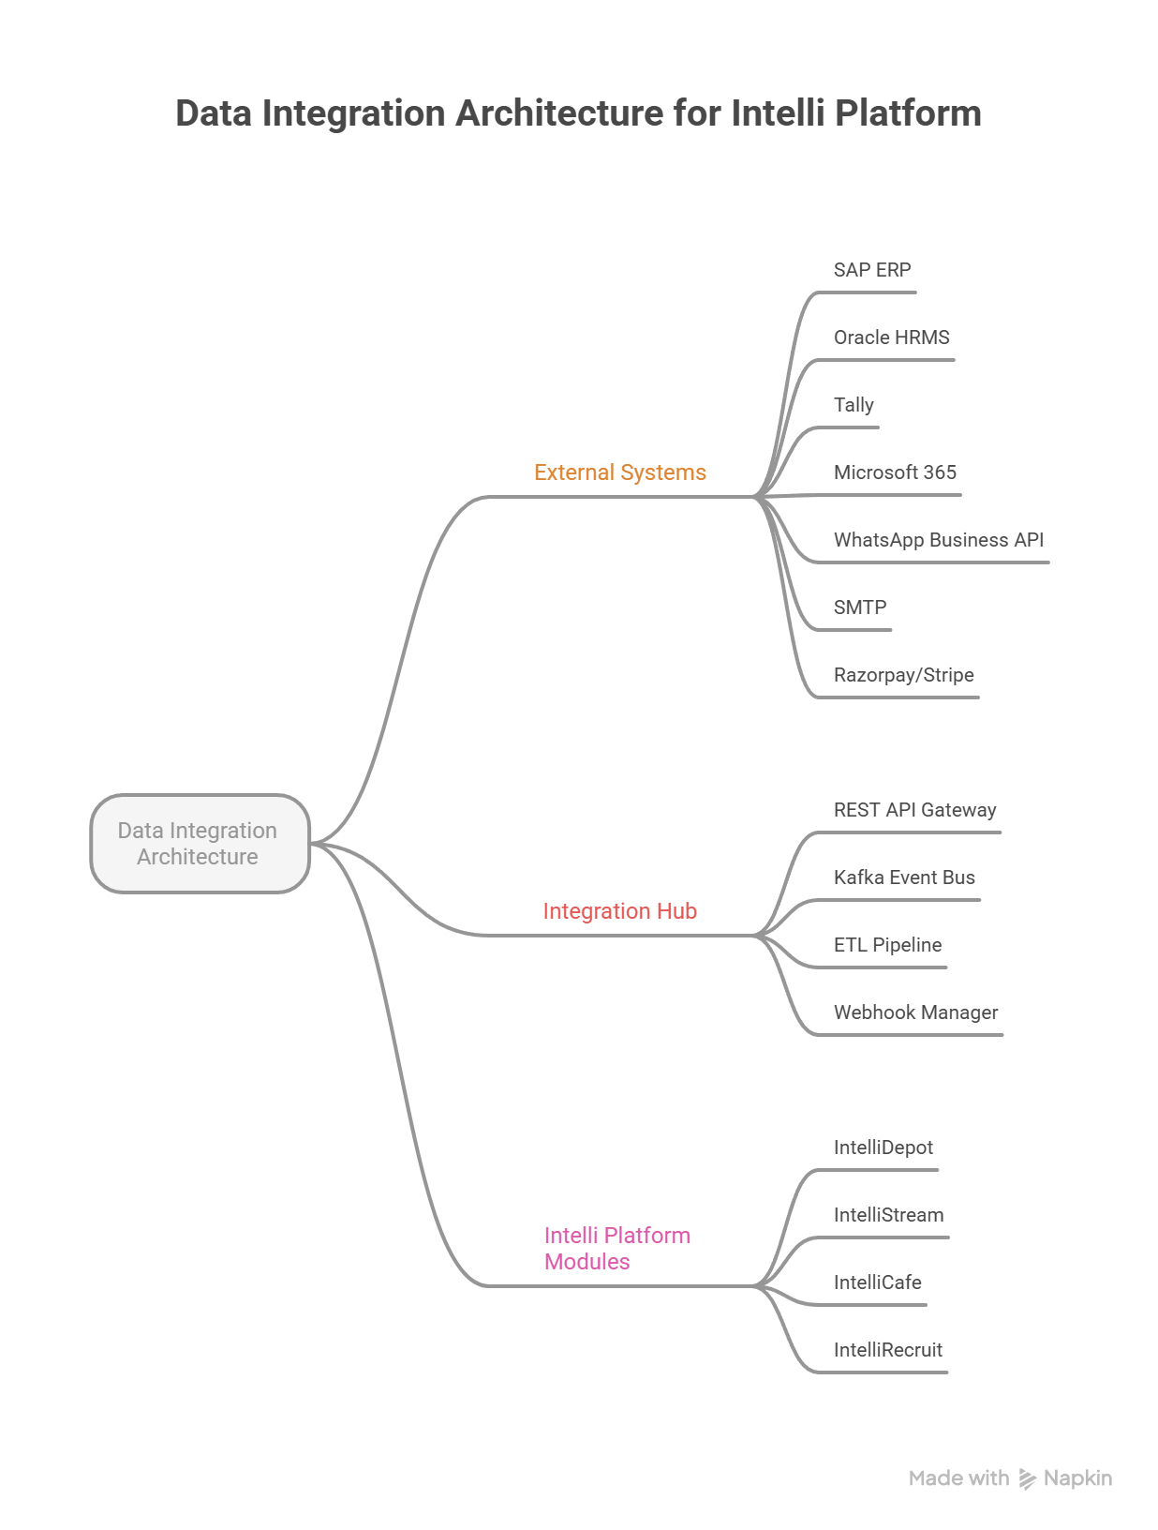
Figure 2.1 — Data Integration Architecture: External Systems ↔ Integration Hub ↔ Intelli Platform

PC-05 — Omni-Channel Delivery & Notification Hub
SUPERS Alignment: Usability, Scalability
Ensures the right insight reaches the right person through the right channel — web, mobile, email, WhatsApp, SMS, Slack, or Teams — with priority queuing and delivery confirmation.

Feature / Sub-Component | Functional Specification
Executive Dashboards | React/Next.js responsive dashboards. Role-adaptive widget layouts with drag-and-drop customization. Real-time data refresh via WebSocket. Dark mode and accessibility (WCAG 2.1 AA) support.
Mobile-First Experience | React Native cross-platform app. Offline-first with SQLite local cache. Push notifications via FCM/APNs. Biometric authentication. Geo-fencing for location-aware features.
Real-Time Alerts & Notifications | Unified notification engine supporting: Email (SendGrid/SES), WhatsApp Business API, SMS (Twilio/Exotel), Slack, MS Teams, and in-app notifications. Priority queuing prevents notification fatigue.
Report Generation Engine | Automated PDF generation using Puppeteer/WeasyPrint. Excel/CSV export for all data views. Branded report templates with charts and KPI summaries. Scheduled report delivery to distribution lists.
Centralized Notification Hub | Configurable escalation rules: unacknowledged alerts escalate to next tier at configured intervals. Multi-channel fallback: primary channel → secondary → tertiary. Escalation audit trail for compliance.

PC-06 — Workflow Automation & Platform Configuration

SUPERS Alignment: Usability, Reliability
Provides the platform's process automation backbone — enabling business users to design, configure, and monitor workflows, SLAs, and feature rollouts without code changes. Ensures operational consistency and controlled releases across all products.

Feature / Sub-Component | Functional Specification
Workflow Automation Engine | Visual drag-and-drop workflow builder with conditional branching, parallel paths, and merge nodes. SLA-linked triggers and escalation rules. Retry logic with configurable backoff. Approval chain support with delegation. Audit trail for every workflow execution. Pre-built templates for common processes (onboarding, incident, procurement).
No-Code / Configuration Engine | Business-user-facing rules engine for configuring thresholds, scoring models, and form layouts without developer involvement. Drag-and-drop form builder with validation rules. Configurable KPI thresholds with auto-alert binding. Template library for workflows, checklists, and reports. Version control for all configurations with rollback support.
SLA Monitoring | SLA definition engine supporting time-based, count-based, and quality-based SLAs. Real-time breach prediction using historical performance patterns. Automated escalation workflows on predicted or actual breach. Performance scorecards with benchmark comparisons. Penalty calculation engine with contract-term integration. Historical SLA trend analysis and reporting.
Feature Flag & Release Management | Feature flag service supporting percentage rollout, user-segment targeting, and environment-based toggles. Canary release support with automatic rollback on error rate thresholds. A/B testing framework with statistical significance tracking. Beta access group management. Version tagging and release notes. Integration with CI/CD pipelines for automated flag management.
Modular Architecture | Plug-and-play module design enabling independent deployment and scaling of each product and sub-module. Feature toggles for enabling/disabling modules per tenant. Dependency mapping and impact analysis for module changes. Phased rollout support for incremental adoption. Independent module versioning and upgrade paths. Shared service registry for cross-module communication.

PC-07 — Predictive Intelligence & Simulation

SUPERS Alignment: Explainability, Scalability
The platform's analytics and intelligence layer — providing predictive forecasting, sentiment analysis, scenario simulation, and ROI measurement as shared services consumed by all product modules. Every prediction includes confidence scores and explainability traces.

Feature / Sub-Component | Functional Specification
Predictive Analytics | Shared forecasting framework supporting time-series (ARIMA, Prophet), regression, and ensemble models. Anomaly detection with configurable sensitivity. Confidence intervals on all predictions. What-if scenario overlays. Automatic model retraining on data drift detection. Pre-built models for demand forecasting, risk scoring, and trend prediction. Results include explainability traces and feature importance rankings.
Sentiment Analysis | NLP-based emotion and sentiment detection from text inputs (feedback, posts, surveys, chat). Multi-language support with context-aware scoring. Trend tracking across time periods and organizational units. Department-level and team-level sentiment heatmaps. Feedback loop integration for model accuracy improvement. Supports both real-time (streaming) and batch analysis modes.
Simulation Engine | Scenario builder supporting variable adjustment, constraint definition, and multi-factor impact cascading. Monte Carlo simulation for probability distribution analysis. Side-by-side scenario comparison with visual overlays. Probability-weighted outcome scoring. Stress testing against extreme scenarios. Shared engine consumed by Depot (capacity), Stream (financial), Café (engagement), and Recruit (hiring) simulation use cases.
ROI & Performance Tracking | Cost-benefit analysis framework with before/after measurement. Productivity scorecards linking platform usage to operational KPIs. Benchmark comparisons against industry standards and historical baselines. Executive summary generation with key ROI metrics. Budget vs. actual tracking for platform investment justification. Configurable ROI models per product and use case.
Orchestrator Agent | Central coordination agent that synthesizes intelligence across all product modules. Cross-domain insight correlation — connecting patterns invisible to individual modules. Priority arbitration when multiple agents generate conflicting recommendations. Auto-routing of insights to the appropriate product module or stakeholder. Learning memory that improves coordination accuracy over time. Unified intelligence feed for CXO-level decision support.

PC-08 — Observability, Governance & AI Experience Engines

SUPERS Alignment: Security, Usability
Ensures full system visibility, regulatory compliance, and advanced user interaction capabilities. Provides audit trails, system health monitoring, multilingual support, and next-generation voice and avatar interfaces as shared platform services.

Feature / Sub-Component | Functional Specification
Audit Logs & Governance | Comprehensive activity logging for all system actions, user events, and AI decisions. Tamper-proof audit trail with cryptographic integrity verification. Exportable logs in compliance-ready formats (SOX, GDPR, ISO 27001). Compliance dashboards with real-time adherence scoring. Configurable retention policies per regulation and geography. Role-based audit log access with data masking for sensitive fields.
Observability & Monitoring Layer | System health dashboards tracking uptime, latency, error rates, and throughput across all services. AI agent tracing — end-to-end visibility into agent execution, tool calls, and decision paths. Latency monitoring with SLA-linked alerting. Log aggregation and structured search (ELK/Loki). Distributed tracing for cross-service request flows. AI decision audit logs capturing inputs, outputs, confidence, and model version for every inference.
Multilingual Support | Dynamic language switching across UI, notifications, and AI-generated content. Support for RTL (right-to-left) languages including Arabic. Locale-aware formatting for dates, numbers, and currency. AI translation layer for real-time content localization. Glossary management for domain-specific terminology per language. Content localization workflow with approval chains for translated content.
Voice Engine | Reusable AI engine for voice-enabled operations. Speech-to-text transcription with multi-language and accent support. Text-to-speech synthesis with configurable voice profiles. Voice command processing for hands-free warehouse, field, and mobile operations. Voice biometric authentication. Noise cancellation and environment-adaptive processing. Integration with platform notification and workflow engines.
Avatar Engine | AI-powered digital persona engine for interactive user experiences. Configurable avatar appearance, voice, and personality traits. Conversational interface with context-aware dialogue management. Emotion expression and empathetic response generation. Brand-aligned avatar customization per tenant. Integration with onboarding, training, and support workflows. Multi-modal interaction (text, voice, gesture) support.

3. IntelliDepot™ — AI-Powered Depot Intelligence Platform
IntelliDepot™
Revolutionizing Bulk Commodity Operations with Automation & Real-Time Control

3.1 Key Business Benefits
✓ 30–40% reduction in manual counting errors
✓ 20–35% improvement in throughput efficiency
✓ Real-time ERP reconciliation eliminating end-of-day data mismatches
✓ Sub-5-second security breach alerts
✓ Predictive SLA breach notification 30–60 minutes before violation

3.2 Problem Statement
Depot operations across industries like Cement, Chemicals, Food & FMCG, Steel, and Logistics are plagued by manual, paper-based processes that introduce human error, inventory inaccuracy, and a lack of real-time accountability. Depot managers rely on manual headcounts and paper tallies for inventory, leading to mismatches between physical stock and ERP records. Gate operations are slow, with no automated vehicle identification or scheduling enforcement. Loading sequences (FIFO/FEFO) are not enforced, causing compliance risk and product wastage. Command centers have no proactive alerting — supervisors only find out about breaches after they occur. Revenue leakage through pilferage, undercounting, and billing errors goes undetected for days. IntelliDepot™ solves all of this with an integrated AI-Vision + Operations + Command + Analytics platform.

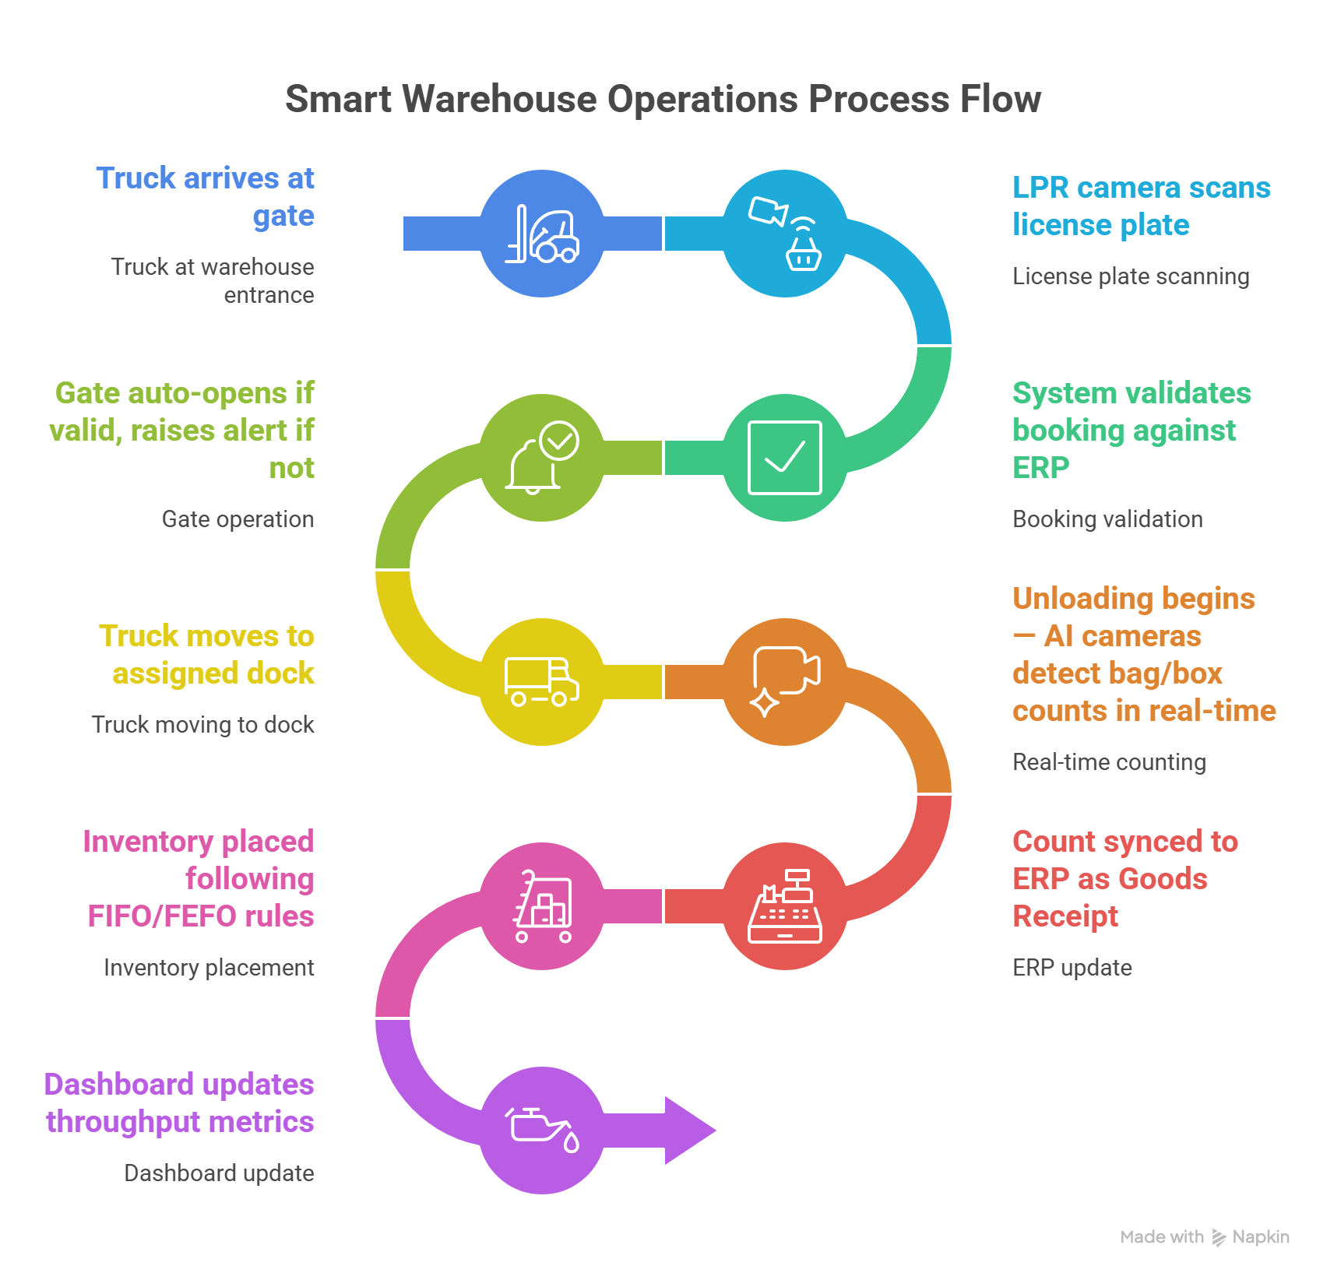
Figure 3.1 — Smart Warehouse Operations: From Truck Arrival to ERP Sync

3.3 Scope — In Scope & Out of Scope
✓ In Scope | ✗ Out of Scope
- AI Vision-based bag/box counting & object detection  - Automated vehicle gate control (LPR)  - Digital task assignment & SOP checklists  - Real-time command center with alert prioritization  - ERP bi-directional sync (SAP, Oracle)  - Predictive forecasting & anomaly detection  - Role-based mobile app for supervisors & field workers  - Compliance monitoring & audit logs | - ERP software development (SAP/Oracle are third-party)  - Hardware procurement (cameras, edge devices, barriers)  - Physical infrastructure installation  - HR payroll processing for depot workers  - Supply chain planning outside the depot boundary  - Transportation route management beyond gate-to-gate

3.4 Module & AI Agent Matrix
Layer | Module | Sub-Module | AI Agent
Layer 1 – Vision | IntelliVision™ | Bag/Box Detection | Object Detection Agent
Layer 1 – Vision | IntelliVision™ | Automated Counting | Counting Agent
Layer 1 – Vision | IntelliVision™ | Cluster Mapping | Cluster Mapping Agent
Layer 1 – Vision | IntelliVision™ | FIFO/FILO/LIFO Logic | Inventory Sequencing Agent
Layer 1 – Vision | IntelliVision™ | LPR & Gate Control | LPR Recognition Agent
Layer 1 – Vision | IntelliVision™ | Perimeter Monitoring | Security Breach Agent
Layer 2 – Operations | IntelliOps™ | Task Assignment | Smart Assignment Agent
Layer 2 – Operations | IntelliOps™ | Guided Checklists | SOP Compliance Agent
Layer 2 – Operations | Depot Operations | Cluster Allocation | Cluster Optimization Agent
Layer 2 – Operations | Depot Operations | Space Optimization | Space Utilization Agent
Layer 2 – Operations | Depot Operations | Exception Handling | Exception Workflow Agent
Layer 3 – Command | IntelliCommand™ | Live Monitoring | Alert Prioritization Agent
Layer 3 – Command | IntelliCommand™ | SLA Tracking | SLA Breach Prediction Agent
Layer 3 – Command | IntelliCommand™ | Fleet & Yard View | Dwell Time Optimization Agent
Layer 3 – Command | IntelliCommand™ | Incident Escalation | Escalation Automation Agent
Layer 4 – Integration | IntelliConnect™ | ERP Sync (SAP/Oracle) | Data Reconciliation Agent
Layer 4 – Integration | IntelliConnect™ | IoT & Weather Feeds | Event Trigger Agent
Layer 4 – Integration | IntelliConnect™ | API Health Monitoring | Integration Health Agent
Layer 5 – Analytics | Analytics & Insights | Operational KPIs | Efficiency Benchmark Agent
Layer 5 – Analytics | Analytics & Insights | Predictive Forecasting | Throughput Forecast Agent
Layer 5 – Analytics | Analytics & Insights | Anomaly Detection | Fraud Detection Agent
Layer 5 – Analytics | Analytics & Insights | Executive Dashboard | Executive Insight Generator
Layer 6 – Risk | Industry Packs | Compliance Monitoring | Compliance Monitoring Agent
Layer 6 – Risk | Industry Packs | Batch/Expiry Monitoring | Expiry Monitoring Agent
Layer 6 – Risk | Security & Governance | RBAC & Audit Logs | Access Risk Agent
Layer 7 – Orchestrator | Depot AI Brain | Cross-Module Optimization | Autonomous Optimization Agent
Layer 7 – Orchestrator | Depot AI Brain | Scenario Simulation | What-If Simulation Agent
Layer 7 – Orchestrator | Depot AI Brain | Revenue Leakage Detection | Revenue Leakage Agent

3.5 Detailed Use Case Specifications
The following Use Case Cards provide complete functional specifications for each key module. Each card covers the full lifecycle of the feature: who uses it, what triggers it, how the system processes it step by step, what outputs are produced, and how errors are handled.

ID-01 – Bag & Box Detection
AI Agent: Object Detection Agent | Module: IntelliVision™ | Layer: Layer 1 – Vision Layer
 | 📋 Feature Description
 | Real-time AI-powered detection of bags, boxes, pallets, and other configurable SKU types from IP camera RTSP streams using YOLOv8/v9 models deployed on edge GPU devices (NVIDIA Jetson) and cloud inference endpoints. The system detects objects with ≥97% mAP accuracy under standard conditions and automatically reconciles detected counts against SAP/Oracle purchase orders within 30 seconds of truck arrival.
 | 👥 Actors Involved
 | • IP Camera System (edge device)
 | • NVIDIA Jetson Edge AI Processor
 | • Object Detection Agent (YOLOv8/v9)
 | • Counting Agent
 | • IntelliConnect™ ERP Layer
 | • Depot Supervisor (mobile app)
 | • SAP MM / Oracle SCM
 | 🔒 Preconditions
 | • IP cameras are mounted, configured, and streaming RTSP at ≥15 FPS
 | • YOLOv8 model is deployed, calibrated, and verified on edge device
 | • Camera ROI (Region of Interest) zones are defined in admin panel per depot layout
 | • SAP/Oracle purchase order (PO) for expected delivery is synced to IntelliDepot
 | • Approved delivery schedule is loaded for current shift
 | • Network connectivity is active between edge device and platform
 | ⚡ Trigger(s)
 | • PRIMARY: Vehicle detected at depot gate triggers automatic zone camera activation
 | • SECONDARY: Scheduled shift start activates all configured zone cameras
 | • MANUAL: Supervisor initiates manual count verification from mobile app or web dashboard
 | 🔄 Step-by-Step System Flow
 | 1 | IP camera captures RTSP video stream at 15–30 FPS; stream forwarded to edge device via local network.
 | 2 | Edge device (NVIDIA Jetson) receives stream via RTSP client; frames buffered in memory queue.
 | 3 | Frame pre-processing pipeline: resize to 640×640 pixels, normalize pixel values to [0,1] range, apply contrast enhancement for dusty/low-light environments.
 | 4 | YOLOv8/v9 inference engine processes frame; generates bounding boxes with class labels and confidence scores for all detected objects.
 | 5 | Non-Maximum Suppression (NMS) applied to remove overlapping bounding boxes (IoU threshold: 0.45); duplicate detections eliminated.
 | 6 | Object class filter applied: only configured SKU classes retained (bags, boxes, pallets, drums, etc.) based on depot configuration profile.
 | 7 | Object count per zone calculated; results passed to Counting Agent for cross-zone tallying and reconciliation.
 | 8 | Counting Agent compares detected count against ERP PO expected quantity; variance percentage calculated.
 | 9 | If variance ≤ configured threshold (default 2%): count accepted, record written to database.
 | 10 | If variance > threshold: alert generated with severity level; supervisor push notification sent via mobile app and command center screen within 5 seconds.
 | 11 | Count record persisted: {timestamp, shift_id, SKU, zone, detected_count, expected_count, variance_pct, camera_id, operator_id, confidence_avg}.
 | 12 | ERP sync payload dispatched to SAP MM / Oracle SCM via IntelliConnect layer; PO goods receipt updated.
 | 13 | Video clip of counting event (T-30s to T+30s) archived to storage with count record linkage for 30-day retention.
 | ✅ Expected Output
 | • Real-time bounding box overlay rendered on Command Center screen with object labels and confidence scores
 | • Count record written to audit database within 30 seconds of truck arrival
 | • ERP goods receipt (GR) updated in SAP MM / Oracle SCM with counted quantity
 | • Push notification sent to Supervisor mobile app: "Zone A Count: 248 bags. Expected: 250. Variance: -0.8% (within threshold)"
 | • Alert raised in Command Center if variance > threshold, requiring supervisor acknowledgment
 | • Video evidence clip archived and linked to count record for audit trail
 | 📌 Postconditions
 | • Count record is persisted with immutable audit timestamp; cannot be modified without supervisor override
 | • ERP stock balance updated to reflect physically counted quantity
 | • If variance > 2%: Open alert status remains until Supervisor acknowledges and resolves
 | • Video clip stored for minimum 30 days; indexed by truck registration, timestamp, and count ID
 | • If FEFO/FIFO mode is active: inventory sequencing recommendations updated based on new stock receipt
 | 📏 Business Rules
 | BR-01 | Variance threshold is configurable per SKU and per client (range: 0.5%–10%; default: 2%)
 | BR-02 | All count events must be linked to a valid shift_id and approved delivery schedule for audit traceability
 | BR-03 | Counts outside approved shift hours require supervisor override with reason logged
 | BR-04 | FEFO/FIFO sequencing rules must be applied per SKU configuration; no manual override without supervisor approval and audit log entry
 | BR-05 | Minimum camera confidence requirement is configurable per deployment (default: 0.75); counts below threshold flagged for manual review
 | BR-06 | All variance alerts must be acknowledged by supervisor within 30 minutes; unacknowledged alerts auto-escalate to Regional Manager
 | ✔ Validation Rules
 | VR-01 | Camera feed frame rate must be ≥15 FPS; below threshold triggers camera health alert and manual count mode
 | VR-02 | Object detection confidence score must be ≥0.75 for inclusion in count; lower scores flagged as "uncertain" and listed for human review
 | VR-03 | Zone must be defined in admin configuration before counting can be performed; unconfigured zone = system error EH-03
 | VR-04 | ERP PO reference must exist for all inbound count events; missing PO triggers "Unscheduled Delivery" alert
 | VR-05 | Count value must be a positive integer; negative or zero values rejected and trigger EH-02
 | VR-06 | Camera ROI zones must not overlap; system validates zone boundaries at configuration time
 | ⚠ Error Handling
 | EH-01 | EH-01: Camera offline → Send "Camera Unavailable" alert (Critical severity) to Supervisor + Command Center; mark count as "Manual Required"; activate manual entry mode; retry camera connection every 60 seconds; escalate to IT after 15 minutes of downtime
 | EH-02 | EH-02: Edge device GPU failure → Re-route stream to cloud inference endpoint; latency increases to 2–3 seconds; performance warning sent to supervisor; maintain continuous counting in degraded mode
 | EH-03 | EH-03: ERP sync failure → Count saved locally to edge device buffer (capacity: 10,000 events); retry ERP sync every 5 minutes for 24 hours; raise sync failure alert after 3 consecutive failures; Operations Manager notified
 | EH-04 | EH-04: Confidence score below threshold for >30% of frame detections → Trigger "Low Visibility Warning"; request supervisor to confirm count manually; activate IR/enhanced mode if available
 | EH-05 | EH-05: Network timeout between edge and cloud → Cache count data locally using SQLite buffer; sync when connectivity restored; display "Offline Mode" status indicator on all connected devices

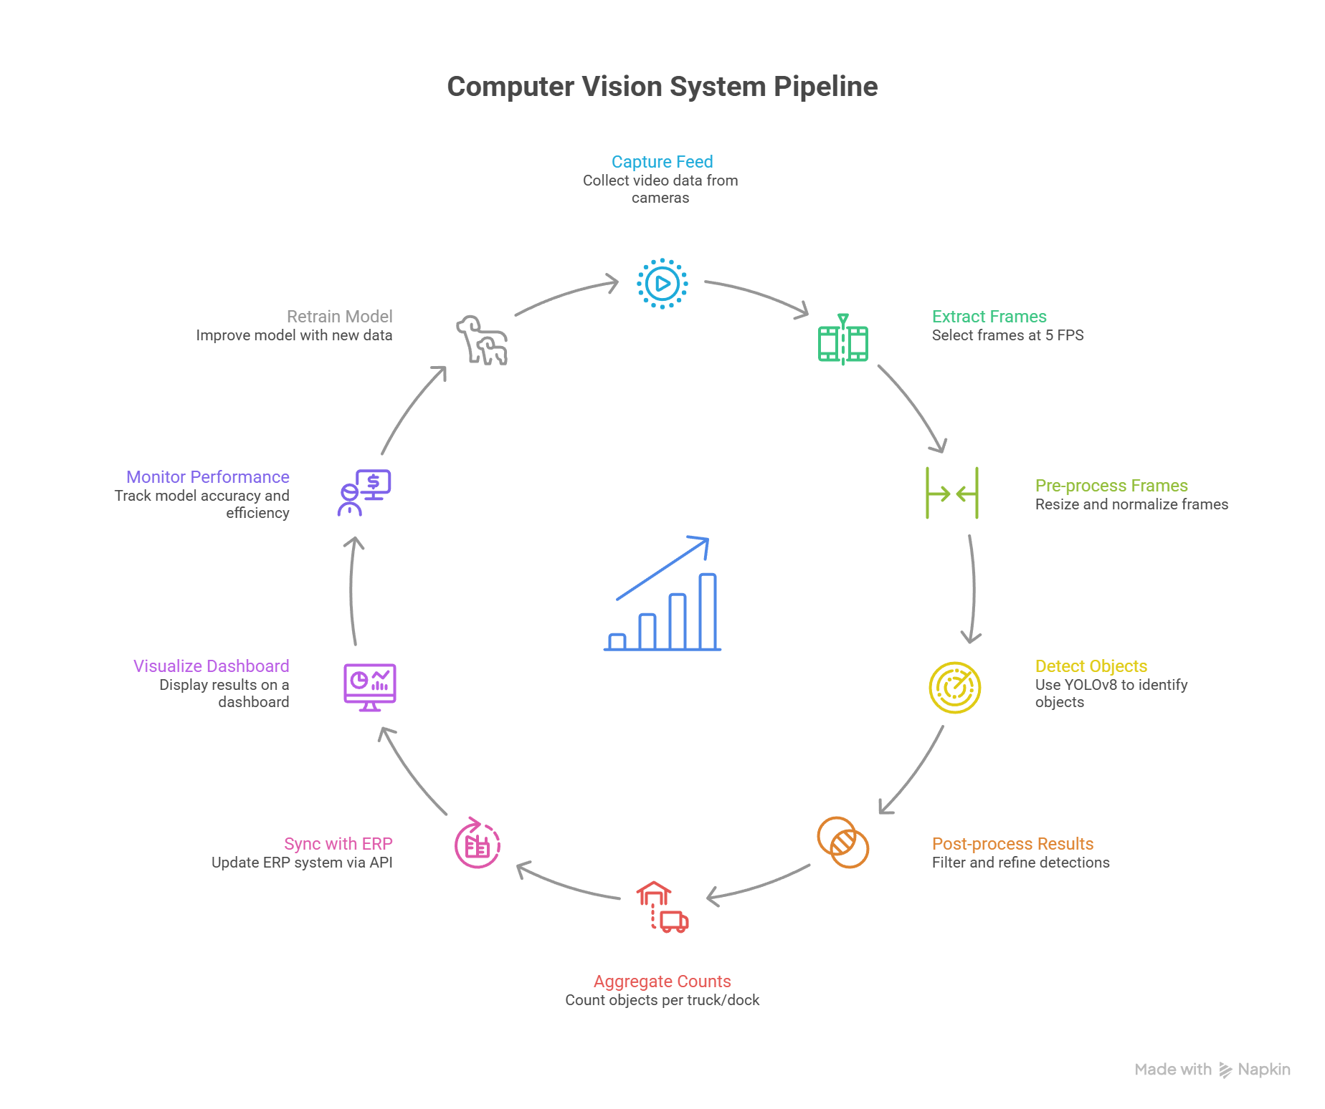
Figure 3.2 — Vision AI Pipeline: Camera Feed to Object Detection & ERP Integration

ID-02 – FIFO / FEFO Inventory Sequencing
AI Agent: Inventory Sequencing Agent | Module: IntelliVision™ | Layer: Layer 1 – Vision Layer
 | 📋 Feature Description
 | Enforces configurable inventory dispatch sequencing (FIFO, LIFO, FILO, FEFO) rules across depot zones using AI-powered zone mapping, ERP batch data integration, and visual guidance displays. The Inventory Sequencing Agent continuously monitors zone occupancy, cross-references batch/expiry data from ERP, and provides real-time visual instructions to loaders on mobile devices and depot display screens to ensure correct dispatch order — eliminating manual errors and reducing product wastage from near-expiry stock.
 | 👥 Actors Involved
 | • Inventory Sequencing Agent
 | • Cluster Mapping Agent
 | • ERP Batch/Expiry Data Feed
 | • Loader / Unloader (mobile app & depot display)
 | • Depot Supervisor
 | • Expiry Monitoring Agent
 | • Counting Agent
 | 🔒 Preconditions
 | • Inventory sequencing mode (FIFO/FEFO/LIFO) is configured per SKU in admin settings
 | • ERP batch records with manufacture/expiry dates are synced and available
 | • Physical stock is mapped to zones via Cluster Mapping Agent
 | • Loader mobile devices are registered and GPS-verified within depot perimeter
 | • Display screens in depot loading bays are operational
 | ⚡ Trigger(s)
 | • PRIMARY: Dispatch order received from ERP for a specific SKU quantity
 | • SECONDARY: Expiry alert raised for a batch approaching within 30/15/7 days
 | • MANUAL: Supervisor initiates sequencing verification from dashboard
 | 🔄 Step-by-Step System Flow
 | 1 | Dispatch order received from ERP (SKU, quantity, destination) via IntelliConnect layer.
 | 2 | Inventory Sequencing Agent queries current zone inventory map from Cluster Mapping Agent.
 | 3 | For FIFO: identifies the oldest receipt batch in stock based on ERP goods receipt date; locates corresponding physical zone.
 | 4 | For FEFO: queries ERP batch data for earliest expiry date among available stock; cross-references with physical zone occupancy map.
 | 5 | Agent generates pick sequence: prioritized list of zones, batch IDs, and quantities in correct dispatch order.
 | 6 | Visual guidance pushed to loader mobile app: zone map with highlighted pick locations, sequence numbers, and batch IDs shown on screen.
 | 7 | Depot bay display screens updated with loading instructions (zone → bay → sequence) in large, easy-to-read format.
 | 8 | Loader scans QR code on picked pallet/stack to confirm pickup; Counting Agent decrements zone inventory.
 | 9 | If loader picks from wrong zone/batch: immediate alert raised on mobile app and supervisor notified within 10 seconds.
 | 10 | Upon dispatch confirmation: ERP inventory records updated; batch movement logged in audit trail with loader ID, timestamp, and destination.
 | 11 | Compliance score for sequencing adherence updated in Supervisor dashboard (per shift, per loader).
 | ✅ Expected Output
 | • Pick sequence list: ordered list of zones, batch IDs, and quantities in correct FIFO/FEFO order
 | • Visual guidance on loader mobile app with highlighted zone map and step-by-step instructions
 | • Depot bay display showing current loading sequence for active dispatch order
 | • Audit log entry: {dispatch_id, batch_id, loader_id, zone, sequence_followed: true/false, timestamp}
 | • ERP dispatch record updated with actual batch numbers dispatched
 | • Sequencing compliance score updated in Supervisor dashboard
 | 📌 Postconditions
 | • ERP inventory reflects actual dispatched batches with correct batch numbers
 | • Audit trail records which loader handled each batch and whether sequencing was followed
 | • Sequencing compliance violation logged if incorrect zone picked; triggers training recommendation
 | • Near-expiry stock status updated after FEFO dispatch; expiry risk dashboard refreshed
 | 📏 Business Rules
 | BR-01 | FEFO mode is mandatory for all food, pharma, and chemical SKUs; cannot be overridden without Depot Manager approval
 | BR-02 | Wrong zone pick events must be logged and reviewed in monthly compliance report
 | BR-03 | Minimum 48-hour advance notification required for FEFO dispatch of near-expiry stock to logistics teams
 | BR-04 | Sequencing compliance rate below 95% per shift triggers automatic training notification to Field Executive
 | BR-05 | All batch movements must be traceable end-to-end from receipt to dispatch for regulatory compliance
 | ✔ Validation Rules
 | VR-01 | Dispatch order must reference a valid ERP PO or Sales Order before sequencing begins
 | VR-02 | Batch ID must exist in ERP master data; unknown batches trigger "Unregistered Batch" alert
 | VR-03 | Zone occupancy must be confirmed by Cluster Mapping Agent before pick instructions are sent; stale data >5 minutes forces re-scan
 | VR-04 | Loader QR scan confirmation must match the batch ID in the pick sequence; mismatch triggers immediate alert
 | VR-05 | Expiry date format must conform to DDMMYYYY standard; malformed dates trigger data validation error and manual review
 | ⚠ Error Handling
 | EH-01 | EH-01: ERP batch data unavailable → Display warning "Batch Data Stale"; fall back to FIFO based on last known receipt date; flag dispatch as "Pending ERP Sync"; Operations Manager notified
 | EH-02 | EH-02: Loader picks wrong sequence → Immediate alert to loader app and supervisor; count deducted from wrong zone; re-sequencing triggered; incident logged for compliance report
 | EH-03 | EH-03: Zone physically inaccessible (blocked aisle) → Agent automatically re-routes to next eligible zone in FIFO/FEFO order; updated pick sequence pushed to loader
 | EH-04 | EH-04: QR scan failure → Loader can manually enter batch ID via keypad; supervisor approval required; event flagged as "Manual Entry" in audit log

ID-03 – LPR & Gate Control
AI Agent: LPR Recognition Agent | Module: IntelliVision™ | Layer: Layer 1 – Vision Layer
 | 📋 Feature Description
 | Automated License Plate Recognition (LPR/ANPR) system that controls depot gate access by reading incoming and outgoing vehicle registration plates from CCTV cameras, cross-referencing against approved delivery schedules loaded from ERP, and automatically operating gate barriers for authorized vehicles. The system supports Indian, UAE, and Saudi plate formats with ≥98% recognition accuracy, calculates vehicle dwell times, and maintains a complete vehicle movement audit trail.
 | 👥 Actors Involved
 | • LPR Camera System (gate-mounted)
 | • LPR Recognition Agent
 | • ERP Delivery Schedule Feed
 | • Gate Barrier Control System (IoT)
 | • Security Personnel (command center)
 | • Depot Supervisor
 | • Transport Vendor
 | • IntelliConnect™ ERP Layer
 | 🔒 Preconditions
 | • LPR cameras are mounted at entry and exit gates with adequate lighting/IR
 | • Gate barrier control system is integrated with IntelliDepot via IoT gateway
 | • ERP delivery schedules (vehicle registrations, time windows, cargo type) are synced for current day
 | • Security guard workstation is active at command center
 | • Vehicle registration whitelist and blacklist are up to date
 | ⚡ Trigger(s)
 | • PRIMARY: Vehicle approaches gate and LPR camera detects a license plate
 | • SECONDARY: Manual gate open/close request from security guard or supervisor
 | • TERTIARY: Emergency override by Depot Manager for unscheduled critical delivery
 | 🔄 Step-by-Step System Flow
 | 1 | Vehicle approaches entry gate; LPR camera activates via motion sensor.
 | 2 | LPR Recognition Agent captures high-resolution image of license plate; applies image enhancement (contrast, deblur, perspective correction).
 | 3 | OCR engine reads plate characters; supports Indian (white/yellow), UAE (silver), and Saudi (white/green) formats.
 | 4 | Recognized plate number validated against approved delivery schedule from ERP for current day/shift.
 | 5 | If plate is on approved schedule: gate barrier opens automatically within 2 seconds; vehicle entry timestamp recorded.
 | 6 | If plate is on blacklist: immediate security alert raised at command center + security guard workstation; gate remains closed; alert SMS sent to Depot Manager.
 | 7 | If plate is unrecognized (not on schedule, not blacklisted): "Unscheduled Vehicle" alert raised; security guard reviews on command center screen; guard can approve or deny via workstation.
 | 8 | On entry: vehicle dwell timer starts; entry event logged: {plate, vehicle_type, driver_name (if known), timestamp, gate_id, schedule_ref}.
 | 9 | Vehicle weight recorded at weighbridge if integrated; weight data linked to entry record.
 | 10 | Operations completed in depot; vehicle approaches exit gate; exit LPR reads plate.
 | 11 | System calculates dwell time; compares against configured SLA for vehicle type.
 | 12 | If dwell time exceeds SLA: alert sent to Depot Supervisor before vehicle departure; reason logged.
 | 13 | Exit barrier opens; exit timestamp recorded; dwell time report updated.
 | 14 | End-of-day vehicle movement report generated and synced to ERP transport module.
 | ✅ Expected Output
 | • Automatic gate barrier operation within 2 seconds of plate recognition for approved vehicles
 | • Vehicle movement record: {plate, entry_time, exit_time, dwell_minutes, gate_id, schedule_compliance, weight_in, weight_out}
 | • Security alert for blacklisted or unscheduled vehicles with vehicle photo attached
 | • Dwell time report per vehicle, per vehicle type, per shift
 | • End-of-day vehicle movement audit exported to ERP transport module
 | • Real-time gate camera feed on command center multi-screen display
 | 📌 Postconditions
 | • Immutable entry/exit audit record created for every vehicle movement
 | • ERP delivery confirmation updated for vehicles completing authorized delivery
 | • Blacklisted vehicle entry attempt escalated to Security Manager and logged for police reference if required
 | • Dwell time violations flagged for transport vendor penalty calculation
 | • Vehicle weight variance (weighbridge in vs. out) alert raised for investigation if variance > configured threshold
 | 📏 Business Rules
 | BR-01 | Vehicles without an approved ERP delivery schedule cannot enter without explicit supervisor override and reason logging
 | BR-02 | Blacklisted vehicles must never be granted access automatically, regardless of schedule status
 | BR-03 | All gate operations (auto and manual) must be logged with operator ID and reason for audit traceability
 | BR-04 | Dwell time SLA is configurable per vehicle type (default: 2 hours for trucks, 45 minutes for vans)
 | BR-05 | Weight variance threshold (default 2%) triggers investigation alert to prevent payload manipulation
 | ✔ Validation Rules
 | VR-01 | Plate recognition confidence must be ≥85% before any automated gate action is taken; lower confidence requires security guard manual review
 | VR-02 | Delivery time window must be within ±60 minutes of scheduled window; outside window requires supervisor approval
 | VR-03 | Vehicle type must match schedule (e.g., a registered tanker cannot enter on a truck delivery schedule)
 | VR-04 | Weighbridge reading must be within valid range (0 kg to vehicle gross weight limit); out-of-range readings trigger sensor calibration alert
 | ⚠ Error Handling
 | EH-01 | EH-01: Camera failure at gate → Alert security guard immediately; switch to manual gate operation mode; IT notified; camera offline logged
 | EH-02 | EH-02: Plate recognition confidence < 85% → Display captured image to security guard on workstation; guard manually confirms or enters plate number; event flagged as "Manual Review"
 | EH-03 | EH-03: Gate barrier malfunction → Emergency alert to maintenance team; manual gate operation activated; security guard stationed at gate; incident logged
 | EH-04 | EH-04: ERP schedule sync failure → Display "Schedule Data Unavailable" warning; fall back to cached schedule data (last sync); supervisor notified immediately; all vehicles require manual approval until sync restored
 | EH-05 | EH-05: Weighbridge offline → Vehicle entry/exit logged without weight; "Weight Pending" flag set; manual weight entry by supervisor required before ERP sync

ID-04 – Smart Task Assignment
AI Agent: Smart Assignment Agent | Module: IntelliOps™ | Layer: Layer 2 – Operations Layer
 | 📋 Feature Description
 | AI-driven task assignment engine that automatically allocates depot tasks (loading, unloading, inventory verification, zone cleaning, vehicle guiding) to available field workers based on real-time availability, GPS proximity to task location, skill profile, current workload, and task priority score. The Smart Assignment Agent continuously monitors task queues, worker status, and SLA deadlines to dynamically reallocate tasks when situations change.
 | 👥 Actors Involved
 | • Smart Assignment Agent
 | • Field Executive (mobile app)
 | • Depot Supervisor (web/mobile)
 | • Counting Agent (task trigger)
 | • LPR Recognition Agent (task trigger)
 | • SLA Breach Prediction Agent
 | • Human Resources data (skill profiles)
 | 🔒 Preconditions
 | • Field workers are logged into IntelliDepot mobile app with GPS location sharing enabled
 | • Worker skill profiles and zone certifications are loaded in system
 | • Active delivery schedule with task templates is loaded for current shift
 | • Mobile devices have push notification capability active
 | • SLA targets for task types are configured in admin settings
 | ⚡ Trigger(s)
 | • PRIMARY: New delivery/dispatch event detected by LPR or ERP schedule triggers automatic task creation
 | • SECONDARY: Counting Agent detects inventory discrepancy requiring physical verification
 | • TERTIARY: Supervisor manually creates a task from web dashboard
 | • ESCALATION: SLA Breach Prediction Agent flags upcoming breach requiring immediate task prioritization
 | 🔄 Step-by-Step System Flow
 | 1 | Task creation event received (from LPR gate, ERP schedule, Counting Agent, or manual input); task object created with: task_type, zone, priority_score, SLA_deadline, required_skills.
 | 2 | Smart Assignment Agent queries current worker availability pool: active workers with GPS location, current task load, and skill tags.
 | 3 | Proximity scoring: calculate distance from each available worker to task zone using depot floor map coordinates.
 | 4 | Workload scoring: calculate current tasks in progress + queue depth for each worker; prefer workers with lighter loads.
 | 5 | Skill matching: verify worker skill profile includes required certification for task type (e.g., forklift operator for heavy pallet task).
 | 6 | Composite assignment score calculated: (Proximity × 0.40) + (Workload × 0.35) + (Skill Match × 0.25).
 | 7 | Top-scored available worker selected as primary assignee; second-ranked worker set as backup.
 | 8 | Task notification pushed to primary worker mobile app: task details, zone map with navigation arrow, SLA countdown timer, step-by-step instructions.
 | 9 | Worker must acknowledge task within 5 minutes; if not acknowledged: reassign to next available worker and escalate to supervisor.
 | 10 | Worker navigates to task zone (GPS-tracked); arrival confirmed automatically when worker enters zone boundary (geo-fence).
 | 11 | Worker executes task following mobile app guided steps; scans QR codes for verification checkpoints.
 | 12 | Task completion: worker submits completion via mobile app; Counting Agent verifies result if inventory-related.
 | 13 | Task record closed with: completion_time, actual_duration, SLA_met (Y/N), worker_id, quality_score.
 | ✅ Expected Output
 | • Task assignment notification delivered to worker mobile app within 30 seconds of task creation
 | • Real-time task board visible on Supervisor dashboard showing all active/queued/completed tasks
 | • Worker GPS track log showing movement from assignment to completion
 | • Task completion record with SLA adherence status
 | • Shift performance report: tasks completed, SLA compliance %, average completion time per task type
 | 📌 Postconditions
 | • Task record closed and archived in audit database with full worker activity log
 | • SLA adherence updated in shift performance metrics
 | • If SLA missed: incident record created and linked to task for root cause analysis
 | • Worker performance score updated based on task completion time and quality check results
 | • If task required inventory action: Counting Agent triggered to update zone inventory
 | 📏 Business Rules
 | BR-01 | Tasks with Critical priority must be assigned within 60 seconds of creation; assignment failure triggers immediate supervisor alert
 | BR-02 | Workers cannot be assigned more than 3 concurrent tasks without supervisor approval
 | BR-03 | A worker must be GPS-verified within depot perimeter before any task can be assigned to them
 | BR-04 | SLA countdown is visible to worker on mobile app throughout task execution
 | BR-05 | Completed tasks cannot be reopened without supervisor approval and reason logging
 | ✔ Validation Rules
 | VR-01 | Worker must be clocked in with active mobile session before assignment is valid
 | VR-02 | Required skill for task must match worker skill profile; unqualified assignment blocked and error logged
 | VR-03 | Zone coordinates for task must exist in depot floor map configuration; invalid zone triggers EH-03
 | VR-04 | Task SLA deadline must be a future timestamp; tasks with past deadlines trigger immediate Critical priority override
 | ⚠ Error Handling
 | EH-01 | EH-01: No available workers in proximity → Alert supervisor immediately; task placed in "Awaiting Assignment" queue; supervisor can manually assign or redeploy workers from other zones
 | EH-02 | EH-02: Worker mobile app offline → Attempt push notification retry every 60 seconds for 5 minutes; if unresponsive, reassign task to next available worker; supervisor notified
 | EH-03 | EH-03: GPS signal lost for assigned worker → Worker location shown as "Last Known"; supervisor prompted to confirm worker status; 10-minute grace period before task reassignment
 | EH-04 | EH-04: Task zone inaccessible (blocked/hazard reported) → Task status set to "Blocked"; supervisor notified with reason field; alternative zone assignment suggested by agent

ID-05 – Live Command Center Monitoring
AI Agent: Alert Prioritization Agent | Module: IntelliCommand™ | Layer: Layer 3 – Command Layer
 | 📋 Feature Description
 | Real-time monitoring hub that aggregates alerts from all IntelliDepot layers (Vision, Operations, Integration) and uses the Alert Prioritization Agent to rank, filter, and route alerts to the appropriate personnel based on severity, SLA impact, and escalation rules. The Command Center provides a multi-screen view of all depot zones, live camera feeds, vehicle positions, and a prioritized alert feed that enables Command Center Operators to make fast, informed decisions.
 | 👥 Actors Involved
 | • Alert Prioritization Agent
 | • Command Center Operator
 | • Depot Supervisor
 | • Regional Manager
 | • All IntelliDepot sub-agents (alert sources)
 | • Notification Hub (Email, SMS, WhatsApp, Teams)
 | • Escalation Automation Agent
 | 🔒 Preconditions
 | • Command Center workstation is active with multi-screen display configured
 | • All IntelliDepot agents are running and connected to alert broker (Kafka)
 | • Alert routing rules and escalation matrix are configured in admin settings
 | • Notification preferences for each user role are set
 | • SLA thresholds for all monitored metrics are configured
 | ⚡ Trigger(s)
 | • CONTINUOUS: Alert broker receives new event from any sub-agent
 | • SCHEDULED: Shift-change summary report generated at end of each shift
 | • MANUAL: Operator opens live camera feed for specific zone from command center interface
 | 🔄 Step-by-Step System Flow
 | 1 | Sub-agent (e.g., Object Detection, LPR, SOP Compliance) publishes alert event to Kafka alert broker: {event_type, source_agent, zone, severity_raw, timestamp, payload}.
 | 2 | Alert Prioritization Agent subscribes to alert broker stream; receives new alert event.
 | 3 | Priority scoring algorithm applied: Severity_raw (0–10) × SLA_Impact_Weight × Recency_Decay_Factor; output: Priority_Score (0–100).
 | 4 | Alert classified into severity tier: Critical (80–100), High (60–79), Medium (40–59), Low (0–39).
 | 5 | Alert deduplication: if same event type from same zone received within 2 minutes, merge into single alert and increment counter.
 | 6 | Routing rules evaluated: determine recipient(s) based on alert type, severity, time of day, and on-call schedule.
 | 7 | Alert inserted into Command Center live feed ranked by Priority_Score; displayed at top of alert panel with color coding (Red/Orange/Yellow/Blue).
 | 8 | Push notifications sent to relevant personnel via configured channels (Slack, Email, SMS, MS Teams, WhatsApp).
 | 9 | Command Center Operator receives alert; clicks to drill down to: live camera feed for affected zone, historical context (last 3 similar events), recommended action.
 | 10 | Operator acknowledges alert, records action taken, and assigns resolution status.
 | 11 | If alert not acknowledged within SLA (Critical: 5 min, High: 15 min, Medium: 60 min): Escalation Automation Agent activates.
 | 12 | Resolved alert archived with: resolution_time, action_taken, operator_id, root_cause_tag.
 | 13 | End-of-shift: Alert Analytics report generated — top alert categories, MTTR (Mean Time to Resolve), unresolved alerts.
 | ✅ Expected Output
 | • Prioritized live alert feed on Command Center screen refreshed in real time (<3 second latency)
 | • Push notifications delivered to correct personnel within 10 seconds of alert creation
 | • Alert detail panel with: live camera feed, event history, recommended action, and one-click escalation button
 | • End-of-shift alert analytics report: alert volume by type, severity distribution, MTTR, unresolved count
 | • Audit log of every alert: created_time, acknowledged_time, resolved_time, operator_id, action_taken
 | 📌 Postconditions
 | • Every alert is archived with acknowledgment and resolution record
 | • Unresolved Critical alerts after 2 hours auto-escalate to Regional Manager and are included in daily report
 | • Alert patterns feed into Anomaly Detection Agent for fraud/pilferage signal detection
 | • MTTR data used to adjust operator performance scorecards
 | • Recurring alert patterns (3+ same alert in 24 hours) automatically flagged for root cause investigation
 | 📏 Business Rules
 | BR-01 | Critical severity alerts must be acknowledged within 5 minutes; High within 15 minutes; breach triggers auto-escalation
 | BR-02 | No alert can be deleted; only resolved or archived with reason
 | BR-03 | Alerts from Vision layer involving security breach are automatically tagged for potential police report archival
 | BR-04 | All alert acknowledgments must include action taken (min 20 characters) for quality audit purposes
 | ✔ Validation Rules
 | VR-01 | Alert payload must include: source_agent, zone, timestamp, and event_type; incomplete alerts rejected and logged to dead-letter queue
 | VR-02 | Alert severity must be one of: Critical, High, Medium, Low; unknown severity defaults to High and triggers data quality alert
 | VR-03 | Operator acknowledgment must be from a user with "Command Center Operator" role or higher; acknowledgment by unauthorized role blocked
 | ⚠ Error Handling
 | EH-01 | EH-01: Kafka broker unavailable → Sub-agents buffer events locally (max 10,000); system alert to IT and Operations Manager; retry connection every 30 seconds
 | EH-02 | EH-02: Command Center workstation failure → Alerts automatically re-routed to Supervisor mobile app and backup workstation; operators notified via SMS
 | EH-03 | EH-03: Notification channel failure (e.g., SMS gateway down) → Attempt next available channel in priority order (WhatsApp → Email → In-app); log channel failure incident
 | EH-04 | EH-04: Alert storm (>50 alerts/minute) → Automatic grouping and suppression of duplicate/low-priority alerts; alert storm notification sent to IT and Operations Manager

ID-06 – SLA Breach Prediction
AI Agent: SLA Breach Prediction Agent | Module: IntelliCommand™ | Layer: Layer 3 – Command Layer
 | 📋 Feature Description
 | Predictive SLA monitoring that analyses current task progress velocity, resource availability, and historical completion patterns to forecast SLA breaches 30–60 minutes before they occur. The SLA Breach Prediction Agent enables supervisors to take corrective action proactively — redeploying workers, expediting tasks, or communicating with clients — rather than managing breaches reactively.
 | 👥 Actors Involved
 | • SLA Breach Prediction Agent
 | • Depot Supervisor
 | • Smart Assignment Agent
 | • Field Executive
 | • Command Center Operator
 | • Client (notification for external SLAs)
 | 🔒 Preconditions
 | • SLA targets (in minutes) are configured for each task type, vehicle type, and process type
 | • Historical task completion data (minimum 30 days) is available for ML model training
 | • Current active tasks with start times and progress markers are tracked in real time
 | • Worker GPS and activity status are being tracked
 | ⚡ Trigger(s)
 | • CONTINUOUS: Every 5 minutes, agent runs prediction model on all active SLA-bound tasks
 | • EVENT: Task progress checkpoint missed (worker not geo-fenced into next zone within expected time)
 | • MANUAL: Supervisor queries SLA risk for a specific task or delivery
 | 🔄 Step-by-Step System Flow
 | 1 | Agent retrieves all active SLA-bound tasks: {task_id, start_time, SLA_deadline, task_type, assigned_worker, current_step, steps_remaining}.
 | 2 | For each active task: calculate current progress rate = steps_completed / elapsed_time_minutes.
 | 3 | Predicted completion time estimated = elapsed_time + (steps_remaining / current_progress_rate).
 | 4 | Time buffer calculated: SLA_deadline - predicted_completion_time = buffer_minutes.
 | 5 | Historical completion variance for task type retrieved from model: P90 completion time vs. SLA.
 | 6 | Risk score calculated: If buffer_minutes < 60: Medium risk; < 30: High risk; < 10: Critical risk.
 | 7 | For High/Critical risk tasks: supervisor push notification sent with: task_id, current_step, predicted_breach_time, recommended_action.
 | 8 | Smart Assignment Agent notified to check if additional workers can be redeployed to accelerate task.
 | 9 | If breach is imminent (< 10 min buffer): automatic resource reallocation attempted; client notification workflow triggered for external SLAs.
 | 10 | Prediction accuracy tracked post-task: predicted vs. actual completion time logged for model improvement.
 | 11 | End-of-shift: SLA prediction accuracy report generated; model retrained weekly on latest data.
 | ✅ Expected Output
 | • SLA Risk Dashboard showing all active tasks with color-coded risk levels (Green/Yellow/Orange/Red)
 | • Push notification to Supervisor: "Task TD-042 (Truck MH12AB1234): High SLA Risk. Predicted completion in 85 min. SLA deadline in 70 min. Recommended: Redeploy 1 additional loader from Zone B."
 | • Automated Smart Assignment Agent query for available workers near task zone
 | • Client notification (for external SLA breaches): estimated delivery time update
 | • Post-shift SLA adherence report: % tasks on time, average buffer at task close, breach count
 | 📌 Postconditions
 | • All SLA breach predictions logged with actual outcomes for model accuracy tracking
 | • SLA breach incidents (predicted or actual) included in vendor/client reporting
 | • Worker performance data updated if breach caused by individual underperformance
 | • Smart Assignment Agent calibration updated based on breach pattern data
 | 📏 Business Rules
 | BR-01 | Predicted SLA breach notifications are informational — actual breach determination is at task close only
 | BR-02 | Client notifications for external SLAs require supervisor approval before dispatch
 | BR-03 | SLA prediction model must be retrained on at minimum 4 weeks of data; model below 70% accuracy threshold automatically reverts to rule-based prediction
 | BR-04 | All SLA configurations must be reviewed and approved by Operations Manager at start of each quarter
 | ✔ Validation Rules
 | VR-01 | SLA deadline must be a future timestamp at time of task creation; past deadline = immediate Critical alert
 | VR-02 | Progress rate calculation requires at least 1 completed step; newly created tasks are in "Monitoring" status for first 10 minutes
 | VR-03 | Task step timestamps must be in chronological order; out-of-order timestamps trigger data integrity alert
 | ⚠ Error Handling
 | EH-01 | EH-01: Insufficient historical data for ML prediction (< 7 days) → Fall back to rule-based prediction (fixed time-per-step estimates); warning displayed on dashboard
 | EH-02 | EH-02: Worker GPS offline → Progress estimation based on last known step completion time; "Estimated" flag shown on SLA dashboard; supervisor prompted to confirm worker status
 | EH-03 | EH-03: SLA configuration missing for task type → Task flagged as "No SLA Configured"; supervisor notified; task monitored for unusual duration (>2x average for similar tasks)

ID-07 – ERP Bi-Directional Sync
AI Agent: Data Reconciliation Agent | Module: IntelliConnect™ | Layer: Layer 4 – Integration Layer
 | 📋 Feature Description
 | Real-time and scheduled bi-directional data synchronization between IntelliDepot and enterprise ERP systems (SAP MM/WM, Oracle SCM, MS Dynamics). The Data Reconciliation Agent manages the complete integration lifecycle: inbound PO/delivery schedule sync, outbound goods receipt and inventory updates, automated reconciliation of physical counts vs. ERP records, and delta change detection to minimize data transfer volume. All sync operations are logged and monitored for health and completeness.
 | 👥 Actors Involved
 | • Data Reconciliation Agent
 | • IntelliConnect™ Integration Layer
 | • SAP MM/WM / Oracle SCM / MS Dynamics
 | • Object Detection Agent (count source)
 | • Operations Manager
 | • IT Administrator
 | • Integration Health Agent
 | 🔒 Preconditions
 | • ERP system API credentials and endpoints are configured in IntelliConnect admin
 | • SAP/Oracle middleware (RFC, IDOC, or REST API) is active and accessible
 | • Field mapping between IntelliDepot data model and ERP schema is configured
 | • Data reconciliation tolerance thresholds are set (default: 2%)
 | • Change Data Capture (CDC) is enabled on ERP delivery schedule tables
 | ⚡ Trigger(s)
 | • REAL-TIME: Count event completed by Object Detection Agent → push goods receipt to ERP
 | • SCHEDULED: Full inventory sync every night at 2:00 AM
 | • DELTA SYNC: Every 5 minutes, check for new/updated POs and delivery schedules in ERP
 | • MANUAL: Operations Manager triggers forced full sync from admin dashboard
 | • EVENT: Discrepancy alert from Counting Agent triggers targeted reconciliation
 | 🔄 Step-by-Step System Flow
 | 1 | INBOUND (ERP → IntelliDepot): Delta sync agent queries ERP for new/updated POs since last sync timestamp.
 | 2 | API call made to ERP (SAP RFC or Oracle REST API); response contains changed PO records.
 | 3 | Data transformation: ERP field schema mapped to IntelliDepot data model (field mapping configured in IntelliConnect admin).
 | 4 | Data validation: required fields checked, data type validation, range checks applied.
 | 5 | Valid records upserted into IntelliDepot database; invalid records quarantined and logged for review.
 | 6 | Sync completion event published: records_received, records_accepted, records_rejected, sync_duration_ms.
 | 7 | OUTBOUND (IntelliDepot → ERP): Counting Agent publishes count_complete event with: PO_ref, SKU, counted_quantity, timestamp.
 | 8 | Data Reconciliation Agent receives event; retrieves PO expected quantity from local cache.
 | 9 | Reconciliation check: |counted_qty - expected_qty| / expected_qty ≤ tolerance (2%).
 | 10 | Within tolerance: Goods Receipt (GR) document created in SAP via BAPI GOODSMVT_CREATE or Oracle inventory update API.
 | 11 | Outside tolerance: Reconciliation Alert raised; GR held pending supervisor review; Operations Manager notified with variance details.
 | 12 | Supervisor reviews variance in IntelliDepot dashboard; approves or rejects GR with reason.
 | 13 | Approved GR posted to ERP; rejected GR triggers recount workflow.
 | 14 | Integration Health Agent monitors sync health metrics; alerts if >3 consecutive failures or sync lag >15 minutes.
 | ✅ Expected Output
 | • ERP POs and delivery schedules synced to IntelliDepot within 5 minutes of creation in ERP
 | • Goods Receipt document created in ERP within 60 seconds of approved count completion
 | • Reconciliation variance report for supervisor review for all counts outside tolerance
 | • Daily sync health report: records synced, failures, average sync latency, data quality score
 | • Audit log of every sync operation: timestamp, direction, records_count, status, operator (for manual triggers)
 | 📌 Postconditions
 | • IntelliDepot and ERP inventory records are consistent post-sync within configured tolerance
 | • All reconciliation decisions (approve/reject) logged with supervisor ID and reason
 | • Failed sync events retained in retry queue for 24 hours; Operations Manager notified after 3 failures
 | • Data quality exceptions quarantined and reviewed within 24 hours by IT administrator
 | 📏 Business Rules
 | BR-01 | ERP is the system of record for PO data; IntelliDepot cannot modify PO quantities, only confirm receipt
 | BR-02 | Goods receipts above 5% variance cannot be auto-posted; require Operations Manager approval regardless of supervisor setting
 | BR-03 | All sync operations must use encrypted API connections (TLS 1.3); unencrypted connections rejected
 | BR-04 | Sync history must be retained for 7 years for financial audit compliance
 | ✔ Validation Rules
 | VR-01 | PO reference must match an open PO in ERP; closed or cancelled POs rejected with alert
 | VR-02 | SKU code must exist in both IntelliDepot and ERP master data; mismatch triggers "Unknown SKU" alert
 | VR-03 | Sync payload timestamp must be within 10 minutes of server time; stale timestamps rejected to prevent replay attacks
 | VR-04 | Numeric quantities must be positive integers; decimal quantities rejected unless SKU is configured for decimal measurement
 | ⚠ Error Handling
 | EH-01 | EH-01: ERP API unreachable → Retry with exponential backoff (1min, 5min, 15min, 30min); after 4 failures, raise Critical integration alert; queue outbound GRs locally; Operations Manager notified immediately
 | EH-02 | EH-02: Data transformation failure (schema mismatch) → Quarantine affected records; log transformation error with field details; IT Administrator notified; other records in batch continue processing
 | EH-03 | EH-03: ERP GR posting failure (ERP business error) → Log ERP error code and message; raise alert for Operations Manager review; do not auto-retry business errors (e.g., closed PO, budget exceeded)
 | EH-04 | EH-04: Reconciliation tolerance breach → GR held in "Pending Approval" queue; supervisor has 4-hour SLA to review; after 4 hours auto-escalate to Operations Manager

ID-08 – Throughput Forecasting
AI Agent: Throughput Forecast Agent | Module: Analytics & Insights | Layer: Layer 5 – Analytics Layer
 | 📋 Feature Description
 | AI-powered forecasting system that generates 7, 14, and 30-day depot throughput predictions using ARIMA and Prophet time-series models trained on 18+ months of historical operational data. Forecasts account for seasonal demand patterns, festival calendars, weather conditions, and ERP pipeline data. Outputs are used for capacity planning, staffing decisions, and proactive SLA management.
 | 👥 Actors Involved
 | • Throughput Forecast Agent
 | • Operations Manager
 | • Regional Manager
 | • HR/Staffing (staffing recommendations)
 | • ERP Production Planning Module
 | • Weather API (AccuWeather/IMD)
 | • Anomaly Detection Agent
 | 🔒 Preconditions
 | • Minimum 90 days of historical throughput data is available in IntelliDepot database
 | • ERP 30-day forward order pipeline is synced
 | • Weather forecast API is connected and returning valid data
 | • Indian/UAE/Saudi festival and public holiday calendar is loaded for current year
 | • Forecast model has been trained and validated (MAPE < 15%)
 | ⚡ Trigger(s)
 | • SCHEDULED: Daily forecast refresh at 6:00 AM; weekly deep-refresh every Monday 5:00 AM
 | • EVENT: Operations Manager requests ad-hoc forecast from analytics dashboard
 | • EVENT: ERP pipeline changes by >20% triggering forecast recalculation
 | 🔄 Step-by-Step System Flow
 | 1 | Forecast Agent retrieves 18-month historical daily throughput data from IntelliDepot data warehouse.
 | 2 | Feature engineering: extract day-of-week, week-of-month, month, quarter, festival indicator, weather_temp, weather_event, ERP_pipeline_value per day.
 | 3 | ARIMA model fitted on historical data; seasonal decomposition applied (weekly and monthly seasonality patterns identified).
 | 4 | Prophet model run as ensemble partner: handles irregular seasonality (festivals, year-end spikes) and missing data gaps.
 | 5 | ERP forward pipeline data (confirmed orders for next 30 days) integrated as external regressor.
 | 6 | Weather forecast data for next 14 days integrated (precipitation probability → throughput impact coefficient applied).
 | 7 | Ensemble forecast generated: weighted average of ARIMA and Prophet outputs; confidence interval (80% and 95%) calculated.
 | 8 | Forecast output generated: {date, predicted_throughput_units, confidence_interval_low, confidence_interval_high, key_risk_factors}.
 | 9 | Staffing recommendation calculated: predicted throughput → required headcount per shift (based on productivity benchmarks).
 | 10 | Forecast published to Operations Dashboard with chart visualization; PDF report generated for Regional Manager email delivery.
 | 11 | Anomaly Detection Agent receives forecast as baseline for future anomaly comparison.
 | ✅ Expected Output
 | • 30-day daily throughput forecast with 80% confidence intervals
 | • Staffing recommendation: required headcount per shift for next 14 days
 | • Capacity utilization forecast: predicted % of maximum depot capacity utilized per day
 | • Top 3 risk factors for each forecast week (e.g., "Festival week - 35% volume surge expected", "Rain forecast - 8% throughput reduction")
 | • Weekly forecast accuracy report: MAPE, bias, and model performance metrics
 | 📌 Postconditions
 | • Forecast data stored in analytics warehouse for comparison against actuals
 | • Previous week forecast vs. actual variance calculated and used for model recalibration
 | • Staffing recommendations published to HR planning system if HRMS integration is configured
 | • Forecast alerts sent to Operations Manager if predicted throughput >20% above depot capacity
 | 📏 Business Rules
 | BR-01 | Forecasts are advisory only; Operations Manager has final decision authority on staffing and capacity planning
 | BR-02 | Forecast model must maintain MAPE (Mean Absolute Percentage Error) ≤15% over rolling 30 days; below this threshold triggers model retraining
 | BR-03 | Festival calendar must be reviewed and approved by Operations Manager at start of each quarter
 | BR-04 | External events (port strikes, government policy changes) can be manually input as forecast adjustments by Operations Manager
 | ✔ Validation Rules
 | VR-01 | Minimum 90 days of historical data required for forecast generation; below this threshold, rule-based seasonal estimates used with warning
 | VR-02 | Forecast horizon cannot exceed 90 days; beyond 90 days, only trend direction is indicated (not specific values)
 | VR-03 | Weather data must be from approved API sources only; manual weather input requires Operations Manager authorization
 | ⚠ Error Handling
 | EH-01 | EH-01: Insufficient historical data → Use seasonal industry benchmarks as base; display "Limited Data — Indicative Forecast Only" warning; Operations Manager notified
 | EH-02 | EH-02: Weather API unavailable → Generate forecast without weather regressor; note "Weather data unavailable" in forecast report; retry API every 30 minutes
 | EH-03 | EH-03: ERP pipeline data stale (>24 hours) → Generate forecast using last known pipeline data; "ERP Data Stale" warning shown; IT notified to investigate sync

ID-09 – Revenue Leakage Detection
AI Agent: Revenue Leakage Agent | Module: Depot AI Brain | Layer: Layer 7 – Orchestrator Layer
 | 📋 Feature Description
 | The Revenue Leakage Agent is a cross-domain intelligence module that continuously correlates physical count data, ERP billing records, vehicle weight measurements, and vendor invoices to identify revenue leakage patterns — including undercounting, billing discrepancies, weight variance manipulation, and unauthorized stock removals. The agent estimates financial impact of each detected leakage pattern and triggers investigation workflows.
 | 👥 Actors Involved
 | • Revenue Leakage Agent
 | • Depot AI Brain (Orchestrator)
 | • Object Detection Agent (count data)
 | • ERP Billing/Accounts Payable module
 | • Weighbridge System
 | • Operations Manager
 | • Finance Department
 | • Anomaly Detection Agent
 | 🔒 Preconditions
 | • Object Detection Agent count data is available for cross-reference
 | • ERP billing and goods receipt records are synced
 | • Weighbridge (weighbridge in vs. out) data is available for all vehicles
 | • Vendor invoice data is available from Accounts Payable module
 | • Baseline count-to-billing reconciliation benchmarks are established
 | ⚡ Trigger(s)
 | • SCHEDULED: Daily overnight cross-reference analysis at 2:30 AM
 | • EVENT: Anomaly Detection Agent raises unusual pattern flag
 | • EVENT: Billing reconciliation run in ERP produces variance > 1%
 | • MANUAL: Finance Manager requests ad-hoc leakage audit for a date range
 | 🔄 Step-by-Step System Flow
 | 1 | Revenue Leakage Agent retrieves count events, GR records, billing records, and weighbridge data for analysis period.
 | 2 | Cross-reference 1 — Count vs. Billing: compare physically counted quantity (per Object Detection Agent) vs. quantity billed to customer.
 | 3 | Cross-reference 2 — Weight In vs. Weight Out: for each vehicle, calculate payload weight difference (in - out) vs. declared cargo weight.
 | 4 | Cross-reference 3 — GR vs. Invoice: compare ERP goods receipt quantities vs. vendor invoice quantities for procurement.
 | 5 | Cross-reference 4 — ERP Stock vs. Vision Count: compare ERP system stock balance vs. last IntelliVision™ physical count per zone.
 | 6 | Statistical anomaly detection: flag transactions where values deviate >3 standard deviations from historical norm.
 | 7 | Leakage pattern classification: undercounting (count < billing), overbilling (invoice > GR), weight manipulation (weight delta anomaly), unauthorized removal (zone count decrease without dispatch record).
 | 8 | Financial impact estimation: leakage_units × unit_price (from ERP price master) = estimated_revenue_leakage_INR/AED/SAR.
 | 9 | Leakage report generated: pattern type, magnitude, affected transactions, estimated financial impact, confidence score.
 | 10 | High-confidence leakage alerts (>80% confidence) sent to Operations Manager and Finance Department with supporting evidence.
 | 11 | Investigation workflow created in IntelliDepot: assigned to Operations Manager with deadline and evidence package.
 | 12 | Resolved investigations logged with root cause and corrective action for pattern learning.
 | ✅ Expected Output
 | • Daily leakage analysis report: total estimated leakage value, breakdown by pattern type, top 5 highest-impact incidents
 | • Alert to Operations Manager and Finance: each high-confidence leakage detection with evidence (count records, weights, billing records)
 | • Investigation workflow created with evidence package and suggested investigation steps
 | • Monthly revenue leakage trend report: trend analysis, resolved vs. open incidents, recovered value
 | • Pattern learning update: newly confirmed leakage patterns added to detection model
 | 📌 Postconditions
 | • All detected leakage patterns logged with evidence in secure audit database (7-year retention)
 | • Confirmed revenue leakage cases escalated to legal/police if above INR 1 lakh / AED 5,000 threshold
 | • Corrective actions (process changes, camera repositioning, staff retraining) tracked against each resolved incident
 | • Detection model updated based on confirmed vs. false positive outcomes
 | 📏 Business Rules
 | BR-01 | Revenue leakage investigations must be completed within 5 business days; overdue investigations escalated to CFO
 | BR-02 | All leakage detections with estimated impact >INR 50,000 / AED 2,000 require Finance Department co-sign on resolution
 | BR-03 | False positive rate must be maintained below 10%; above this threshold triggers model review
 | BR-04 | Leakage data is confidential and accessible only to Operations Manager, Finance, and C-Suite roles
 | ✔ Validation Rules
 | VR-01 | Analysis requires minimum 7 days of concurrent count and billing data; shorter periods generate "Insufficient Data" warning
 | VR-02 | Weighbridge data timestamps must be within ±30 minutes of LPR entry/exit timestamps for valid cross-reference
 | VR-03 | Financial impact calculations must use ERP-sourced unit prices; manual price overrides require Finance approval
 | ⚠ Error Handling
 | EH-01 | EH-01: Billing data unavailable from ERP → Skip cross-reference 1 and 3; generate partial report with "Billing Data Missing" note; Finance notified to investigate ERP sync
 | EH-02 | EH-02: Weighbridge offline → Skip weight cross-reference; note in report; flag all vehicles that passed during offline period as "Weight Unverified"
 | EH-03 | EH-03: High false positive rate (>15% of alerts disproven) → Automatic sensitivity adjustment (raise detection threshold); model review scheduled; Operations Manager and Data Team notified

4. IntelliStream™ — CFO Intelligence Suite
IntelliStream™
Empowering CFOs with AI-Driven Intelligence for Agile Planning & Strategic Foresight

4.1 Key Business Benefits
✓ Average 4–6 hours saved per week on manual intelligence gathering
✓ 15–20% reduction in supply chain disruption incidents through early vendor risk detection
✓ 8–12% improvement in customer retention through proactive churn intervention
✓ CFO decision cycle reduced from weekly reviews to real-time signal monitoring
✓ 90-day advance warning on vendor financial distress events

4.2 Problem Statement
CFOs and finance leaders face a critical intelligence gap: their decisions rely on historical, backward-looking data from ERP and spreadsheets, while the business environment moves in real time. Market signals (interest rates, FX, competitor moves) are scattered across dozens of news feeds, analyst reports, and regulatory portals — requiring hours of manual aggregation. Vendor risks (credit deterioration, geopolitical exposure, delivery failures) go undetected until they cause supply disruptions. Customer churn and revenue concentration risks are identified only after clients have already decided to leave. IntelliStream™ solves this by deploying always-on AI agents across three domains — Market Intelligence, Vendor Intelligence, and Customer Intelligence — that continuously monitor, synthesize, and deliver actionable intelligence directly to the CFO's screen, inbox, and mobile device.

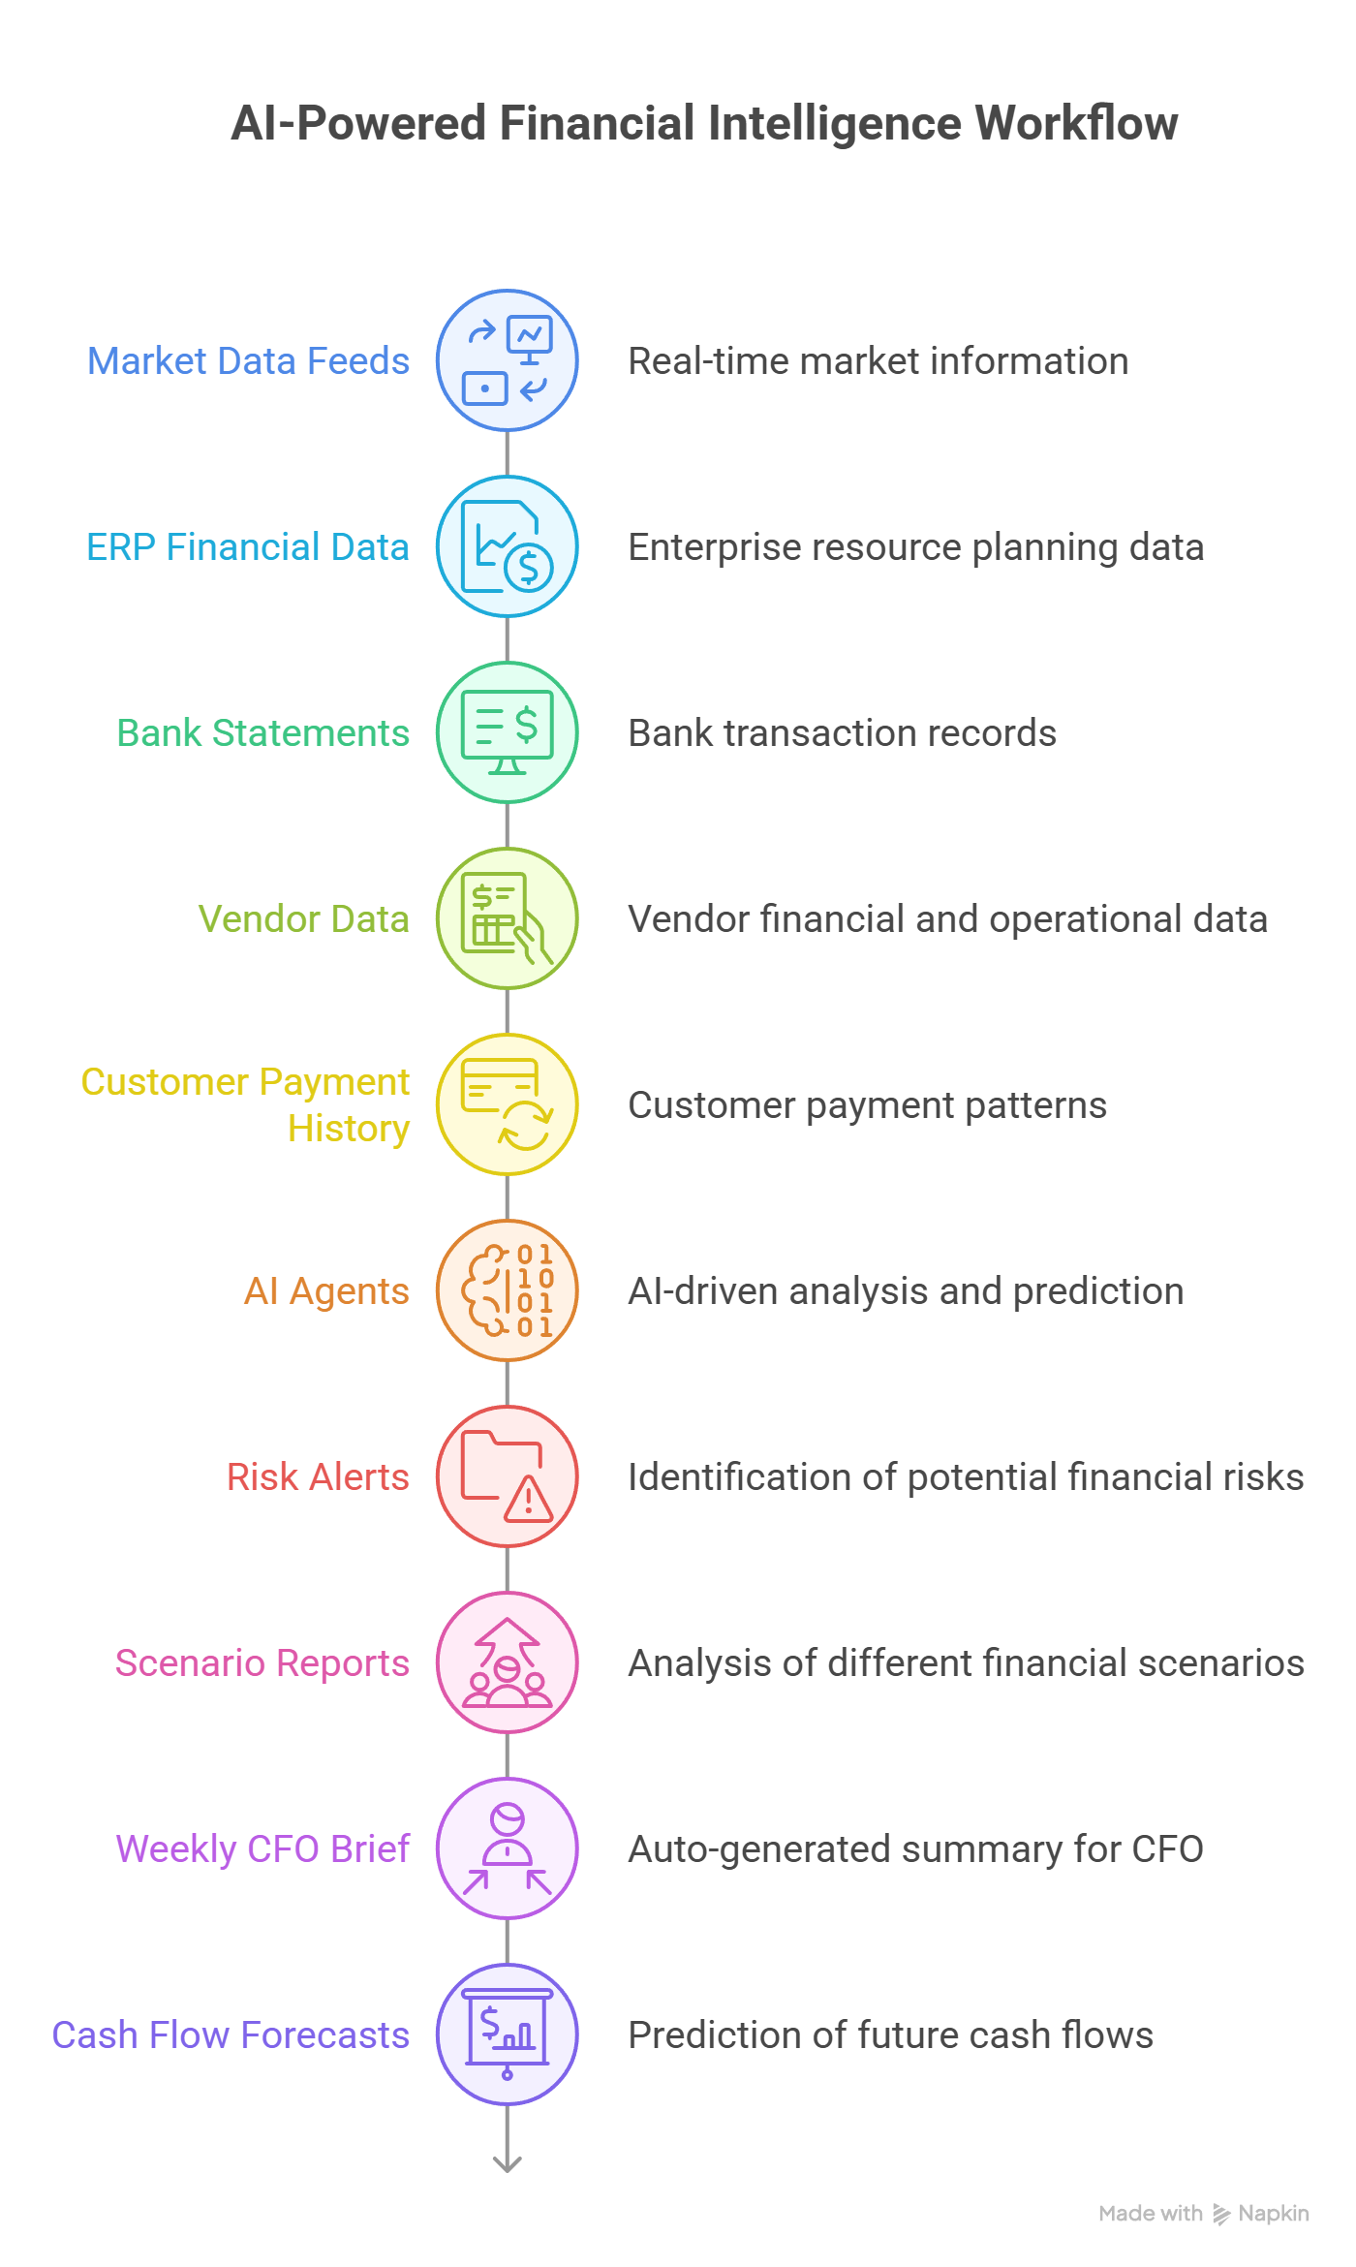
Figure 4.1 — AI-Powered Financial Intelligence: From Data Feeds to CFO Insights

4.3 Scope — In Scope & Out of Scope
✓ In Scope | ✗ Out of Scope
- Real-time macroeconomic signal monitoring (interest rates, FX, commodities)  - Competitor earnings transcript analysis and peer benchmarking  - Vendor financial health monitoring and distress prediction  - Geopolitical and supply chain route disruption tracking  - Customer CLV modeling, churn prediction, and upsell identification  - Revenue and margin forecasting with scenario simulation  - Automated CFO brief generation (weekly reports)  - ERP, CRM, and data warehouse integration | - Execution of financial hedging transactions (IntelliStream advises; treasury executes)  - Direct trading or investment decisions  - ERP data entry or modification of financial records  - Legal enforcement of vendor contract penalties  - Customer relationship management workflows beyond intelligence and alerts  - HR payroll or employee data outside of cost modeling context

4.4 Module & AI Agent Matrix
Layer | Module | Sub-Module | AI Agent
Layer 1 – Market Intelligence | MacroPulse | Interest Rate Monitoring | Rate Impact Analysis Agent
Layer 1 – Market Intelligence | MacroPulse | FX & Currency Exposure | Currency Risk Agent
Layer 1 – Market Intelligence | MacroPulse | Commodity Tracking | Commodity Sensitivity Agent
Layer 1 – Market Intelligence | CompeteLens | Earnings Transcript Analysis | Transcript Insight Agent
Layer 1 – Market Intelligence | CompeteLens | Peer Benchmarking | Competitive Benchmark Agent
Layer 1 – Market Intelligence | CompeteLens | Market Sentiment Tracking | Market Sentiment Agent
Layer 2 – Vendor Intelligence | RiskRadar | Credit Rating Monitoring | Vendor Credit Risk Agent
Layer 2 – Vendor Intelligence | RiskRadar | Distress Probability | Distress Prediction Agent
Layer 2 – Vendor Intelligence | GeoRisk | Geopolitical Monitoring | Geo Exposure Agent
Layer 2 – Vendor Intelligence | GeoRisk | Port & Route Disruption | Supply Chain Disruption Agent
Layer 2 – Vendor Intelligence | SLA Monitor | On-Time Delivery Tracking | SLA Compliance Agent
Layer 2 – Vendor Intelligence | SLA Monitor | Penalty Exposure Calculation | Penalty Calculation Agent
Layer 3 – Customer Intelligence | Pulse Meter | CLV Modeling | CLV Computation Agent
Layer 3 – Customer Intelligence | Pulse Meter | Revenue Concentration | Revenue Risk Agent
Layer 3 – Customer Intelligence | Churn Guard | Churn Prediction | Churn Prediction Agent
Layer 3 – Customer Intelligence | Churn Guard | Payment Behavior Tracking | Payment Risk Agent
Layer 3 – Customer Intelligence | CLV Tracker | Renewal Forecasting | Renewal Probability Agent
Layer 3 – Customer Intelligence | CLV Tracker | Upsell Opportunity Detection | Upsell Scoring Agent
Layer 4 – Predictive Intelligence | Scenario Engine | What-if Simulations | Scenario Simulation Agent
Layer 4 – Predictive Intelligence | Scenario Engine | Impact Sensitivity Mapping | Financial Impact Agent
Layer 4 – Predictive Intelligence | Forecasting Engine | Revenue Forecasting | Revenue Forecast Agent
Layer 4 – Predictive Intelligence | Forecasting Engine | Margin Sensitivity | Margin Forecast Agent
Layer 5 – Analytics | Executive Dashboard | KPI Monitoring | Executive Insight Agent
Layer 5 – Analytics | Automated Reports | Weekly CFO Brief | Brief Generation Agent
Layer 5 – Analytics | Alert Engine | Real-Time Alerts | Alert Prioritization Agent
Layer 5 – Analytics | Audit & Governance | Confidence Scoring | Explainability Agent
Layer 6 – Integration | ERP Integration | SAP/Oracle Sync | ERP Sync Agent
Layer 6 – Integration | CRM Integration | Customer Data Sync | CRM Sync Agent
Layer 6 – Integration | Data Warehouse | Snowflake/BigQuery | KPI SQL Query Agent
Layer 6 – Integration | Vector Store | Embedding Retrieval | Semantic Retrieval Agent
Layer 7 – Orchestrator | CFO Orchestrator | Multi-Agent Coordination | Orchestrator Agent
Layer 7 – Orchestrator | CFO Orchestrator | Cross-Domain Insight Synthesis | Insight Synthesis Agent
Layer 7 – Orchestrator | CFO Orchestrator | Automated Notification Dispatch | Notification Agent

4.5 Detailed Use Case Specifications
The following Use Case Cards provide complete functional specifications for each key module. Each card covers the full lifecycle of the feature: who uses it, what triggers it, how the system processes it step by step, what outputs are produced, and how errors are handled.

IS-01 – Interest Rate & Borrowing Cost Impact Analysis
AI Agent: Rate Impact Analysis Agent | Module: MacroPulse | Layer: Layer 1 – Market Intelligence
 | 📋 Feature Description
 | Continuously monitors central bank policy announcements and yield curve movements across RBI (India), Fed (US), ECB (Europe), SAMA (Saudi Arabia), and CBUAE (UAE). The Rate Impact Analysis Agent translates macro rate movements into direct, quantified P&L impact statements for the CFO — "A 50bps RBI rate hike increases your annual interest outflow by ₹2.5 Cr on ₹100 Cr floating-rate debt" — enabling proactive treasury and refinancing decisions.
 | 👥 Actors Involved
 | • Rate Impact Analysis Agent
 | • MacroPulse Data Ingestion Layer
 | • CFO / Treasury Team
 | • FP&A Analyst
 | • ERP Finance Module (debt schedule)
 | • News API (Reuters, Bloomberg)
 | • Central Bank Open Data APIs
 | 🔒 Preconditions
 | • Central bank API credentials are configured and active
 | • Client debt schedule (outstanding loans, interest rates, maturity dates) is synced from ERP Finance module
 | • Interest rate sensitivity coefficients are configured per loan facility (fixed vs. floating, currency)
 | • CFO notification preferences are set for rate change alerts
 | • Scenario simulation parameters are pre-configured for common rate shock scenarios
 | ⚡ Trigger(s)
 | • EVENT: Central bank announces policy rate change (detected via news API NLP within 60 seconds of publication)
 | • SCHEDULED: Weekly rate environment summary every Monday 7:00 AM
 | • EVENT: Yield curve inversion detected (short-term rate > long-term rate for 3+ consecutive days)
 | • MANUAL: CFO queries current interest rate exposure from IntelliStream dashboard
 | 🔄 Step-by-Step System Flow
 | 1 | News API stream monitored continuously; NLP classifier scans headlines for rate decision keywords from tracked central banks.
 | 2 | Rate decision event detected: extract central bank name, rate change direction (hike/cut/hold), magnitude (in basis points), effective date.
 | 3 | Central bank policy statement downloaded and parsed; forward guidance language classified (hawkish/dovish/neutral) using LLM analysis.
 | 4 | Rate change data written to MacroPulse rate database; historical rate series updated.
 | 5 | Impact calculation engine activated: retrieve client debt schedule from ERP (outstanding principal, interest rate type, reset frequency per loan).
 | 6 | For each floating-rate facility: new interest rate = current rate ± rate_change_bps/100; annual interest cost delta = principal × rate_delta.
 | 7 | Total portfolio impact calculated: sum of all facility impacts; expressed in reporting currency (INR/AED/SAR/USD).
 | 8 | Scenario extension: model 3 further scenarios (50bps, 100bps, 150bps additional moves) to show range of outcomes.
 | 9 | CFO alert generated: "RBI raised repo rate by 25bps to 6.75%. Impact on your floating-rate debt: +₹1.25 Cr/year. Further 50bps hike scenario: +₹3.75 Cr/year total."
 | 10 | Hedging recommendation appended (based on pre-configured strategy rules): interest rate swap options, fixed-rate refinancing window.
 | 11 | Impact report updated on CFO dashboard; weekly brief updated with rate environment section.
 | 12 | Alert delivered via CFO preferred channels: in-app, email, WhatsApp.
 | ✅ Expected Output
 | • Real-time rate change alert within 60 seconds of central bank announcement with P&L impact quantification
 | • CFO dashboard update: current effective interest rate, year-to-date rate changes, total floating-rate exposure
 | • Impact report: per-facility breakdown of interest cost delta in absolute currency and percentage terms
 | • 3-scenario P&L sensitivity table: base case, +50bps, +100bps additional moves
 | • Hedging options summary: available instruments, estimated cost, and risk reduction estimates
 | 📌 Postconditions
 | • Rate event logged in MacroPulse historical database for trend analysis
 | • P&L impact estimate added to CFO weekly brief for board presentation
 | • If impact exceeds CFO-configured threshold (e.g., >₹1 Cr/year): auto-scheduled treasury review meeting task created
 | • Debt schedule marked for review if >50% of debt is floating-rate and rate environment is hawkish
 | 📏 Business Rules
 | BR-01 | Rate impact calculations are estimates based on current debt schedule; actual impact depends on loan reset dates and contract terms
 | BR-02 | IntelliStream does not execute hedging transactions; all recommended actions require treasury team execution
 | BR-03 | Alert thresholds are configurable by CFO: default is any rate change from tracked central banks
 | BR-04 | Forward guidance analysis is labeled as "AI interpretation" and not to be treated as official guidance
 | ✔ Validation Rules
 | VR-01 | Rate change magnitude must be within plausible range (−200bps to +200bps); values outside this range flagged for manual verification
 | VR-02 | Debt schedule data must be fresher than 30 days; stale data triggers "Debt Schedule Update Required" warning to CFO
 | VR-03 | Currency conversion for multi-currency debt must use mid-market rates from configured FX provider; rates older than 24 hours trigger FX data refresh
 | ⚠ Error Handling
 | EH-01 | EH-01: Central bank API unavailable → Monitor news API as backup source; rate events detected via NLP on news headlines; data quality flag set to "Inferred from News"
 | EH-02 | EH-02: ERP debt schedule sync failure → Use cached debt schedule with "Data as of [date]" label; CFO alerted to update schedule manually; impact calculations paused until schedule refreshed
 | EH-03 | EH-03: LLM forward guidance analysis failure → Policy statement forwarded to CFO unanalyzed with note "Auto-analysis unavailable; please review directly"; retry LLM analysis every 30 minutes

IS-02 – Vendor Financial Distress Prediction
AI Agent: Distress Prediction Agent | Module: RiskRadar | Layer: Layer 2 – Vendor Intelligence
 | 📋 Feature Description
 | Always-on financial health monitoring system that tracks vendor credit scores, liquidity ratios, news sentiment, and bankruptcy filings to generate a proprietary Distress Probability Score (0–100%) for each tracked vendor. The Distress Prediction Agent issues 90-day advance warnings of potential vendor financial distress — giving procurement and supply chain teams time to qualify alternative suppliers, renegotiate payment terms, or request bank guarantees before disruption occurs.
 | 👥 Actors Involved
 | • Distress Prediction Agent
 | • RiskRadar Data Ingestion Layer
 | • CFO / Procurement Head
 | • Supply Chain Manager
 | • Vendor Management Team
 | • Credit Agency APIs (CRISIL, ICRA, AECB, SIMAH)
 | • News & Regulatory APIs
 | 🔒 Preconditions
 | • Vendor master list with legal entity names and CIN/CRN numbers is loaded in IntelliStream
 | • Credit agency API credentials configured for CRISIL (India), AECB (UAE), SIMAH (Saudi)
 | • News API with vendor-specific keyword monitoring is active
 | • Historical financial health data (minimum 2 years) is available for each tracked vendor
 | • Distress probability thresholds are configured: Low (<30%), Medium (30–60%), High (>60%)
 | ⚡ Trigger(s)
 | • SCHEDULED: Weekly financial health refresh every Sunday 3:00 AM for all tracked vendors
 | • EVENT: Credit rating downgrade detected (immediate alert within 15 minutes of publication)
 | • EVENT: Negative news event detected (keyword match: "insolvency", "NCLT", "bankruptcy", "winding up", "loan default")
 | • EVENT: Payment delay >30 days detected in Accounts Payable module
 | 🔄 Step-by-Step System Flow
 | 1 | Distress Prediction Agent retrieves latest financial data for each vendor: credit rating (from CRISIL/AECB/SIMAH API), news sentiment score (from News API NLP), AP payment behavior (from ERP sync).
 | 2 | Financial ratio analysis: calculate Current Ratio, Quick Ratio, Debt-to-Equity, Interest Coverage Ratio from available financial statements.
 | 3 | Credit rating trend analysis: extract 12-month rating history; classify trend (stable/improving/deteriorating).
 | 4 | News sentiment analysis: aggregate vendor-specific news from last 30 days; classify sentiment (-100 to +100); weight recent news higher.
 | 5 | Distress probability model (XGBoost) applies all features: {credit_rating_score, rating_trend, current_ratio, debt_coverage, news_sentiment, AP_delay_days, bankruptcy_news_flag}.
 | 6 | Distress Probability Score (0–100%) output with 90-day prediction horizon.
 | 7 | Risk tier assigned: Low (<30%), Medium (30–60%), High (>60%).
 | 8 | If score crosses tier boundary vs. previous week: change alert generated.
 | 9 | For High risk vendors: detailed risk narrative generated by LLM — summarizing key risk factors, evidence sources, and recommended procurement actions.
 | 10 | Alert sent to CFO and Procurement Head for all vendors moving to High tier.
 | 11 | Vendor Risk Dashboard updated with current scores, trend charts, and tier counts.
 | 12 | High-risk vendor report appended to weekly CFO brief.
 | ✅ Expected Output
 | • Weekly Vendor Distress Report: all vendors ranked by Distress Probability Score with trend indicators
 | • Real-time alert for High-risk vendors: "Vendor XYZ Distress Score: 72% (up from 45% last week). Key factors: credit rating downgrade to BB-, 45-day AP delay, negative NCLT news. Recommended action: request bank guarantee for open orders."
 | • Vendor Risk Dashboard: visual heat map of vendor portfolio by risk tier
 | • Procurement action recommendations: alternative vendor suggestions, payment term adjustments, security deposit requests
 | • Monthly portfolio risk trend: % vendors in each tier over 12 months
 | 📌 Postconditions
 | • Distress scores logged in vendor risk database for 3-year historical analysis
 | • High-risk vendor alerts reviewed and actioned by Procurement team within 5 business days
 | • Confirmed distress events (actual bankruptcy/default) feed back into model as training data
 | • Alternative vendor qualification workflow triggered automatically for High-risk critical vendors
 | 📏 Business Rules
 | BR-01 | Distress Probability Scores are advisory; all procurement decisions remain with the Procurement and CFO teams
 | BR-02 | High-risk vendors with exposure >5% of total procurement spend automatically escalate to CFO level
 | BR-03 | Single-source critical vendors (no alternative available) receive additional monitoring frequency (daily vs. weekly)
 | BR-04 | Model must be validated annually against actual distress events; precision target >70% for High-risk alerts
 | ✔ Validation Rules
 | VR-01 | Vendor must have minimum 12 months of observable data for distress score generation; newer vendors shown with "Insufficient Data" flag
 | VR-02 | Credit rating must be from configured approved agency list; ratings from unknown sources flagged as "Unverified"
 | VR-03 | News sentiment analysis requires minimum 3 news articles in 30-day window for reliable scoring; below this threshold, sentiment component excluded from score with warning
 | ⚠ Error Handling
 | EH-01 | EH-01: Credit agency API limit reached → Queue requests; process in off-peak hours; notify IT to review API tier subscription
 | EH-02 | EH-02: Insufficient financial data for model (new vendor) → Apply industry-average baseline distress score; display "Limited Data" flag; request Procurement team to upload latest vendor financial statements
 | EH-03 | EH-03: Conflicting signals (strong credit rating but severe negative news) → Flag as "Conflicted Assessment"; present both signals to CFO with confidence scores; request human judgment decision

IS-03 – Customer Churn Prediction & Intervention
AI Agent: Churn Prediction Agent | Module: Churn Guard | Layer: Layer 3 – Customer Intelligence
 | 📋 Feature Description
 | Predictive analytics engine that identifies customers at risk of churning 60–90 days before they leave, giving account management teams time to intervene effectively. The Churn Prediction Agent combines CRM engagement data, billing and payment behavior, product usage telemetry, support ticket patterns, and social sentiment into a multi-dimensional churn risk score. When risk exceeds a configurable threshold, an automated intervention playbook is generated and assigned to the account manager.
 | 👥 Actors Involved
 | • Churn Prediction Agent
 | • Churn Guard Module
 | • Customer Success Manager / Account Manager
 | • CFO / Revenue Team
 | • CRM System (Salesforce/HubSpot)
 | • Billing & AR Module (ERP)
 | • Product Usage Telemetry Platform
 | • AI Intervention Agent (playbook generation)
 | 🔒 Preconditions
 | • CRM is integrated and customer engagement data is available (last 12 months)
 | • ERP AR module is synced with payment history and DSO data
 | • Product usage telemetry is available (login frequency, feature usage, API call volume)
 | • Churn prediction model is trained on minimum 18 months of historical data with confirmed churn events
 | • Churn risk thresholds are configured: Low (<30%), Medium (30–60%), High (>60%)
 | • Intervention playbook templates are configured per customer segment and revenue tier
 | ⚡ Trigger(s)
 | • SCHEDULED: Weekly churn score refresh every Sunday night for all active customers
 | • EVENT: DSO spike >30% above customer historical average detected in AR module
 | • EVENT: Product usage drop >40% over 14 days detected in telemetry
 | • EVENT: Support ticket volume spike >3x average or sentiment score drops below -20
 | • MANUAL: CFO or Account Manager queries churn risk for specific customer
 | 🔄 Step-by-Step System Flow
 | 1 | Churn Prediction Agent retrieves customer feature vector for each active customer: {last_login_days, product_usage_score, feature_adoption_pct, support_tickets_30d, support_sentiment, DSO_current, DSO_delta_vs_3m_avg, NPS_last, contract_months_remaining, revenue_tier}.
 | 2 | Feature normalization and preprocessing: standardize scales, handle missing values with median imputation.
 | 3 | Gradient Boosting model (XGBoost) applies feature vector; output: churn_probability_60d (0.0–1.0).
 | 4 | SHAP (SHapley Additive exPlanation) values calculated: identify top 3 risk drivers for each at-risk customer.
 | 5 | Churn risk tier assigned: Low/Medium/High based on probability threshold.
 | 6 | Customers moving from lower to higher tier vs. last week: change alerts generated.
 | 7 | For High-risk customers: intervention playbook generated by AI Intervention Agent.
 | 8 | Playbook contains: recommended actions ranked by historical effectiveness, talking points for account manager, escalation triggers, timeline.
 | 9 | Playbook assigned to Account Manager with notification: "Customer [Name] churn risk: 73%. Top factors: -45% product usage, DSO up 28 days, no exec engagement in 60 days. Intervention playbook attached."
 | 10 | Account Manager reviews playbook; marks actions as taken; updates CRM notes.
 | 11 | Outcome tracking: 30 days post-intervention, re-score customer; compare to control group (same risk, no intervention).
 | 12 | Model retrained monthly incorporating latest churn outcomes for continuous improvement.
 | ✅ Expected Output
 | • Weekly Customer Churn Risk Report: all customers ranked by churn probability with risk tier and key drivers
 | • High-risk customer alerts: immediate notification to Account Manager and CFO for customers crossing High-risk threshold
 | • Personalised intervention playbook: specific actions, talking points, and timeline per at-risk customer
 | • Revenue at Risk dashboard: aggregate ARR at risk by risk tier (High/Medium/Low)
 | • Monthly churn prediction accuracy report: precision, recall, and intervention effectiveness metrics
 | 📌 Postconditions
 | • Churn score history logged for each customer for trend analysis
 | • Intervention playbooks tracked: actions taken vs. recommended, outcome (retained/churned)
 | • Retained customers post-intervention logged as positive training examples for model improvement
 | • Churned customers retrospectively analyzed for missed signals; model gaps identified for next iteration
 | 📏 Business Rules
 | BR-01 | Churn intervention resources (customer success hours) are finite; prioritize top 20 High-risk customers by revenue impact
 | BR-02 | Intervention playbooks are recommendations; Account Manager retains decision authority on approach
 | BR-03 | Model must maintain precision >65% for High-risk tier over rolling 90 days; below target triggers model review
 | BR-04 | Customer churn data is confidential; accessible only to CFO, Customer Success, and Revenue leadership
 | ✔ Validation Rules
 | VR-01 | Customer must have minimum 6 months of CRM and billing history for churn score generation
 | VR-02 | DSO calculation requires minimum 3 invoices; customers with fewer invoices use payment delay indicator only
 | VR-03 | Product usage telemetry must be fresher than 48 hours; stale telemetry triggers "Usage Data Unavailable" flag
 | VR-04 | Churn scores for customers in active acquisition/migration phase must be excluded from reports
 | ⚠ Error Handling
 | EH-01 | EH-01: CRM data sync failure → Use cached CRM data (up to 7 days old); flag affected customers with "CRM Data Stale"; Account Manager notified for manual review of at-risk accounts
 | EH-02 | EH-02: Missing telemetry for customer → Exclude usage features from model; increase weight on billing and CRM features; flag score as "Partial Data"
 | EH-03 | EH-03: Model drift detected (accuracy drops below 60% over 30 days) → Auto-revert to previous model version; data science team notified; manual review triggered

IS-04 – What-If Scenario Simulation
AI Agent: Scenario Simulation Agent | Module: Scenario Engine | Layer: Layer 4 – Predictive Intelligence
 | 📋 Feature Description
 | Interactive simulation engine that allows CFOs and FP&A teams to model compound business scenarios and instantly see their combined impact on Revenue, EBITDA, Cash Flow, and Working Capital. Scenarios can combine macroeconomic shocks (FX, rate moves), customer events (churn, volume growth), and vendor risks (supply disruption, price increase) into a single integrated financial impact model. Output includes P&L sensitivity tables, confidence intervals, and natural-language narrative summaries.
 | 👥 Actors Involved
 | • Scenario Simulation Agent
 | • CFO / FP&A Team
 | • MacroPulse (rate/FX inputs)
 | • Churn Prediction Agent (customer inputs)
 | • Distress Prediction Agent (vendor inputs)
 | • ERP Finance Module (base financials)
 | • Board / Audit Committee (report recipients)
 | 🔒 Preconditions
 | • Base case financial model is synced from ERP (Revenue, COGS, Opex, EBITDA, Debt, Working Capital)
 | • Sensitivity coefficients for each scenario variable are pre-calculated and stored in scenario library
 | • CFO has defined at minimum 3 standard scenarios (base, bull, bear) for current financial year
 | • Scenario simulation model has been validated against 2+ years of historical data
 | ⚡ Trigger(s)
 | • MANUAL: CFO or FP&A analyst creates new simulation from Scenario Engine interface
 | • EVENT: Multiple High-risk signals received simultaneously (rate hike + key customer churn + vendor distress = compound scenario auto-generated by Orchestrator)
 | • SCHEDULED: Monthly board scenario refresh on 25th of each month
 | 🔄 Step-by-Step System Flow
 | 1 | CFO opens Scenario Engine; selects or creates scenario definition: name, scenario variables and magnitudes, correlation assumptions.
 | 2 | Example scenario: "USD/INR moves to 88 (+4%) + Top 3 customers churn (15% ARR) + Steel vendor disrupts supply for 30 days."
 | 3 | Scenario Simulation Agent retrieves base case P&L from ERP integration: Revenue, COGS by category, Opex, EBITDA, net interest, and cash position.
 | 4 | For each scenario variable: retrieve pre-calculated sensitivity coefficient (e.g., 1% INR depreciation = 0.3% COGS increase for company with 40% imported input cost).
 | 5 | Variable impacts calculated: FX impact on COGS, customer churn impact on Revenue, supply disruption impact on COGS and Revenue from lost sales.
 | 6 | Correlation matrix applied: identify offsetting and compounding interactions between variables.
 | 7 | Monte Carlo simulation run (1,000 iterations) to generate probability distribution of outcomes.
 | 8 | P&L impact table generated: Revenue change, COGS change, EBITDA change, Net Cash impact — each with point estimate and 80/95% confidence intervals.
 | 9 | Break-even analysis: at what magnitude of each variable does EBITDA turn negative?
 | 10 | Natural language narrative generated by LLM: "Under this scenario, IntelliStream estimates a ₹12–18 Cr EBITDA impact (80% confidence). The dominant driver is customer churn (₹9 Cr), followed by FX impact on COGS (₹4 Cr). Recommended hedging and retention actions could reduce impact to ₹6–9 Cr."
 | 11 | Scenario saved to library; PDF report generated for board presentation.
 | 12 | Recommended mitigation actions appended from relevant sub-agents (rate hedging from Rate Agent, retention playbooks from Churn Guard).
 | ✅ Expected Output
 | • Interactive P&L sensitivity table: Revenue, COGS, EBITDA, Cash Flow delta for each scenario variable and combined
 | • Monte Carlo distribution chart: probability distribution of EBITDA outcomes
 | • Break-even analysis: threshold values for each variable at which EBITDA breaks even
 | • Natural language scenario narrative suitable for board presentation
 | • Recommended mitigation actions with estimated impact reduction for each action
 | • Scenario comparison view: base case vs. bull vs. bear vs. custom scenarios side by side
 | 📌 Postconditions
 | • Scenario saved to library for reuse and comparison against actuals
 | • Board-ready PDF report auto-generated and emailed to distribution list
 | • Scenario assumptions and methodology logged for audit trail
 | • Actual vs. scenario tracking enabled: system compares actual monthly financials against scenario predictions
 | 📏 Business Rules
 | BR-01 | Scenario simulation outputs are estimates with stated confidence intervals; not to be treated as financial guarantees
 | BR-02 | Base case financial model must be reviewed and approved by CFO before scenarios can be generated
 | BR-03 | Scenario library is retained for 3 years for historical analysis and board reference
 | BR-04 | Monte Carlo simulation must use minimum 1,000 iterations; below this threshold output labeled as "Low Confidence"
 | ✔ Validation Rules
 | VR-01 | Base case financials must be synced from ERP within 30 days; older data triggers "Stale Base Case" warning
 | VR-02 | Scenario variable magnitudes must be within configured plausible range per variable type (e.g., FX change ≤ ±30%)
 | VR-03 | Sum of probability weights for Monte Carlo scenarios must equal 100%; misconfiguration blocked with validation error
 | ⚠ Error Handling
 | EH-01 | EH-01: ERP base case sync failure → Allow scenario using last approved base case; display "Base Case as of [date]" warning; CFO alerted to refresh
 | EH-02 | EH-02: Scenario computation timeout (>30 seconds) → Reduce Monte Carlo iterations to 500 for quick estimate; full calculation queued for background processing; result delivered when complete
 | EH-03 | EH-03: Missing sensitivity coefficient for scenario variable → Use industry-average coefficient with "Estimated Sensitivity" flag; CFO can override with custom coefficient

IS-05 – Automated Weekly CFO Brief Generation
AI Agent: Brief Generation Agent | Module: Automated Reports | Layer: Layer 5 – Analytics
 | 📋 Feature Description
 | Every Monday at 7:00 AM, the Brief Generation Agent autonomously assembles a structured, board-quality CFO Intelligence Brief by synthesizing the latest signals from all IntelliStream modules — market conditions, vendor risk status, customer health, and financial forecasts. The brief is delivered as a formatted PDF to the CFO and FP&A team, providing a complete situational awareness update that would otherwise require 4–6 hours of manual aggregation.
 | 👥 Actors Involved
 | • Brief Generation Agent
 | • CFO Orchestrator
 | • All IntelliStream Sub-Agents (signal sources)
 | • CFO / FP&A Team
 | • Board Members (optional distribution)
 | • Report Delivery Engine (Email/PDF)
 | 🔒 Preconditions
 | • All IntelliStream sub-agents have completed their weekly refresh cycles (by Sunday 11:59 PM)
 | • CFO brief template is configured with section preferences and distribution list
 | • LLM brief generation service is active and responding within SLA
 | • CFO email and notification preferences are set
 | ⚡ Trigger(s)
 | • SCHEDULED: Every Monday 7:00 AM local time (timezone configured per client)
 | • MANUAL: CFO requests ad-hoc brief from dashboard (any day)
 | • EVENT: Orchestrator detects compound high-risk scenario (>2 Critical alerts in 24 hours) triggers emergency brief
 | 🔄 Step-by-Step System Flow
 | 1 | Brief Generation Agent retrieves latest signals from all sub-agents: top market alerts (MacroPulse), vendor risk changes (RiskRadar/GeoRisk), customer churn alerts (Churn Guard), forecast updates (Forecasting Engine).
 | 2 | Signals ranked by business impact (financial magnitude × confidence score).
 | 3 | Top 5 Risks: highest-impact risk signals selected and ranked.
 | 4 | Top 3 Opportunities: positive signals (upsell opportunities, favorable macro trends) selected.
 | 5 | Key Metrics Changed: compare current week vs. last week for 10 headline KPIs (Revenue at Risk, Vendor Distress Count, Churn Probability Pool, FX Exposure, etc.).
 | 6 | LLM narrative generation: each section converted to concise, board-ready prose. Example: "Steel prices rose 8% this week driven by China export controls. Your Q4 COGS sensitivity is ₹3.2 Cr per additional 5% move."
 | 7 | Charts generated: key trend charts for top 3 signals.
 | 8 | Recommended Actions section: top 5 actions ranked by urgency and business impact.
 | 9 | Brief assembled into PDF with company branding: cover page, executive summary, detailed sections per domain, appendix with data sources.
 | 10 | Quality check: LLM self-review for factual consistency and completeness.
 | 11 | PDF emailed to distribution list; in-app notification sent to CFO with preview.
 | 12 | Brief archived in IntelliStream document library; searchable by date and topic.
 | ✅ Expected Output
 | • Structured 4–6 page PDF CFO Intelligence Brief delivered by 7:30 AM every Monday
 | • Brief sections: Executive Summary, Top 5 Risks, Top 3 Opportunities, Key Metrics Dashboard, Recommended Actions
 | • Charts: 3–5 trend charts for highest-impact signals
 | • Natural language narrative per section: concise, jargon-free, board-presentation quality
 | • Email delivery confirmation and in-app read receipt
 | • Archive access: 52 weeks of past briefs searchable from IntelliStream document library
 | 📌 Postconditions
 | • Brief delivery confirmed via email read receipt (if enabled); undelivered emails trigger retry and alert
 | • CFO can annotate brief sections with comments for FP&A team action
 | • Recommended actions from brief can be converted to tracked tasks directly from the brief interface
 | • Brief generation time logged; target is <30 minutes from data retrieval to email delivery
 | 📏 Business Rules
 | BR-01 | Brief delivery time must be 7:00–7:30 AM; delays >30 minutes trigger escalation to IT
 | BR-02 | All data in brief must be sourced from IntelliStream verified data feeds; no manual data insertion without audit trail
 | BR-03 | Brief must not contain unverified market rumors or speculative claims without "Unverified Signal" label
 | BR-04 | Distribution list changes must be approved by CFO; unauthorized distribution of brief is a data security policy violation
 | ✔ Validation Rules
 | VR-01 | All source data for brief must be fresher than 7 days; stale sections flagged with "Data as of [date]" marker
 | VR-02 | Brief must contain at minimum: 1 risk signal, 1 metric comparison, and 1 recommended action; incomplete brief not sent — alert raised instead
 | VR-03 | PDF generation must complete within 5 minutes; timeout triggers simplified text-format brief as fallback
 | ⚠ Error Handling
 | EH-01 | EH-01: LLM service unavailable → Fall back to structured data brief (tables and lists without narrative prose); labeled "Auto-Narrative Unavailable"; CFO alerted
 | EH-02 | EH-02: Insufficient signals (all agents returned no new signals) → Brief generated with "No Significant Changes This Week" executive summary; metrics section still included
 | EH-03 | EH-03: PDF generation failure → Brief delivered as structured HTML email; archive PDF generation retried every 30 minutes
 | EH-04 | EH-04: Email delivery failure → Brief made available in-app with push notification; IT notified; retry email delivery after 30 minutes

5. IntelliCafe™ (SmartCafe) — Employee Experience Platform
IntelliCafe™ (SmartCafe)
AI-Powered Employee Engagement, Recognition, Wellness & Learning

5.1 Key Business Benefits
✓ 25–40% reduction in voluntary attrition in first 12 months
✓ 3× improvement in peer recognition frequency
✓ 60–75% employee adoption within 90 days of go-live
✓ Burnout detection 30–45 days before manifestation enabling early HR intervention
✓ eNPS improvement of 15–25 points within 6 months

5.2 Problem Statement
Employee disengagement is a silent profitability crisis. Studies show 70%+ of employees are disengaged, costing organizations 20–34% of annual salary per disengaged employee in lost productivity and eventual attrition. Organizations lack a unified, intelligent platform that combines social connection, meaningful recognition, continuous learning, and proactive wellness into a single experience. Recognition programs are manual and inconsistent. Learning is siloed and not personalized. Wellness programs are reactive — counselling is offered only after burnout manifests. HR has no real-time view of culture health or early attrition signals. IntelliCafe™ solves this by providing an AI-powered employee experience layer that proactively engages, recognizes, develops, and supports employees — while giving HR and leadership continuous, AI-derived culture intelligence to act before problems escalate.

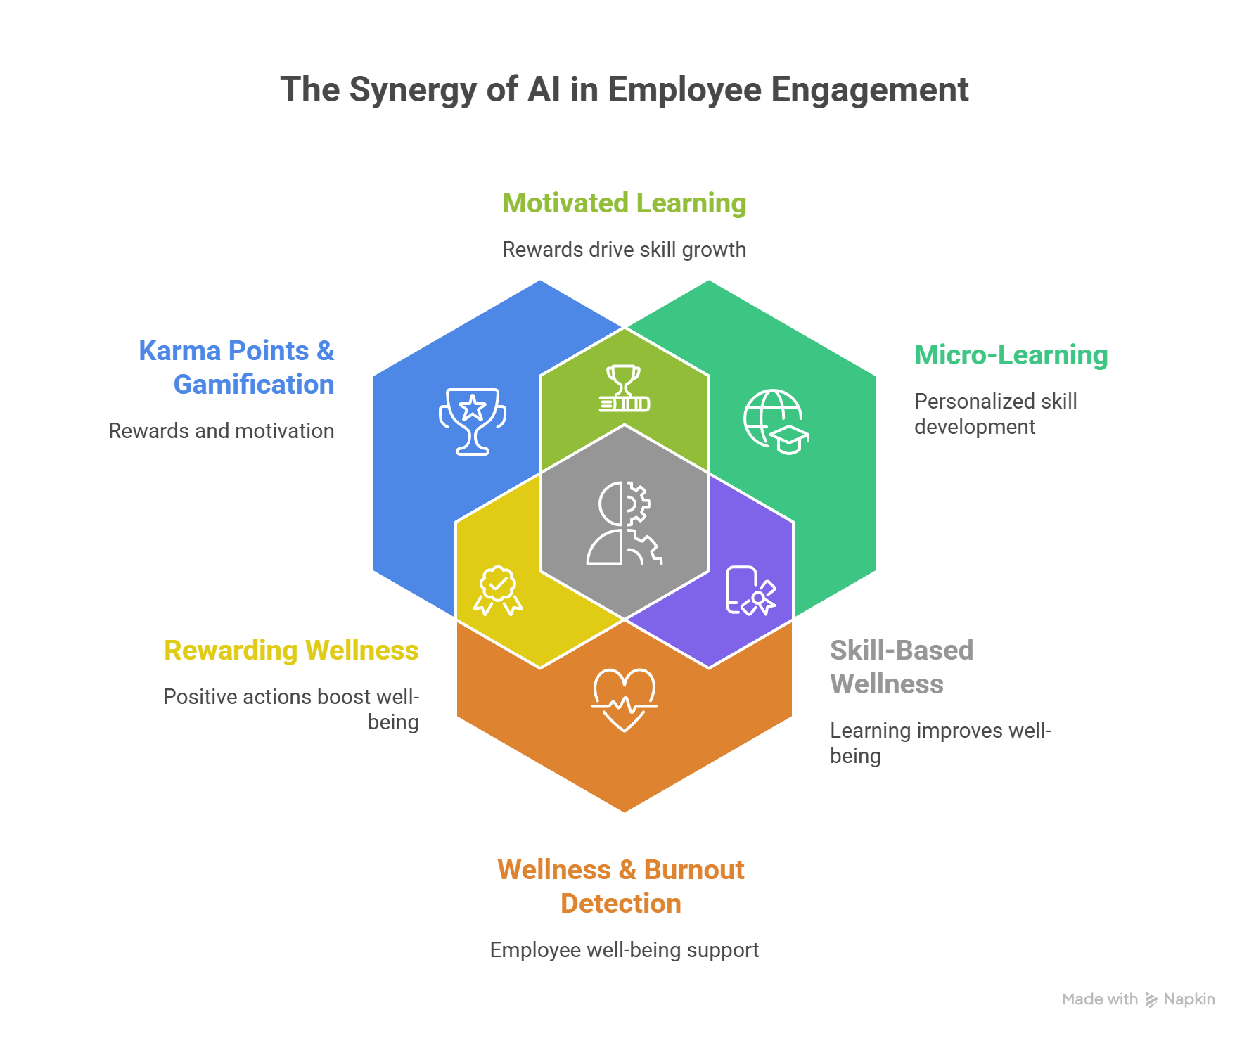
Figure 5.1 — The Synergy of AI in Employee Engagement: Karma, Learning, Wellness & Attrition

5.3 Scope — In Scope & Out of Scope
✓ In Scope | ✗ Out of Scope
- Social collaboration feed, posts, and community features  - Anonymous and named feedback submission and tracking  - Karma points, kudos, and rewards redemption system  - Micro-learning modules and skill certification  - Know Your Colleague (KYC) and Know Your Company (KYCO) tools  - Guided wellness: meditation, counselling, pulse surveys  - Burnout and attrition prediction AI  - HRMS and SSO integration  - Engagement, sentiment, and ROI analytics dashboard | - Performance management and annual appraisal processes  - Payroll processing (integration only for reward accounting)  - Recruitment and onboarding (covered by IntelliRecruit)  - Legal compliance for labor law (advisory only)  - Mandatory corporate training compliance tracking (basic LMS function only)  - Physical wellness programs (gym, events — platform notifies; does not manage)

5.4 Module & AI Agent Matrix
Layer | Module | Sub-Module | AI Agent
Layer 1 – Collaboration | Posts & Feed | Social Feed | Content Moderation Agent
Layer 1 – Collaboration | Posts & Feed | Trending Topics | Engagement Analytics Agent
Layer 1 – Collaboration | Feed-Box | Feedback Submission | Sentiment Analysis Agent
Layer 1 – Collaboration | Feed-Box | Suggestion Tracking | Execution Tracking Agent
Layer 1 – Collaboration | Virtual Townhall | AI Summary | Meeting Summary Agent
Layer 1 – Collaboration | Hobby Clubs & Events | Interest Matching | Community Matching Agent
Layer 2 – Recognition | Karma Points | Good/Bad Karma Allocation | Behavior Scoring Agent
Layer 2 – Recognition | Karma Points | Ledger & Reconciliation | Fairness Audit Agent
Layer 2 – Recognition | Karma Points | Gamification & Badges | Gamification Engine Agent
Layer 2 – Recognition | Kudos | Peer Recognition | Recognition Insight Agent
Layer 2 – Recognition | Rewards Redemption | Reward Catalog | Reward Optimization Agent
Layer 3 – Learning | Any Time Learning | Micro Learning Modules | Personalized Learning Agent
Layer 3 – Learning | Any Time Learning | Skill Certification | Skill Gap Analysis Agent
Layer 3 – Learning | KYC | Profile Discovery | Skill Matching Agent
Layer 3 – Learning | KYCO | Policy Search | Policy Bot Agent
Layer 4 – Wellness | Guided Meditation | Mindfulness Sessions | Wellness Recommendation Agent
Layer 4 – Wellness | Counselling Services | Session Scheduling | Mental Health Risk Agent
Layer 4 – Wellness | Health Polls | Pulse Surveys | Wellness Analytics Agent
Layer 4 – Wellness | Wellness Check | Periodic Check-ins | Burnout Detection Agent
Layer 5 – Analytics | Engagement Dashboard | EQ Score Tracking | Engagement Scoring Agent
Layer 5 – Analytics | Sentiment Analysis | Emotion Detection | Culture Health Agent
Layer 5 – Analytics | Adoption Metrics | Usage Tracking | Adoption Intelligence Agent
Layer 5 – Analytics | ROI Tracking | Cost & Productivity Metrics | ROI Calculation Agent
Layer 6 – Integration | HRMS Integration | Employee Data Sync | Data Reconciliation Agent
Layer 6 – Integration | SSO & Authentication | User Access Control | Access Risk Agent
Layer 6 – Integration | Payroll Integration | Gift & Reward Accounting | Payroll Sync Agent
Layer 7 – Orchestrator | SmartCafe AI Brain | Cross-Module Insights | Engagement Optimization Agent
Layer 7 – Orchestrator | SmartCafe AI Brain | Predictive Attrition Signals | Attrition Prediction Agent
Layer 7 – Orchestrator | SmartCafe AI Brain | Intervention Playbooks | AI Intervention Agent

5.5 Detailed Use Case Specifications
The following Use Case Cards provide complete functional specifications for each key module. Each card covers the full lifecycle of the feature: who uses it, what triggers it, how the system processes it step by step, what outputs are produced, and how errors are handled.

IC-01 – Karma Points & Behavior Scoring System
AI Agent: Behavior Scoring Agent | Module: Karma Points | Layer: Layer 2 – Recognition
 | 📋 Feature Description
 | The Karma Points system is a comprehensive behavioral recognition framework that captures and rewards actions aligned with organizational values. The Behavior Scoring Agent uses AI sentiment analysis and contextual understanding to fairly allocate Good Karma (positive behaviors) and Bad Karma (policy violations), maintaining an immutable ledger with a monthly Fairness Audit to detect and correct distribution bias. Employees accumulate karma points redeemable for rewards, creating a continuous reinforcement loop for desired behaviors.
 | 👥 Actors Involved
 | • Behavior Scoring Agent
 | • Fairness Audit Agent
 | • Employee (all levels)
 | • Manager / Peer (karma giver)
 | • HR Administrator
 | • Rewards Redemption Module
 | • Payroll Integration (reward accounting)
 | 🔒 Preconditions
 | • Organizational values and behavior categories are mapped to karma point values by HR Admin
 | • Karma giving rules are configured: who can give karma, per transaction limits, monthly giving budget per manager
 | • Content Moderation Agent is active to validate karma reason text
 | • Employee HRMS profiles are synced (department, role, tenure, manager hierarchy)
 | • Karma ledger database is initialized for current financial year
 | ⚡ Trigger(s)
 | • EVENT: Manager or peer submits karma award via mobile app or web portal
 | • EVENT: System detects automated karma trigger (e.g., learning module completed, SOP checklist streak)
 | • SCHEDULED: Monthly Fairness Audit runs on 1st of each month
 | • EVENT: Karma balance reaches redemption threshold (employee eligible to redeem)
 | 🔄 Step-by-Step System Flow
 | 1 | Employee/Manager opens IntelliCafe mobile app or web portal; navigates to "Give Karma" feature.
 | 2 | Giver selects recipient from employee directory; enters karma amount (within configured per-transaction limit).
 | 3 | Giver selects organizational value tag from pre-defined list (e.g., "Teamwork", "Innovation", "Customer Focus", "Safety").
 | 4 | Giver enters reason text (minimum 20 characters required for quality audit).
 | 5 | Content Moderation Agent scans reason text: check for inappropriate content, verify sincerity score, detect gaming patterns (repeated identical reasons from same giver).
 | 6 | Behavior Scoring Agent applies contextual weighting: senior-to-junior karma = standard weight; peer-to-peer = 1.2× weight (peer recognition is harder to earn); cross-department = 1.1× weight.
 | 7 | Karma transaction created: {giver_id, recipient_id, amount_weighted, value_tag, reason, timestamp, moderation_score}.
 | 8 | Recipient balance updated in Karma Ledger; transaction confirmed via push notification to recipient.
 | 9 | Bad Karma: if triggered by manager for policy violation, HR approval required before deduction applied; employee notified with explanation.
 | 10 | Monthly Fairness Audit: Fairness Audit Agent analyzes distribution by gender, department, tenure, and role; calculates Gini coefficient for karma distribution equity.
 | 11 | If bias detected (e.g., specific team consistently receives <50% of benchmark karma): HR alert with distribution report.
 | 12 | HR reviews fairness report; takes corrective action (e.g., karma giving nudges to underutilizing managers).
 | ✅ Expected Output
 | • Real-time karma award confirmation: recipient push notification with giver name, amount, and reason
 | • Karma balance update on recipient profile and leaderboard
 | • Monthly Karma Ledger Report: total karma earned/given per employee, per department, per value tag
 | • Monthly Fairness Audit Report: distribution analysis by demographic segment, Gini coefficient, bias detection alerts
 | • Redemption eligibility notification when employee balance crosses threshold
 | 📌 Postconditions
 | • Karma transaction permanently recorded in immutable ledger; cannot be deleted
 | • Recipient karma balance updated and reflected on public leaderboard (if employee has opted in)
 | • Gamification Engine Agent evaluates if transaction triggers a badge or achievement milestone
 | • Fairness Audit findings logged; corrective actions tracked with completion status
 | 📏 Business Rules
 | BR-01 | Karma cannot be self-awarded; self-nomination triggers EH-02
 | BR-02 | Manager karma-giving budget is configurable (default: 500 points/month to distribute); prevents favoritism
 | BR-03 | Bad Karma requires manager justification (min 50 characters) and HR approval; cannot be applied without dual authorization
 | BR-04 | Karma points expire after 18 months if not redeemed; expiry notification sent at 60 days and 7 days before expiry
 | BR-05 | Leaderboard participation is opt-in; employees can choose private balance without public display
 | ✔ Validation Rules
 | VR-01 | Reason text must be minimum 20 characters; below threshold transaction rejected with error message
 | VR-02 | Karma amount must be positive integer within configured per-transaction range (default: 1–100 points)
 | VR-03 | Giver must have sufficient karma giving budget remaining in current month; over-budget transactions blocked
 | VR-04 | Recipient must be active employee in HRMS; terminated employees cannot receive karma
 | ⚠ Error Handling
 | EH-01 | EH-01: Content moderation flags reason as inappropriate → Transaction blocked; giver notified of policy violation; HR alerted if repeated violations from same giver
 | EH-02 | EH-02: Self-award attempt detected → Transaction blocked immediately; giver notified; event logged for HR review (3 attempts = HR investigation trigger)
 | EH-03 | EH-03: HRMS sync failure (employee not found) → Transaction queued; retry HRMS lookup every 30 minutes; after 4 hours, manual HR verification required
 | EH-04 | EH-04: Fairness Audit detects severe bias (Gini > 0.7 in any segment) → Immediate HR alert; karma-giving nudge campaign auto-initiated for under-participating managers

IC-02 – Personalized Micro-Learning
AI Agent: Personalized Learning Agent | Module: Any Time Learning | Layer: Layer 3 – Learning
 | 📋 Feature Description
 | An AI-driven micro-learning system that delivers 5–15 minute role-relevant learning modules to employees on demand, with AI-personalized learning paths based on individual skill gaps, career goals, and role requirements. The Personalized Learning Agent continuously analyses completion patterns, assessment scores, and skill gap data to recommend the right content at the right time — on mobile and desktop — with seamless SCORM-compatible content integration.
 | 👥 Actors Involved
 | • Personalized Learning Agent
 | • Skill Gap Analysis Agent
 | • Employee (learner)
 | • L&D / HR Administrator
 | • Content Management System (SCORM-compatible)
 | • HRMS (role/competency data)
 | • Skill Certification Module
 | 🔒 Preconditions
 | • Learning content library is uploaded and tagged with skill tags, role applicability, and difficulty level
 | • Employee competency framework and role-to-skill mapping is configured by L&D team
 | • Employee HRMS profiles with current role, department, and career path are synced
 | • Minimum 10 courses are available per role family for meaningful personalization
 | • Skill assessment baseline is completed by employees during onboarding
 | ⚡ Trigger(s)
 | • EVENT: Employee opens "Learn" section of IntelliCafe app
 | • SCHEDULED: Weekly learning nudge notification if no module completed in past 7 days
 | • EVENT: Skill Gap Analysis Agent identifies new skill gap from assessment result
 | • EVENT: New role-relevant content uploaded to library by L&D team
 | 🔄 Step-by-Step System Flow
 | 1 | Employee opens IntelliCafe Learning module; Personalized Learning Agent loads employee profile: {role, department, skills_completed, skills_in_progress, career_goal, weekly_learning_minutes, last_module_completed}.
 | 2 | Skill gap matrix calculated: current skills vs. role benchmark skills → gap score per skill category.
 | 3 | Content recommendation algorithm: filter library by role applicability; rank by skill gap priority × employee engagement score × content freshness.
 | 4 | Top 5 recommended modules displayed: module title, estimated time, skill tag, completion %, and a "Why this is recommended for you" explanation.
 | 5 | Employee selects module; SCORM content player launches in-app with progress tracking.
 | 6 | Learning session tracked: time_spent, completion_percentage, interaction_events (clicks, answers, video pause points).
 | 7 | Post-module quiz: 5–10 questions; score recorded; pass mark is 70% (configurable).
 | 8 | Pass: skill credit awarded; learner profile updated; gamification event triggered (streak, badge check).
 | 9 | Fail: agent recommends supplementary content; employee can retake assessment after 24 hours.
 | 10 | Completion certificate generated (PDF) if skill certification requirements met.
 | 11 | Personalized learning path updated: completed skill removed from gap matrix; next recommended skill identified.
 | 12 | L&D Admin receives weekly learning analytics: completion rates, popular modules, skill coverage by department.
 | ✅ Expected Output
 | • Personalized top 5 module recommendations refreshed weekly per employee with explainability
 | • SCORM-compliant learning session with progress auto-save (resume from any device)
 | • Post-module quiz result with pass/fail and topic-level performance breakdown
 | • Skill credit added to employee profile upon successful completion
 | • Digital certificate PDF downloadable and shareable to LinkedIn
 | • Weekly L&D analytics: engagement rates, skill coverage heatmap, completion trends by department
 | 📌 Postconditions
 | • Skill completion recorded in employee profile, visible in KYC (Know Your Colleague) directory
 | • Skill gap matrix updated; next recommended module recalculated
 | • Learning streak maintained if module completed within 7-day window (streak = gamification driver)
 | • If certification threshold reached (e.g., 5 modules in same skill + assessment passed): digital certificate issued and emailed
 | 📏 Business Rules
 | BR-01 | Learning is voluntary and not linked to performance appraisal data without employee consent
 | BR-02 | Certificate issuance requires passing assessment at ≥70%; certificates cannot be issued for completion without assessment
 | BR-03 | L&D team must review and approve all content before publication; unreviewed content cannot be recommended to employees
 | BR-04 | Mandatory compliance training (if configured by HR) overrides personalization and is always shown first in recommendations
 | ✔ Validation Rules
 | VR-01 | Module content must be SCORM 1.2 or SCORM 2004 compliant for progress tracking; non-SCORM content supported as link-out only without tracking
 | VR-02 | Assessment questions must have minimum 4 options with exactly 1 correct answer; malformed questions blocked at upload
 | VR-03 | Employee must complete minimum 80% of module content before assessment is unlocked; partial completion blocked
 | ⚠ Error Handling
 | EH-01 | EH-01: SCORM player crash → Save last progress checkpoint (every 30 seconds); on reopen, resume from last checkpoint; event logged for content quality review
 | EH-02 | EH-02: Assessment submission timeout → Cache answers locally; retry submission when connection restored; employee not penalized for timeout
 | EH-03 | EH-03: Recommendation engine cold start (new employee, no history) → Use role-based default learning path (curated by L&D for each role family); switch to personalized recommendations after 3 completions

IC-03 – Burnout Detection & Wellness Check
AI Agent: Burnout Detection Agent | Module: Wellness Check | Layer: Layer 4 – Wellness
 | 📋 Feature Description
 | The Burnout Detection Agent monitors a combination of behavioral signals — pulse survey response patterns, login timing and frequency, karma interaction activity, learning engagement, and voluntary support ticket sentiment — to detect emerging burnout risk 30–45 days before it manifests as disengagement or voluntary resignation. Early detection enables HR Business Partners to intervene with personalized wellness support, workload review, and confidential counselling referrals.
 | 👥 Actors Involved
 | • Burnout Detection Agent
 | • Wellness Analytics Agent
 | • Mental Health Risk Agent
 | • Employee (monitored with consent)
 | • HR Business Partner (intervention recipient)
 | • Manager (notification for workload review)
 | • Counselling Services Module
 | 🔒 Preconditions
 | • Employee has consented to wellness monitoring during onboarding (opt-in with data minimization disclosure)
 | • Pulse survey cadence is configured (weekly or bi-weekly)
 | • Baseline behavioral patterns established for each employee (minimum 30 days of data)
 | • HRMS sync provides: working hours logged, leave taken, role change history
 | • HR Business Partner assignments are configured per employee population
 | • Counselling Services booking system is integrated
 | ⚡ Trigger(s)
 | • CONTINUOUS: Behavioral signal analysis runs nightly for all opted-in employees
 | • EVENT: Pulse survey response contains highly negative sentiment or "I need support" indicator
 | • EVENT: Employee has not completed a pulse survey for 3+ consecutive periods (avoidance signal)
 | • EVENT: HR Business Partner requests burnout risk assessment for specific employee or team
 | 🔄 Step-by-Step System Flow
 | 1 | Burnout Detection Agent retrieves nightly behavioral signal matrix for each employee: {pulse_survey_score_trend, login_frequency_7d, login_time_anomaly (unusual hours), karma_given_received_trend, learning_activity_trend, voluntary_app_usage, support_ticket_sentiment}.
 | 2 | Trend analysis: compare current 14-day period vs. employee's personal 90-day baseline for each signal.
 | 3 | Deviation score calculated per signal: (current_value - baseline_mean) / baseline_std_dev = Z-score.
 | 4 | Composite Burnout Risk Score calculated: weighted average of signal Z-scores (survey score: 30%, login anomaly: 20%, disengagement signals: 30%, support sentiment: 20%).
 | 5 | Risk tier assigned: Low (<2.0), Moderate (2.0–3.5), High (>3.5).
 | 6 | Mental Health Risk Agent applies secondary validation: cross-reference with recent counselling session topics, manager feedback notes.
 | 7 | For High-risk employees: HR Business Partner alert generated with anonymized signal summary (not individual signal details).
 | 8 | HR Business Partner receives: "Team member in [Department] is showing elevated burnout risk indicators. Signals: declining engagement over 3 weeks, unusual working hour patterns, survey sentiment decline. Recommended action: 1:1 check-in."
 | 9 | HR Business Partner acknowledges alert; initiates 1:1 conversation; documents outcome in system.
 | 10 | If employee consents: automatic Counselling Services session suggestion sent to employee via in-app notification.
 | 11 | Intervention outcome tracked: burnout score trend post-intervention vs. control group.
 | 12 | If no improvement after 2 weeks of HR intervention: escalation recommendation to HR Manager with case summary.
 | ✅ Expected Output
 | • Nightly burnout risk score update for each opted-in employee
 | • HR Business Partner alert (anonymized for individual privacy, specific for team-level patterns)
 | • Wellness Risk Dashboard: distribution of employees by risk tier (without individual identification for team views)
 | • Employee-level confidential report: available to HR BP with employee consent
 | • Intervention tracking: actions taken, timeline, outcome (improved/unchanged/escalated)
 | • Monthly Organizational Wellness Report: aggregate burnout risk trends by department, role family, and office location
 | 📌 Postconditions
 | • Burnout risk scores logged with date for longitudinal trend analysis (retained for 3 years)
 | • All HR interventions logged against employee record (accessible to HR BP and HR Manager only)
 | • Improved employees moved to "Monitoring" tier; sustained improvement moves to "Low Risk"
 | • Unresolved High-risk cases after 4 weeks trigger Attrition Prediction Agent re-evaluation
 | 📏 Business Rules
 | BR-01 | Wellness monitoring is strictly opt-in; employees who opt out are excluded and cannot be added by managers or HR
 | BR-02 | Individual burnout scores are confidential; HR BPs see only their assigned population; no cross-departmental access
 | BR-03 | Burnout alerts sent to HR BP only — never to direct manager without employee consent — to prevent discrimination risk
 | BR-04 | All data used for burnout detection is anonymized in aggregate reports; individual identification requires explicit consent
 | ✔ Validation Rules
 | VR-01 | Minimum 30 days of behavioral baseline required before burnout scoring begins; new employees in "Establishing Baseline" status
 | VR-02 | Employee must have opted in to wellness monitoring; consent recorded with timestamp and version of privacy notice
 | VR-03 | Pulse survey data used in burnout scoring must be the employee's own responses; proxy responses (manager-submitted) excluded
 | ⚠ Error Handling
 | EH-01 | EH-01: Employee opts out mid-monitoring → Immediately stop monitoring; delete all historical behavioral signals within 24 hours per data retention policy; HR BP notified
 | EH-02 | EH-02: Anomalous data spike (e.g., system outage causing zero logins for all employees) → Exclude outage period from trend calculation; flag affected dates in baseline calculation
 | EH-03 | EH-03: HR BP unavailable → Escalate High-risk alert to HR Manager; create coverage plan for unassigned employee population

IC-04 – Predictive Attrition & Intervention AI
AI Agent: Attrition Prediction Agent | Module: SmartCafe AI Brain | Layer: Layer 7 – Orchestrator
 | 📋 Feature Description
 | The Attrition Prediction Agent synthesizes signals across all IntelliCafe layers — engagement scores, karma activity, learning participation, wellness risk, and HRMS data — to predict voluntary attrition risk 60–90 days in advance. When risk exceeds threshold, the AI Intervention Agent automatically generates a personalized, actionable intervention playbook for the HR Business Partner, specifying recommended conversations, recognition actions, development opportunities, and manager coaching steps with a 30-day execution timeline.
 | 👥 Actors Involved
 | • Attrition Prediction Agent
 | • AI Intervention Agent
 | • HR Business Partner
 | • HR Manager / CHRO
 | • Manager (coaching guidance recipient)
 | • Employee (subject of prediction — privacy protected)
 | • HRMS (tenure, promotion, salary data)
 | • All IntelliCafe sub-agents (signal sources)
 | 🔒 Preconditions
 | • Employee has minimum 6 months of IntelliCafe behavioral history
 | • HRMS data is synced: tenure, last promotion date, salary band, last rating (if available), manager changes
 | • Attrition prediction model is trained on minimum 18 months of historical data with confirmed attrition outcomes
 | • Intervention playbook templates are configured per employee segment (tenure band, role family, career stage)
 | • Attrition risk thresholds set: Low (<20%), Moderate (20–50%), High (>50%)
 | ⚡ Trigger(s)
 | • SCHEDULED: Weekly attrition risk refresh every Sunday night for all employees with sufficient data history
 | • EVENT: Burnout Detection Agent raises High-risk alert → immediate attrition risk re-evaluation
 | • EVENT: Employee tenure milestone (6-month, 1-year, 3-year) approaching — trigger retention risk review
 | • MANUAL: HR Business Partner queries attrition risk for specific employee or team
 | 🔄 Step-by-Step System Flow
 | 1 | Attrition Prediction Agent assembles feature vector for each employee from all IntelliCafe modules.
 | 2 | Feature vector: {tenure_months, months_since_promotion, eNPS_last, karma_received_trend_90d, learning_completions_90d, wellness_risk_score, burnout_score, manager_change_90d, recognition_gap_days (days since last kudos/karma), app_usage_trend}.
 | 3 | HRMS features added: {salary_percentile_in_band, peer_promotions_in_department (feel of being left behind), recent_team_restructure_flag}.
 | 4 | Gradient Boosting model generates attrition_probability_90d (0.0–1.0).
 | 5 | SHAP explainability: top 3 risk drivers identified for each high-risk employee.
 | 6 | Attrition risk tier assigned: Low/Moderate/High.
 | 7 | Segment-specific context applied: early career (<2 years) weight tenure gaps higher; mid-career (2–5 years) weight promotion recency higher; senior (5+ years) weight recognition and autonomy signals higher.
 | 8 | For High-risk employees: AI Intervention Agent generates personalized playbook.
 | 9 | Playbook construction: retrieve employee profile; match to intervention template for segment; customize with specific action recommendations based on dominant SHAP drivers.
 | 10 | Example playbook section: "Primary risk driver: 127 days since last recognition. Recommended action: Manager to give meaningful recognition within 5 days. Suggested talking point: acknowledge [specific recent project]. Expected impact: 15–20% risk reduction."
 | 11 | Playbook delivered to HR Business Partner: "Employee in [role/department] has 68% 90-day attrition risk. Playbook generated. Actions assigned. 30-day execution window."
 | 12 | Actions tracked in IntelliCafe; HR BP marks actions complete; outcome measured at 30 and 60 days.
 | ✅ Expected Output
 | • Weekly Attrition Risk Report: employees ranked by attrition probability with segment, risk tier, and top drivers (anonymized for data protection)
 | • Personalized Intervention Playbook: specific, actionable steps with owner, timeline, talking points, and expected impact
 | • HR Manager Dashboard: aggregate retention risk metrics — % High-risk population, ARR at risk from attrition, department-level risk concentration
 | • Monthly Attrition Prediction Accuracy Report: model precision, recall, and intervention effectiveness metrics
 | • CHRO-level Retention Intelligence Brief: trend analysis, benchmark comparison, recommended strategic actions
 | 📌 Postconditions
 | • Attrition risk scores and intervention records retained for 3 years for longitudinal analysis
 | • Confirmed attrition events feed back into model as training data for continuous improvement
 | • Successfully retained employees (post-intervention) logged as positive training examples
 | • Departure surveys (exit interviews) integrated to validate prediction drivers and improve model accuracy
 | 📏 Business Rules
 | BR-01 | Attrition predictions are strictly confidential HR intelligence; sharing outside HR without CHRO approval is a data policy violation
 | BR-02 | No employment decisions (promotion, termination) can be based solely on attrition prediction scores; human judgment required
 | BR-03 | Attrition model must maintain recall >70% for High-risk tier; below target triggers retraining
 | BR-04 | Employees must not be informed of their individual attrition score; interventions must be framed as development and recognition initiatives
 | ✔ Validation Rules
 | VR-01 | Minimum 6 months of combined IntelliCafe and HRMS data required for attrition scoring; below threshold, employee shown as "Insufficient Data"
 | VR-02 | All feature data must be sourced from consented data collection channels; features from non-consented sources automatically excluded
 | VR-03 | Model predictions above 90% probability flagged for Human HR Review before playbook dispatch — extreme scores suggest data anomaly
 | ⚠ Error Handling
 | EH-01 | EH-01: HRMS sync failure (missing tenure/promotion data) → Generate prediction using IntelliCafe signals only; flag as "Partial Model — HRMS Data Missing"; HR notified to verify HRMS sync
 | EH-02 | EH-02: Model drift detected (recall < 65% over 30 days) → Auto-revert to previous model version; Data Science team notification; weekly monitoring increased to daily until model is retrained
 | EH-03 | EH-03: HR BP unresponsive to playbook (>5 business days) → Auto-escalate playbook to HR Manager with urgency flag; create overdue task notification

6. IntelliRecruit™ (RazorSwift) — AI-Native Talent Intelligence Platform
IntelliRecruit™ (RazorSwift)
From Sourcing to Submission in One Click

6.1 Key Business Benefits
✓ 30–50% reduction in cost-per-hire
✓ 30–50% faster time-to-hire
✓ 2–3× increase in recruiter throughput
✓ 40% reduction in time spent on administrative tasks
✓ >78% attrition prediction accuracy for new hires at 6 months

6.2 Problem Statement
Recruitment is one of the highest-cost, most time-consuming business operations — and most organizations are doing it with a patchwork of disconnected tools: one job board here, a spreadsheet there, a manual interview scheduling process, and a Word document resume format. The result is chaos: recruiters spend 60–70% of their time on administrative tasks instead of building relationships; candidates experience poor, slow, inconsistent processes; and hiring managers receive poorly matched shortlists. For staffing firms and RPOs, margin pressure is relentless — cost-per-hire is growing while revenue-per-placement is declining. IntelliRecruit™ consolidates the entire hiring lifecycle — JD generation, multi-channel sourcing, AI screening, agentic 24/7 interviews, automated scheduling, client-ready submission packaging, and predictive analytics — into a single AI-native platform that reduces cost-per-hire by 30–50% and cuts time-to-hire by 30–50%.

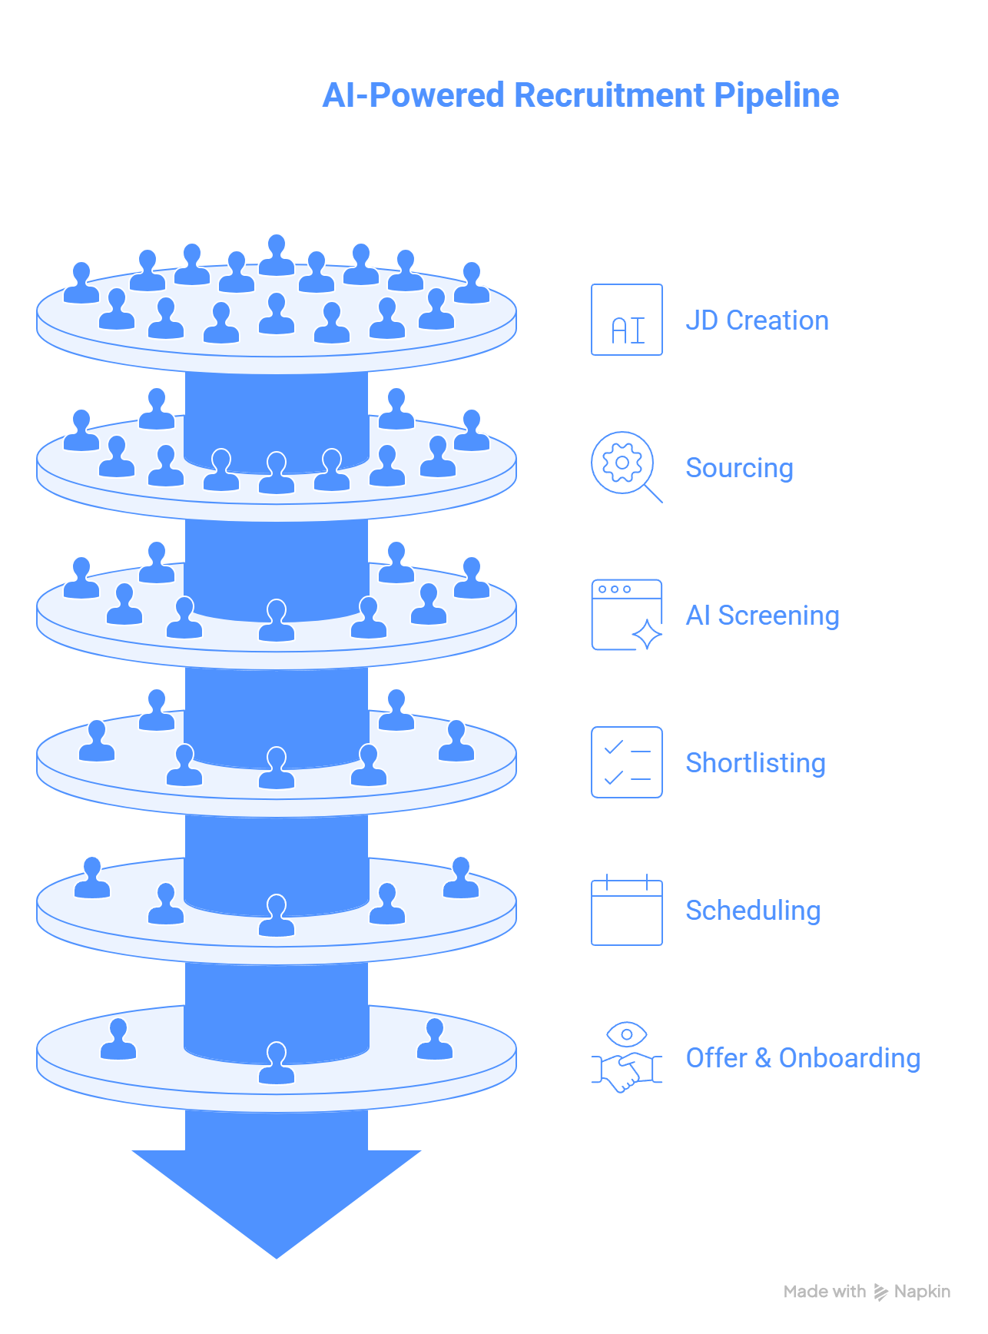
Figure 6.1 — AI Recruitment Pipeline: JD Creation to Hiring Prediction

6.3 Scope — In Scope & Out of Scope
✓ In Scope | ✗ Out of Scope
- AI job description generation and skill mapping  - Multi-channel talent sourcing (job boards, LinkedIn, internal pools)  - Automated resume parsing and structured profile creation  - AI-powered candidate fit scoring and shortlisting  - Bias detection and diversity compliance checks  - 24/7 AI agentic interview bot  - Skill-based assessments with adaptive testing  - Smart calendar scheduling  - Client-ready resume packaging and submission portal  - Offer letter generation and digital signature  - Recruiter SLA monitoring dashboard  - Predictive hiring success and attrition forecasting  - ATS, CRM, and HRMS integrations  - Revenue and margin analytics for staffing firms | - Background verification and reference checking (integration with third-party BGV providers, not built-in)  - Visa and immigration processing  - Payroll processing for placed candidates  - Physical interview logistics (venue booking, travel)  - Campus recruitment event management  - Internal HR performance management post-joining  - Grievance redressal post-joining

6.4 Module & AI Agent Matrix
Layer | Module | Sub-Module | AI Agent
Layer 1 – Sourcing | Job Intelligence | JD Auto Generation | JD Generation Agent
Layer 1 – Sourcing | Job Intelligence | JD Skill Mapping | Skill Extraction Agent
Layer 1 – Sourcing | Talent Sourcing | Multi-Channel Sourcing | Candidate Discovery Agent
Layer 1 – Sourcing | Talent Sourcing | Talent Pool Creation | Talent Cohort Agent
Layer 1 – Sourcing | Outreach Engine | WhatsApp/Email Campaigns | Personalized Outreach Agent
Layer 2 – Screening | Resume Parsing | CV Structuring | Resume Parsing Agent
Layer 2 – Screening | AI Matching Engine | Fit Scoring | Candidate Fit Scoring Agent
Layer 2 – Screening | AI Matching Engine | Ranking & Shortlisting | Ranking Agent
Layer 2 – Screening | Bias & Compliance | Diversity Checks | Bias Detection Agent
Layer 3 – Interview | Agentic Interview | 24/7 AI Interviews | Interview Bot Agent
Layer 3 – Interview | Assessment Engine | Skill-Based Tests | Assessment Evaluation Agent
Layer 3 – Interview | Video Intelligence | Interview Transcript Analysis | Interview Insight Agent
Layer 3 – Interview | Scheduling | Auto Calendar Sync | Smart Scheduling Agent
Layer 4 – Submission | Submission Packaging | Client-Ready Resume Format | Resume Packaging Agent
Layer 4 – Submission | Client Collaboration | Client Feedback Loop | Feedback Analysis Agent
Layer 4 – Submission | Offer Management | Offer Letter Generation | Offer Automation Agent
Layer 5 – Workflow | Recruiter Dashboard | Pipeline Health | Pipeline Health Agent
Layer 5 – Workflow | SLA Monitoring | Time-to-Hire Tracking | SLA Monitoring Agent
Layer 5 – Workflow | Automation Engine | Task Automation | Workflow Automation Agent
Layer 5 – Workflow | Compliance & Audit | Hiring Audit Trail | Compliance Monitoring Agent
Layer 6 – Analytics | Hiring Analytics | Cost-per-Hire Analysis | Recruitment ROI Agent
Layer 6 – Analytics | Predictive Hiring | Success Probability | Hiring Success Prediction Agent
Layer 6 – Analytics | Attrition Forecasting | Early Exit Risk | Attrition Risk Agent
Layer 6 – Analytics | Diversity Metrics | Inclusion Tracking | Diversity Analytics Agent
Layer 7 – Integration | ATS Integration | Bi-Directional Sync | ATS Sync Agent
Layer 7 – Integration | CRM Integration | Client Data Sync | CRM Sync Agent
Layer 7 – Integration | HRMS Integration | Employee Data Transfer | Onboarding Sync Agent
Layer 7 – Integration | API Gateway | Webhook & Event Triggers | Integration Health Agent
Layer 8 – Orchestrator | Recruitment AI Brain | Cross-Module Intelligence | Recruitment Optimization Agent
Layer 8 – Orchestrator | Recruitment AI Brain | What-if Hiring Simulation | Hiring Scenario Agent
Layer 8 – Orchestrator | Recruitment AI Brain | Revenue & Margin Optimization | Margin Optimization Agent

6.5 Detailed Use Case Specifications
The following Use Case Cards provide complete functional specifications for each key module. Each card covers the full lifecycle of the feature: who uses it, what triggers it, how the system processes it step by step, what outputs are produced, and how errors are handled.

IR-01 – AI Job Description Generation & Skill Mapping
AI Agent: JD Generation Agent | Module: Job Intelligence | Layer: Layer 1 – Sourcing
 | 📋 Feature Description
 | The JD Generation Agent creates complete, structured job descriptions from minimal input — a few keywords, a hiring manager conversation summary, or a role title — using LLM generation against a library of 500+ role templates. It then automatically maps the JD to a standardized skill taxonomy via the Skill Extraction Agent, enabling downstream AI matching, sourcing targeting, and assessment configuration. Generated JDs are optimized for search engine visibility (job board SEO) and bias-free language.
 | 👥 Actors Involved
 | • JD Generation Agent
 | • Skill Extraction Agent
 | • Hiring Manager
 | • Recruiter
 | • Talent Sourcing Module
 | • AI Matching Engine
 | • Assessment Engine
 | • HRMS (competency framework)
 | 🔒 Preconditions
 | • JD role template library (500+ templates) is loaded and maintained by HR Admin
 | • Standardized skill taxonomy is configured (ESCO/O*NET or custom organizational taxonomy)
 | • Hiring Manager has access to IntelliRecruit portal or has submitted request via intake form
 | • Salary benchmarking data is loaded for target geography (India/UAE/Saudi Arabia)
 | • Bias-free language rules are configured (EEO guidelines per geography)
 | ⚡ Trigger(s)
 | • EVENT: Hiring Manager submits new vacancy request via IntelliRecruit intake form
 | • EVENT: ATS sync detects new approved requisition in connected ATS (Greenhouse/Workday/iCIMS)
 | • MANUAL: Recruiter creates new JD from IntelliRecruit dashboard
 | • MANUAL: Recruiter uploads existing JD for skill mapping and optimization
 | 🔄 Step-by-Step System Flow
 | 1 | Hiring Manager accesses IntelliRecruit intake portal; fills minimal fields: Job Title, Department, Level (Analyst/Manager/Director), Location, Key Responsibilities (optional free text).
 | 2 | JD Generation Agent retrieves closest matching template from role library (cosine similarity on title + department + level embeddings).
 | 3 | LLM (GPT-4 / Azure OpenAI) generates complete JD: Job Summary (3–5 lines), Key Responsibilities (8–12 bullets), Required Qualifications, Preferred Qualifications, About the Company section.
 | 4 | Bias check: JD scanned against EEO language rules; gendered language (e.g., "rockstar", "aggressive") flagged and replaced with neutral alternatives.
 | 5 | Geography-specific salary benchmark appended: "Salary range: ₹12–18 LPA (India, as per market benchmark)".
 | 6 | JD structured output sent to Skill Extraction Agent.
 | 7 | Skill Extraction Agent NLP pipeline: entity recognition extracts: Required Skills, Experience Band, Educational Qualification, Certifications, Industry Experience.
 | 8 | Extracted skills mapped to standardized taxonomy (e.g., "Python" → Programming Language → Data/Engineering cluster).
 | 9 | Skill profile created: {required_skills: [{skill, level, mandatory_flag}], experience_min, experience_max, education, certifications}.
 | 10 | JD + Skill Profile presented to Hiring Manager for review in portal; edits tracked.
 | 11 | After approval: JD published to configured job boards (Naukri, Indeed, LinkedIn, company careers page); skill profile activated for candidate matching.
 | 12 | Assessment Engine notified with skill profile to auto-suggest relevant assessment modules for this role.
 | ✅ Expected Output
 | • Complete, bias-free job description in structured format (HTML/DOCX) ready for job board posting
 | • Standardized skill profile with mandatory/preferred skill flags, experience band, and qualification requirements
 | • Job board postings created on configured platforms within 15 minutes of JD approval
 | • Assessment module recommendations for role (from Assessment Engine)
 | • JD quality score: completeness %, readability score, SEO keyword density, bias-free score
 | 📌 Postconditions
 | • JD and skill profile saved to requisition record with version history
 | • Talent Sourcing Module activated with skill profile for multi-channel candidate discovery
 | • AI Matching Engine calibrated with skill profile as matching target
 | • Hiring Manager notified via email: JD live on [X] platforms; candidate pipeline will be visible within 24 hours
 | 📏 Business Rules
 | BR-01 | All JDs must pass bias check before publication; manual override requires HR Administrator approval with justification
 | BR-02 | Salary range must be published for positions in India (SEBI listed companies) per regulatory guidelines
 | BR-03 | JDs older than 90 days without a hire must be reviewed and re-approved by Hiring Manager before sourcing continues
 | BR-04 | Standardized skill taxonomy must be used for all skill extraction; free-text skills not in taxonomy added to review queue for taxonomy committee approval
 | ✔ Validation Rules
 | VR-01 | Job Title must match one of the configured role families; completely unknown titles trigger "New Role Family" workflow for HR team to configure template
 | VR-02 | Location must be a valid configured office location or "Remote"; freetext location entries require HR Admin confirmation
 | VR-03 | Salary range, if provided manually, must be within band defined for the role level in compensation framework; out-of-band salaries blocked without HR Director approval
 | ⚠ Error Handling
 | EH-01 | EH-01: LLM generation timeout (>15 seconds) → Return closest matching template as draft; display "AI Generation Incomplete — Please Review"; retry LLM in background; notify recruiter when full JD ready
 | EH-02 | EH-02: Skill extraction produces <5 skills → Recruiter prompted to add skills manually; JD marked as "Skill Profile Incomplete"; cannot progress to sourcing without minimum 5 skills
 | EH-03 | EH-03: Job board API failure → JD saved in IntelliRecruit; board posting queued; retry every 30 minutes for 24 hours; recruiter notified of posting delay

IR-02 – 24/7 AI Agentic Candidate Interview
AI Agent: Interview Bot Agent | Module: Agentic Interview | Layer: Layer 3 – Interview
 | 📋 Feature Description
 | The Interview Bot Agent conducts structured, conversational first-round interviews autonomously via WhatsApp Business API, web portal chat, or phone, available 24 hours a day, 7 days a week. It dynamically adapts questions based on candidate responses — probing deeper on strong answers, pivoting away from areas of demonstrated weakness, and ensuring all mandatory competency areas are covered. Each interview is scored across multiple dimensions and produces a structured interview summary with evidence quotes for recruiter review.
 | 👥 Actors Involved
 | • Interview Bot Agent
 | • Candidate
 | • Recruiter (review)
 | • Hiring Manager (competency input)
 | • Assessment Evaluation Agent (handoff)
 | • Smart Scheduling Agent (post-interview)
 | • Candidate Fit Scoring Agent (score update)
 | 🔒 Preconditions
 | • Competency framework for role is mapped: 4–6 competencies with behavioral indicators from JD skill profile
 | • Interview question library is configured for role family (minimum 20 questions per competency)
 | • Candidate has been shortlisted by AI Matching Engine and invited to interview via email/WhatsApp
 | • Candidate has confirmed interview via scheduling link and has access to interview channel (WhatsApp/web)
 | • Interview scoring rubric is configured: each competency scored 1–5 with behavioral anchor descriptions
 | ⚡ Trigger(s)
 | • EVENT: Candidate clicks interview start link in invitation email or WhatsApp message
 | • EVENT: Candidate sends "Start Interview" to IntelliRecruit WhatsApp number
 | • SCHEDULED: Candidate has a confirmed interview appointment at specific time
 | • MANUAL: Recruiter re-schedules a missed interview from dashboard
 | 🔄 Step-by-Step System Flow
 | 1 | Candidate initiates interview via WhatsApp or web portal; language detected (English/Hindi/Arabic); interview conducted in detected or candidate-selected language.
 | 2 | Interview Bot Agent sends opening: "Hi [Name]! I'm the IntelliRecruit AI interviewer for [Company] for the [Role] position. This will take about 20–30 minutes. I'll ask questions about your experience and skills. Ready to start?"
 | 3 | Candidate confirms readiness; agent begins structured interview following role competency framework.
 | 4 | Competency 1 (e.g., Problem Solving): behavioral question asked: "Tell me about a time you solved a complex problem with limited information."
 | 5 | Candidate response received; NLP analysis: extract STAR elements (Situation, Task, Action, Result); assess depth and relevance.
 | 6 | If response is shallow: follow-up probe generated: "Can you tell me more about what specific steps you took?"
 | 7 | If response demonstrates strong evidence: move to next competency; if weak: note weakness and probe alternate competency angle.
 | 8 | Repeat for all 4–6 competencies; agent maintains conversational context throughout (remembers earlier answers).
 | 9 | Mandatory screening questions asked (e.g., notice period, location preference, salary expectation, right to work).
 | 10 | Interview conclusion: "Thank you, [Name]! The interview is complete. You'll receive an update within 2 business days."
 | 11 | Post-interview processing: Transcription Agent transcribes full conversation; STAR extraction applied to each response.
 | 12 | Interview Score Card generated: {competency_scores[1–5], overall_interview_score, top_strengths, development_areas, evidence_quotes, screening_data, recommendation (Strong Hire / Hire / Maybe / No Hire)}.
 | 13 | Score card added to candidate profile; Candidate Fit Scoring Agent updates composite fit score.
 | 14 | Recruiter receives notification: interview completed with summary scorecard.
 | ✅ Expected Output
 | • Full interview transcript (text) stored in candidate profile
 | • Structured Interview Score Card: competency-by-competency scores with behavioral evidence quotes
 | • Hiring recommendation: Strong Hire / Hire / Maybe / No Hire with confidence score
 | • Screening data captured: notice period, location flexibility, salary expectation, right to work status
 | • Candidate-facing completion message and expected timeline update
 | • Recruiter dashboard update: candidate stage moved to "Interview Complete"; scorecard accessible
 | 📌 Postconditions
 | • Interview scorecard permanently linked to candidate profile for current and future roles (with consent)
 | • Candidate stage updated in ATS (if integrated) via ATS Sync Agent
 | • Recruiter review of scorecard required before progressing candidate to next stage
 | • If recommendation is "No Hire": rejection communication queued for recruiter review before dispatch
 | • Smart Scheduling Agent notified to arrange next-stage interview if recommendation is "Hire" or "Strong Hire"
 | 📏 Business Rules
 | BR-01 | Interview Bot must cover all configured mandatory competencies; incomplete interview (< 3 competencies covered) requires re-interview
 | BR-02 | Candidate can pause interview and resume within 4 hours; after 4 hours, session expires and must restart
 | BR-03 | Interview recordings (if voice/video) require explicit candidate consent before capture; text transcripts do not require separate consent under standard privacy policy
 | BR-04 | All interview decisions (advancement/rejection) must be reviewed and confirmed by human recruiter; AI bot cannot autonomously reject candidates
 | ✔ Validation Rules
 | VR-01 | Interview must be initiated by the candidate listed in invitation; phone number or session token verification required to prevent proxy interviews
 | VR-02 | Response length must be minimum 50 characters for a response to be scored; shorter responses trigger follow-up probe ("Could you expand on that?")
 | VR-03 | Candidate must complete mandatory screening questions before interview score is finalized; missing screening data = "Incomplete Interview" flag
 | ⚠ Error Handling
 | EH-01 | EH-01: WhatsApp message delivery failure → Retry delivery 3 times at 5-minute intervals; after failure, switch to email interview link; recruiter notified
 | EH-02 | EH-02: Candidate drops mid-interview (connectivity loss) → Save progress at last complete question; send resume link: "We lost connection. Resume your interview here: [link]. Valid for 4 hours."
 | EH-03 | EH-03: Inappropriate candidate response (abuse, spam) → Flag response; agent responds: "I'm unable to continue this conversation. Your response has been flagged."; session closed; recruiter and HR notified
 | EH-04 | EH-04: Language model scoring failure → Mark competency as "Manual Review Required"; recruiter alerted to review transcript and score manually

IR-03 – Candidate Fit Scoring & Bias-Free Shortlisting
AI Agent: Candidate Fit Scoring Agent + Bias Detection Agent | Module: AI Matching Engine + Bias & Compliance | Layer: Layer 2 – Screening
 | 📋 Feature Description
 | Multi-dimensional AI candidate scoring system that ranks candidates against a role's skill profile across four dimensions: Skills Match, Experience Relevance, Culture Fit Indicators, and Compensation Alignment. The Bias Detection Agent runs concurrently to audit every shortlist for gender, age, and diversity representation — and provides a Blind Screening Mode that removes identifying information during initial scoring to eliminate unconscious bias from the shortlisting process.
 | 👥 Actors Involved
 | • Candidate Fit Scoring Agent
 | • Bias Detection Agent
 | • Resume Parsing Agent (score input)
 | • Interview Bot Agent (score input)
 | • Recruiter
 | • HR Compliance Officer
 | • Hiring Manager (shortlist reviewer)
 | 🔒 Preconditions
 | • JD skill profile is active with required/preferred skills, experience band, and salary range
 | • Resume Parsing Agent has structured all candidate CVs into standard profile format
 | • Fit scoring weights are configured per organization/role family (default: Skills 40%, Experience 30%, Culture 15%, Compensation 15%)
 | • Bias detection thresholds are configured per geography (India, UAE, Saudi EEO guidelines)
 | • Blind screening mode preference is configured per organization (default: ON for first-round screening)
 | ⚡ Trigger(s)
 | • EVENT: New candidate profile available (from sourcing or direct application)
 | • EVENT: Interview Bot Agent completes interview → score updated
 | • EVENT: Hiring Manager requests shortlist generation for a requisition
 | • SCHEDULED: Daily re-ranking of all active candidates in pipeline as new applications arrive
 | 🔄 Step-by-Step System Flow
 | 1 | Resume Parsing Agent provides structured candidate profile: {skills_list, experience_years, experience_companies, education, last_role, last_salary_if_provided}.
 | 2 | Skills Match Score (40%): overlap calculation between candidate skills and JD required/preferred skills; mandatory skills weighted higher (missing mandatory skill caps score at 50).
 | 3 | Experience Relevance Score (30%): years of experience in role family, industry relevance coefficient, recency weighting (last 3 years most relevant).
 | 4 | Culture Fit Indicators Score (15%): analyzed from behavioral keywords in resume (leadership language, collaboration indicators, achievement orientation) — labeled as "soft signal only".
 | 5 | Compensation Alignment Score (15%): last drawn salary (if provided) vs. role budget band; within band = 100%, <30% below = 80% (may expect higher), >30% above band = 50% (likely to decline).
 | 6 | Composite Fit Score calculated (0–100): weighted sum of four dimension scores.
 | 7 | BIAS DETECTION: Bias Detection Agent extracts demographic proxies from profile: name (gender proxy), graduation year (age proxy), college location (socioeconomic proxy).
 | 8 | Blind Screening Mode (if enabled): demographic proxies masked on recruiter view; recruiter sees only skills, experience, and score.
 | 9 | Shortlist audit: analyze top-N shortlist composition; compare to organization diversity targets and population benchmarks.
 | 10 | If diversity gap detected (e.g., female representation in shortlist < 30% when role target is 40%): bias alert generated with specific demographic gap report.
 | 11 | Alternative diverse candidates within 5% of top score surfaced and flagged for recruiter consideration.
 | 12 | Shortlist presented to recruiter with: ranked candidates, dimension score breakdowns, diversity audit result.
 | 13 | Recruiter approves shortlist; selected candidates advance to interview stage; unselected receive deferred status.
 | ✅ Expected Output
 | • Ranked shortlist with composite fit scores and dimension-level breakdown for each candidate
 | • Bias audit report for shortlist: demographic composition, gap vs. targets, alternative diverse candidates surfaced
 | • Blind screening view: candidate cards with demographic information masked until recruiter explicitly unlocks
 | • Shortlist quality metrics: average fit score, score distribution, skills coverage of shortlisted pool
 | • Rejected candidate list with score and primary reason code (for audit trail and candidate feedback)
 | 📌 Postconditions
 | • All fit scores and bias audit results logged in candidate record and requisition audit trail
 | • Shortlist approval by recruiter triggers interview invitations via Smart Scheduling Agent
 | • Rejected candidates receive automated status update (configurable timing: immediate or batched)
 | • Shortlist composition data feeds into Diversity Analytics Agent for monthly DEI reporting
 | 📏 Business Rules
 | BR-01 | Fit score is a tool to assist shortlisting, not to automatically reject candidates; final shortlist decisions require recruiter review
 | BR-02 | Blind screening mode cannot be permanently disabled; temporary disable requires HR Compliance Officer approval and is time-limited (max 48 hours)
 | BR-03 | All shortlists must meet minimum diversity representation thresholds configured by HR; shortlists below threshold require HR Compliance Officer review before advancing
 | BR-04 | Score explanations must be available to recruiter for all candidates; "black box" scoring is prohibited
 | ✔ Validation Rules
 | VR-01 | Minimum 5 candidates must be evaluated before a shortlist can be generated; fewer candidates = "Insufficient Pool" warning
 | VR-02 | Skill profile must have minimum 5 required skills defined; shortlisting against a sparse skill profile generates "Low Quality Match" warning
 | VR-03 | Candidate profile must have minimum structured work experience or education; profiles with only a name and phone number cannot be scored
 | ⚠ Error Handling
 | EH-01 | EH-01: Resume parsing failure (unreadable format) → Flag candidate as "Manual Review Required"; recruiter notified; candidate can be manually scored by recruiter
 | EH-02 | EH-02: Salary data unavailable → Exclude Compensation Alignment from scoring; redistribute weight to Skills (47%) and Experience (35%); note in scorecard
 | EH-03 | EH-03: Diversity gap persists after alternative surfacing (insufficient diverse candidates in pipeline) → Recruiter prompted to expand sourcing channels targeting underrepresented segments; requisition flagged for HR Compliance review

IR-04 – Smart Scheduling & Calendar Automation
AI Agent: Smart Scheduling Agent | Module: Scheduling | Layer: Layer 3 – Interview
 | 📋 Feature Description
 | Zero-friction interview scheduling automation that reads interviewer calendar availability, presents self-scheduling options to candidates, sends multi-channel reminders, and handles rescheduling without recruiter manual intervention. The Smart Scheduling Agent reduces average scheduling cycle time from 2–3 days (manual) to under 2 hours (automated), dramatically improving candidate experience and recruiter bandwidth.
 | 👥 Actors Involved
 | • Smart Scheduling Agent
 | • Candidate
 | • Recruiter
 | • Hiring Manager / Interviewers
 | • Google Calendar / Outlook (calendar integration)
 | • WhatsApp / Email (notification channels)
 | • Interview Bot Agent (scheduling trigger)
 | 🔒 Preconditions
 | • Interviewer calendar access is granted (Google Calendar or Outlook OAuth integration)
 | • Interview stages and panel configurations are defined per role (who must attend each stage)
 | • Interviewer and recruiter working hours / time zones are configured
 | • Candidate contact details (email, WhatsApp) are available in profile
 | • Minimum notice period for interview scheduling is configured (default: 24 hours)
 | ⚡ Trigger(s)
 | • EVENT: Candidate shortlisted and approved by recruiter → Stage 1 interview scheduling initiated
 | • EVENT: Interview Bot Agent completes AI interview with "Hire/Strong Hire" recommendation → Stage 2 scheduling initiated
 | • EVENT: Candidate or interviewer cancels an existing appointment
 | • MANUAL: Recruiter manually triggers scheduling from candidate profile
 | 🔄 Step-by-Step System Flow
 | 1 | Smart Scheduling Agent receives scheduling request: {candidate_id, stage, required_interviewers[], interview_duration, mode (video/phone/in-person)}.
 | 2 | Agent reads calendar availability for all required interviewers for the next 14 days via Google Calendar / Outlook API.
 | 3 | Availability slots identified: find overlapping free slots across all required interviewers (minimum 3 slots required).
 | 4 | Filter slots: exclude blocked times (focus time, out-of-office), apply minimum notice period (24 hours from now).
 | 5 | Top 3–5 slots selected: prioritize morning slots (higher show-up rate), avoid Friday afternoon (lower attendance).
 | 6 | Candidate scheduling link generated: personalized link showing 3–5 time options with time zone auto-detection.
 | 7 | WhatsApp message and email sent to candidate: "Hi [Name]! Your interview for [Role] at [Company] is ready to schedule. Please choose a time that works for you: [link]. Options expire in 48 hours."
 | 8 | Candidate selects preferred slot via self-scheduling portal.
 | 9 | Calendar invites created and sent to candidate and all interviewers with: meeting link (Zoom/Teams/Meet auto-generated), JD attached, interview scorecard template, candidate profile attached.
 | 10 | Reminders scheduled: T-24h (WhatsApp + Email to candidate and interviewers), T-2h (WhatsApp to candidate), T-15min (WhatsApp to candidate).
 | 11 | If no response from candidate in 48 hours: follow-up message sent; after additional 48 hours of no response: recruiter notified; candidate moved to "Unresponsive" status.
 | 12 | If rescheduling requested: agent automatically offers next 3 available slots; re-sends calendar updates to all parties.
 | ✅ Expected Output
 | • Calendar invites created and confirmed for all interviewers and candidate within 2 hours of scheduling trigger
 | • Candidate scheduling link with 3–5 time options delivered via WhatsApp and email
 | • Automated reminder messages at T-24h, T-2h, and T-15min
 | • Rescheduling handled autonomously without recruiter intervention (up to 2 reschedules)
 | • Scheduling analytics: average scheduling cycle time, no-show rate, rescheduling rate per recruiter/role
 | 📌 Postconditions
 | • Confirmed interview records in IntelliRecruit and in all interviewer/candidate calendars
 | • No-show tracking: if candidate or interviewer misses interview, agent automatically offers next available slot
 | • Interview completion triggers Interview Bot Agent (for AI rounds) or requests manual scorecard from interviewer (for human rounds)
 | • Scheduling cycle time logged for recruiter performance analytics
 | 📏 Business Rules
 | BR-01 | Maximum 2 autonomous reschedules allowed; 3rd rescheduling requires recruiter manual review and decision on candidate disqualification
 | BR-02 | Interview scheduling link expires after 48 hours of inactivity; recruiter must extend or re-initiate scheduling
 | BR-03 | Interviewers cannot be double-booked via IntelliRecruit scheduling even if their calendar shows availability due to sync lag — 15-minute buffer applied between consecutive interviews
 | BR-04 | Candidate contact via scheduling system must not exceed 3 messages without candidate response; additional contact requires recruiter approval
 | ✔ Validation Rules
 | VR-01 | Minimum 3 available slots must be found before scheduling link is sent; if fewer than 3 slots in 14 days, recruiter alerted to expand interviewer panel or extend availability window
 | VR-02 | Interview duration must be between 15 and 240 minutes; values outside this range blocked with validation error
 | VR-03 | Video conference links must be generated from configured approved platforms only (Zoom/Teams/Meet); external link insertion blocked
 | ⚠ Error Handling
 | EH-01 | EH-01: Calendar API authorization failure (expired OAuth token) → Send re-authorization request to interviewer via email; notify recruiter; scheduling held until authorization refreshed
 | EH-02 | EH-02: No available slots in 14-day window → Recruiter notified; interviewer panel expansion suggested; option to send manual availability request to interviewers
 | EH-03 | EH-03: Calendar invite creation failure (API error) → Retry 3 times; if persistent, email interview details without calendar invite; recruiter notified to manually create invite

IR-05 – Hiring Success Prediction & Attrition Forecasting
AI Agent: Hiring Success Prediction Agent | Module: Predictive Hiring | Layer: Layer 6 – Analytics
 | 📋 Feature Description
 | Predictive analytics module that forecasts the probability of a placed candidate's 6-month performance success and 1-year retention at the time of hiring — before the offer is made. The model is trained continuously on actual performance and retention outcomes, creating a self-improving hiring intelligence engine. It also identifies roles with historically high early attrition (< 6 months) and recommends assessment and screening configuration changes to improve hire quality for those positions.
 | 👥 Actors Involved
 | • Hiring Success Prediction Agent
 | • Attrition Risk Agent
 | • Recruiter
 | • Hiring Manager
 | • HR Analytics Team
 | • HRMS (performance and retention data)
 | • Candidate Fit Scoring Agent (input features)
 | • Interview Bot Agent (input features)
 | 🔒 Preconditions
 | • Minimum 18 months of historical hire data with confirmed outcomes (performance ratings, tenure) is available
 | • HRMS is integrated and returns 6-month performance ratings and 1-year retention status for past hires
 | • Model has been trained and validated: precision >65% for "High Attrition Risk" tier
 | • Feature importance review has been completed and approved by HR Analytics team
 | ⚡ Trigger(s)
 | • EVENT: Candidate receives "Hire" or "Strong Hire" recommendation from Interview Bot Agent → pre-offer prediction run
 | • SCHEDULED: Weekly model performance review — retrain if accuracy drops below threshold
 | • MANUAL: HR Analytics team requests batch prediction for all active candidates in final round
 | 🔄 Step-by-Step System Flow
 | 1 | Hiring Success Prediction Agent retrieves candidate feature vector at time of offer decision: {fit_score, skills_match_pct, interview_score, assessment_score, years_experience, role_fit_band, expected_vs_offered_salary_gap, notice_period, location_match}.
 | 2 | HRMS historical features for role applied: {avg_tenure_in_role, attrition_rate_6m_for_role, performance_rating_avg_for_role, time_since_last_successful_hire_from_same_source_channel}.
 | 3 | Model inference: Gradient Boosting → outputs: {success_probability_6m, retention_probability_12m, attrition_risk_tier}.
 | 4 | SHAP explainability: top 3 success drivers and top 3 attrition risk factors identified.
 | 5 | Prediction displayed on candidate profile: "Predicted 6-month success probability: 78%. Predicted 12-month retention: 65%. Top attrition risk: 28% salary gap (candidate expected ₹18 LPA, offer is ₹15 LPA)."
 | 6 | If attrition risk is High (>60%): specific alert to recruiter and hiring manager with suggested mitigations (e.g., "Consider compensation adjustment" or "Structured onboarding for this risk profile").
 | 7 | Offer stage: prediction summary included in offer recommendation sent to Hiring Manager.
 | 8 | Post-join: at 6-month mark, actual performance rating retrieved from HRMS; compared to prediction.
 | 9 | Prediction accuracy tracked per recruiter, per source channel, per role family.
 | 10 | Monthly model retraining: new outcome data incorporated; model performance dashboard updated.
 | 11 | Roles with >30% early attrition rate flagged for assessment configuration review; Attrition Risk Agent generates recommendation report.
 | ✅ Expected Output
 | • Pre-offer prediction scorecard: 6-month success probability, 12-month retention probability, attrition risk tier, key risk factors with explanations
 | • Recommendation to Hiring Manager: proceed with offer / proceed with caution (specific risk notes) / reconsider (high attrition risk)
 | • Monthly Hiring Quality Report: predicted vs. actual success rates by recruiter, source channel, and role family
 | • High-attrition role analysis: roles with >30% early attrition with root cause attribution and assessment recommendations
 | • Model accuracy dashboard: precision, recall, and AUC-ROC by prediction tier
 | 📌 Postconditions
 | • Prediction outcome tracked post-join; actual performance vs. predicted performance logged
 | • Model retrained monthly with new outcome data; accuracy improvement tracked over time
 | • High-attrition role recommendations reviewed by HR Analytics and implemented as assessment changes within 30 days
 | • Recruiter performance scorecard updated with "hire quality" metric based on prediction accuracy of their placed candidates
 | 📏 Business Rules
 | BR-01 | Hiring predictions are advisory; no offer decision should be made solely on prediction score — hiring manager retains final authority
 | BR-02 | Prediction model must be audited annually for bias against protected characteristics; model showing >5% accuracy differential by gender, age, or ethnicity must be retrained
 | BR-03 | Past prediction data and outcomes must be retained for 3 years for model validation and legal compliance
 | BR-04 | Prediction scores must not be shared with candidates; internal use only
 | ✔ Validation Rules
 | VR-01 | Prediction requires minimum feature completeness: fit_score, interview_score, and years_experience must be available; missing more than 2 features = "Insufficient Data" prediction not generated
 | VR-02 | HRMS outcome data must be linked by employee ID at 6-month and 12-month marks; unlinked outcomes cannot be used for model training
 | VR-03 | Prediction confidence interval must be reported alongside point estimate; predictions without confidence intervals blocked from display
 | ⚠ Error Handling
 | EH-01 | EH-01: HRMS outcome data unavailable (integration failure) → Model retains last training snapshot; predictions still generated; "Training Data Stale" flag shown on model accuracy dashboard; IT notified
 | EH-02 | EH-02: Model accuracy drops below 55% precision → Auto-revert to previous model version; alert sent to HR Analytics team with performance degradation report; retraining triggered on next weekly cycle
 | EH-03 | EH-03: Feature vector incomplete for candidate (e.g., no assessment score) → Generate prediction on available features; flag as "Partial Prediction"; recruiter advised to complete assessment before offer decision

7. Non-Functional Requirements
Non-Functional Requirements
System-Wide Quality Attributes & Constraints

7.1 Performance Requirements
ID | Requirement | Specification
NFR-P01 | API Response Time | P50 <100ms, P95 <200ms, P99 <500ms for standard API calls. AI-generated responses: P95 <2 seconds. Complex multi-agent orchestration: <5 seconds.
NFR-P02 | Vision Processing Latency | Real-time video analysis: object detection per frame <100ms on edge GPU. Alert delivery from event detection to operator screen: <5 seconds.
NFR-P03 | Concurrent Users | 10,000 concurrent users per product instance. Horizontal pod auto-scaling activates at 70% CPU. Max scale-out: 50 pods per service.
NFR-P04 | Report Generation | Standard dashboard reports: <10 seconds. Complex analytics reports: <60 seconds. Bulk export (10,000 rows): <5 minutes.
NFR-P05 | Notification Delivery | In-app notifications: <3 seconds. Push notifications: <10 seconds. Email: <60 seconds. WhatsApp: <15 seconds.
NFR-P06 | Data Sync Latency | Real-time ERP delta sync: <5 minutes lag. Vision count to ERP GR: <60 seconds. HRMS profile sync: <15 minutes.

7.2 Availability & Reliability
ID | Requirement | Specification
NFR-R01 | Uptime SLA | 99.9% uptime for production environments (<8.76 hours downtime/year). 99.5% for staging environments. Measured monthly.
NFR-R02 | Recovery Time Objective (RTO) | RTO < 4 hours for full platform recovery from complete failure. RTO < 30 minutes for single microservice failure (auto-restart via Kubernetes).
NFR-R03 | Recovery Point Objective (RPO) | RPO < 1 hour: maximum 1 hour of data loss in disaster scenario. Achieved via transaction log streaming to secondary region.
NFR-R04 | Backup Strategy | Automated daily snapshots: 30-day retention. Weekly full backup: 90-day retention. Air-gapped backup for on-premise deployments. Point-in-time recovery within 30-day window.
NFR-R05 | Circuit Breakers | Circuit breakers on all inter-service calls. Open after 5 consecutive failures. Half-open probe after 30 seconds. Closed on 3 consecutive successes.
NFR-R06 | Graceful Degradation | If AI agent fails: fall back to rule-based logic with "AI Unavailable" notice. If real-time sync fails: serve cached data with staleness timestamp displayed.

7.3 Security Requirements
ID | Requirement | Specification
NFR-S01 | Data Encryption | AES-256 encryption for all data at rest. TLS 1.3 for all data in transit. Separate encryption namespaces per tenant. BYOK (Bring Your Own Key) for enterprise clients.
NFR-S02 | Authentication & Access | MFA mandatory for admin users. SSO via SAML 2.0/OAuth 2.0. JWT token expiry: 30 minutes web, 8 hours mobile. Refresh token rotation on every use.
NFR-S03 | Security Testing | Quarterly VAPT (Vulnerability Assessment and Penetration Testing) by certified third-party. Annual SOC 2 Type II audit roadmap. OWASP Top 10 mitigation in all modules.
NFR-S04 | Data Residency | India client data stored in AWS Mumbai (ap-south-1) or Azure India Central. UAE in AWS UAE (me-central-1). Saudi in AWS Bahrain (me-south-1). No cross-border transfer without consent.
NFR-S05 | PII Protection | Automated PII detection in all data pipelines. Column-level masking for non-essential roles. Right-to-erasure workflow (GDPR/India PDPB) completing within 72 hours of request.
NFR-S06 | Audit Trail | Immutable audit logs for all data access, modifications, and AI decisions. Retained for 7 years (financial), 3 years (HR), 30 days (operational). SIEM integration: Splunk/Azure Sentinel.

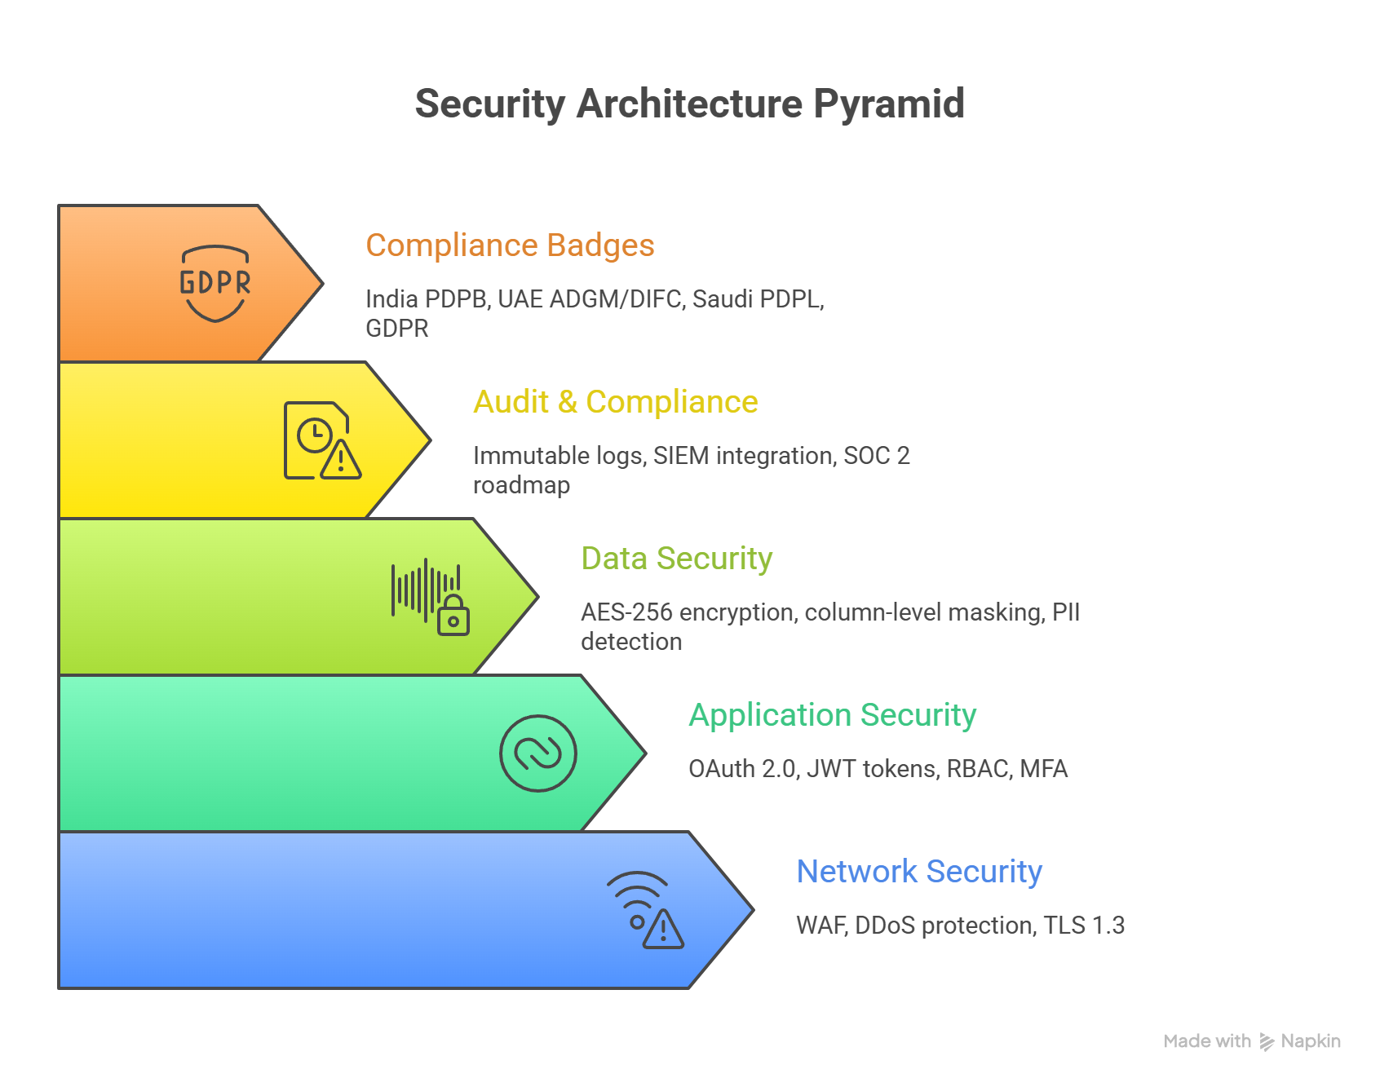
Figure 7.1 — Security Architecture: Layered Defense Model

7.4 Regulatory & Compliance Requirements
Geography | Regulation | Compliance Requirement
India | IT Act 2000 / PDPB 2023 | Personal data processing requires consent. Data localization for sensitive personal data. Grievance officer designation. Privacy notice in regional languages.
India | Companies Act 2013 | Board-level data governance accountability. Audit trail retention for financial data minimum 8 years.
UAE | ADGM / DIFC PDPL | Data subject rights (access, correction, deletion). Data Protection Officer required for large-scale processing. Cross-border transfer restrictions.
UAE | UAE Cybercrime Law | Mandatory incident reporting for data breaches within 72 hours. Prohibition on unauthorized data access. Specific provisions for cloud data storage.
Saudi Arabia | PDPL 2021 | Explicit consent for data collection. Data subject rights (access, correction, deletion, objection). Data Protection Officer required. Breach notification within 72 hours.
Saudi Arabia | NCA ECC | Essential Cybersecurity Controls compliance for systems handling sensitive data. Annual cybersecurity assessment. Incident response plan requirement.
International | GDPR (EU-origin data) | Applicable when processing EU citizen data (e.g., GCC expatriates). DPA (Data Processing Agreement) required with all sub-processors. 72-hour breach notification.

8. Technology Stack

8.1 Core Technology Components
Layer | Technology Choices & Specifications
Backend Framework | FastAPI (Python 3.11+) for AI/ML microservices. Node.js 20 LTS for real-time WebSocket services. gRPC for high-performance inter-service communication.
Frontend Web | React 18 / Next.js 14 for web dashboards. TypeScript for type safety. TailwindCSS for styling. Zustand for state management. Chart.js + D3.js for visualizations.
Mobile Apps | React Native 0.73 for iOS and Android. Offline-first architecture with WatermelonDB local cache. Expo for OTA updates. React Navigation for routing.
AI & ML | OpenAI GPT-4o for primary LLM. Anthropic Claude Sonnet as fallback. Azure OpenAI for enterprise private deployments. LangChain 0.2 / LangGraph for agent orchestration. YOLOv8/v9 (Ultralytics) for computer vision.
ML Models | XGBoost / LightGBM for structured predictions. Prophet + ARIMA for time-series forecasting. Isolation Forest for anomaly detection. SHAP for model explainability. MLflow for experiment tracking.
Embedding & Vector | OpenAI text-embedding-3-large (3072 dim). Multilingual-E5-large for Hindi/Arabic. Pinecone / Qdrant vector stores. Cosine similarity for semantic search.
Primary Databases | PostgreSQL 16 with pgvector extension. TimescaleDB for time-series. Redis 7 for cache and sessions. Elasticsearch 8 for full-text search.
Data Warehouse | Snowflake (primary analytics). BigQuery (GCP alternative). Apache Iceberg table format for data lake. dbt for data transformation.
Message Streaming | Apache Kafka 3.6 for event streaming. Schema Registry for event schema management. Kafka Connect for CDC integration. Amazon SQS as lightweight queue alternative.
Infrastructure | Docker + Kubernetes (EKS/AKS/GKE). Terraform for IaC. ArgoCD for GitOps. Helm for K8s package management. KEDA for event-driven autoscaling.
Cloud Providers | AWS (primary): Mumbai, UAE, Bahrain regions. Azure (secondary + India enterprise). GCP (analytics workloads). Supports on-premise private cloud with same Kubernetes stack.
Integration Middleware | Boomi and MuleSoft for enterprise integration. Temporal.io for workflow orchestration. Zapier-style automation for no-code triggers.
Security | HashiCorp Vault for secrets. AWS KMS / Azure Key Vault for BYOK. Cloudflare WAF + DDoS protection. OWASP ZAP for automated scanning. Falco for runtime security.
Observability | Grafana + Prometheus for metrics. Datadog APM for distributed tracing. ELK Stack for log aggregation. Jaeger for distributed tracing. Sentry for error tracking. PagerDuty for alerting.
Edge (IntelliDepot) | NVIDIA Jetson Orin (8GB) for on-device YOLOv8 inference. RTSP client (FFmpeg). MQTT for IoT sensor data. SQLite for edge local cache (offline buffer 10,000 events).

8.2 Cloud Deployment Architecture
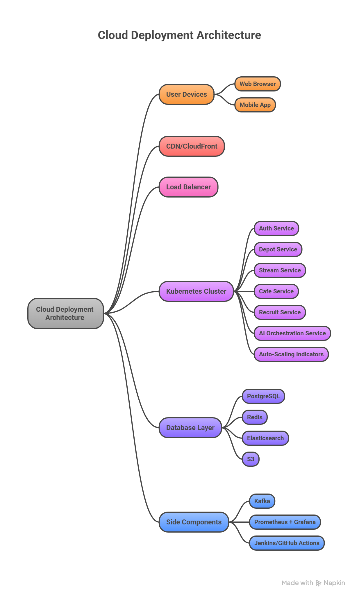
Figure 8.1 — Cloud Deployment Architecture: Infrastructure, Services & Observability

9. Glossary & Acronyms
Term / Acronym | Definition
AI Agent | Autonomous software component that perceives inputs, reasons, and acts to achieve a defined objective without continuous human supervision.
Agentic AI | AI systems capable of executing multi-step workflows, using tools, and making sequential decisions autonomously.
ANPR / LPR | Automatic Number Plate Recognition / License Plate Recognition — computer vision technology reading vehicle plates from camera images.
ARIMA | Autoregressive Integrated Moving Average — statistical model for time-series forecasting.
ATS | Applicant Tracking System — software for managing job applications and candidate pipelines (e.g., Greenhouse, Workday Recruiting).
BYOK | Bring Your Own Key — security model where the client controls their own data encryption keys.
CDC | Change Data Capture — technique tracking database changes in real time for synchronization.
CLV | Customer Lifetime Value — total net profit expected from a customer relationship over its duration.
DEI | Diversity, Equity & Inclusion — organizational commitment to fair representation and opportunity.
DSO | Days Sales Outstanding — average days to collect payment after a sale; key credit health indicator.
EEO | Equal Employment Opportunity — legal framework prohibiting discriminatory hiring practices.
FRD | Functional Requirements Document — specification describing expected system behavior, features, and constraints.
FEFO | First Expired, First Out — inventory rule ensuring items closest to expiry are dispatched first.
FIFO | First In, First Out — inventory rule ensuring earliest-received items are dispatched first.
GDPR | General Data Protection Regulation — EU law governing personal data processing and privacy rights.
GCC (country) | Gulf Cooperation Council — regional organization comprising UAE, Saudi Arabia, Kuwait, Qatar, Bahrain, and Oman.
GCC (org) | Global Capability Center — offshore unit of a multinational corporation providing technology and business services.
HRMS | Human Resource Management System — software managing employee data, payroll, and HR workflows.
IoT | Internet of Things — network of physical devices (sensors, cameras, weighbridges) collecting and transmitting data.
KPI | Key Performance Indicator — measurable value tracking progress against an objective.
LangChain/LangGraph | Open-source Python frameworks for building LLM-powered applications and multi-agent workflows.
LLM | Large Language Model — AI model trained on large text corpora capable of understanding and generating natural language.
MAPE | Mean Absolute Percentage Error — metric measuring forecast accuracy as % deviation from actuals.
MFA | Multi-Factor Authentication — security requiring two or more verification factors (password + OTP).
NCLT | National Company Law Tribunal — India's adjudicating authority for corporate insolvency proceedings.
NMS | Non-Maximum Suppression — computer vision post-processing step removing duplicate bounding box detections.
OKR | Objectives and Key Results — goal-setting framework for organizations and individuals.
PII | Personally Identifiable Information — any data that can identify a specific individual (name, ID, email).
RAG | Retrieval-Augmented Generation — AI technique combining vector database search with LLM generation for grounded responses.
RBAC | Role-Based Access Control — permission system granting access based on user role.
RPO | Recruitment Process Outsourcing — outsourcing part or all of a company's recruitment to a third party.
RTSP | Real-Time Streaming Protocol — standard for streaming video from IP cameras to processing systems.
RTO / RPO | Recovery Time Objective / Recovery Point Objective — disaster recovery metrics for restoration time and data loss tolerance.
SAML | Security Assertion Markup Language — XML-based protocol for SSO authentication between identity providers and service providers.
SCORM | Sharable Content Object Reference Model — standard for interoperable e-learning content packages.
SHAP | SHapley Additive exPlanations — model explainability technique identifying contribution of each feature to an AI prediction.
SLA | Service Level Agreement — contractual commitment defining expected service performance levels and penalties for breach.
SSO | Single Sign-On — authentication scheme allowing one set of credentials to access multiple applications.
SUPERS | Security, Usability, Performance, Extensibility, Reliability, Scalability — Fidelis Digital's platform design evaluation framework.
TLS | Transport Layer Security — cryptographic protocol for secure communication over a network (current standard: TLS 1.3).
VAPT | Vulnerability Assessment and Penetration Testing — security testing methodology to identify system weaknesses.
YOLO | You Only Look Once — real-time object detection algorithm; IntelliDepot uses YOLOv8/v9 for vision AI.

